Subjects I am taking: 1. Maths, 2. Science, 3. English, 4. 5. 6. 7. 8. .
 | Monday | Tuesday | Wednesday | Thursday | Friday
3-4 pm
4-5 pm
5-6 pm
6-7 pm
8- 9pm

 | Saturday | Sunday
Morning
Afternoon
Evening
After watching each video tick a box below or write down your own goals in spaces below.
Getting organised
- Ensure I have my book at home to help revise.
- Purchase revision guides for my subjects.
- Speak to my teachers about attending revision sessions.
- Talk to teachers about getting a personal learning checklist for my subject.
- Ask a teacher to provide me with some resources to revise from.
- Ensure I know my password and login from online resources.

Memory Hacks and revision tips
- Educake, myMaths, Maths Watch.
- Teach a subject.
- Mind map
- GCSE bitesize
- Cover up and recall.

Expert Memory Hacks and tips
Tip 1
Rather than passively repeating information over and over, try to elaborate on the information meaningfully, connect it to information you already know, and relate it to yourself and your life.
Tip 2
Testing yourself often, for example with flashcards, is a great way to remember information. Don’t cram too much information on each card – use cues to prompt yourself on single concepts.
Tip 3
You can use mnemonics to remember all kinds of things, for example in physics, the visible light spectrum can be remembered by Richard Of York Gave Battle In Vain… the more bizarre the better. You can use things that are personal to you to help you remember.
Tip 4
Mind maps can help you make links within subjects and can be a great way to elaborate on, and make connections between, topics.
Tip 5
The 'memory palace' can help you visualise and remember sequences by linking words to objects in an imaginary room. You can write a story using the objects and tell the story from memory to recall that list of words.
Tip 6
Space out your revision a little bit every day rather than cramming it all in the night before, then go back after a period of time and try to remember it. We call this the 'spacing effect'.

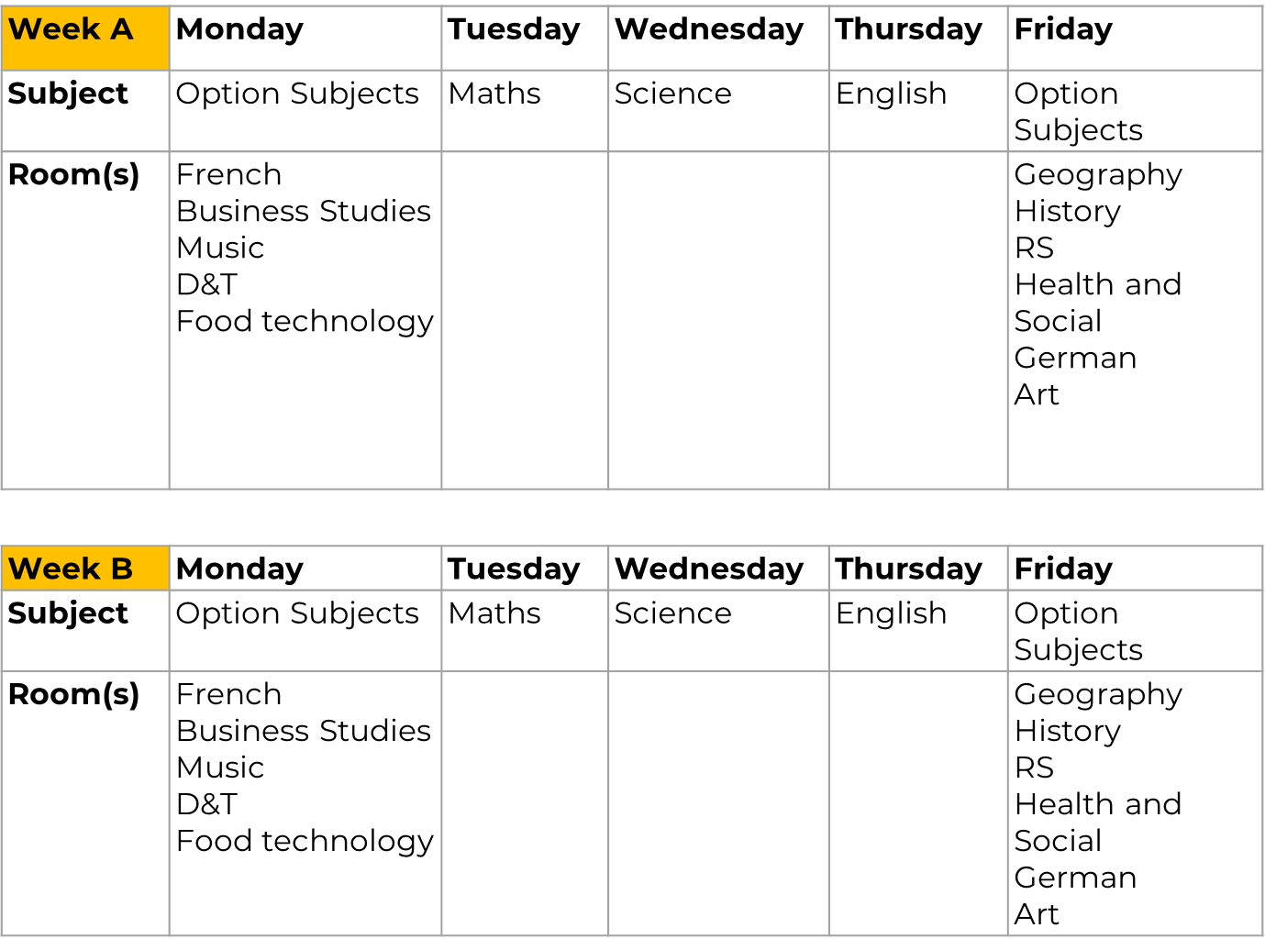
Five tips to reduce exam stress
Here are our tips for reducing stress during exam season. We hope they'll make you feel calmer than a sloth wearing sunglasses and sipping a smoothie whilst meditating on a beach, listening to whale sounds. Trust us, this sloth is caaaaaalm.
- Revise little and often It can be overwhelming trying to tackle all your revision at once, so plan ahead and break your revision up into small, more manageable chunks. We suggest creating a revision timetable and making sure you plan time for fun things like seeing friends and chilling out.
- Work on the subjects you are worried about Ask your teachers questions about the topics you struggle with the most. This will help you fill the gaps in your knowledge and allow you to focus on the things you find most difficult. It can be hard to focus when you find a topic hard, so why not break your revision up into twenty or thirty minute sessions with a ten minute break in between? We've got a guide on how to do this here.
- Exercise is a great way to de-stress Doing something fun that helps you stay healthy is a great way to boost your endorphins. This will help reduce your stress levels too. If you want to know more about how exercise can help you revise, we've got a guide for that.
- Check in with your mates Revising can be very lonely, so chatting with friends either face-to-face, over the phone or on a video call, will help boost your mood. You can chat about revision, or just have a good old natter about how you're feeling. Catching up with friends can be a big stress-reliever!
- Talk to someone you trust If you're struggling with stress, it's important to talk to someone you trust, like a parent, carer, teacher or GP. Reaching out to someone when you feel worried can help take a weight off your shoulders and can help steer you in the right direction to receive help. Sometimes you need to remember that it's not always about the grade you get in your exams. It's about trying your hardest and doing the best you can.

