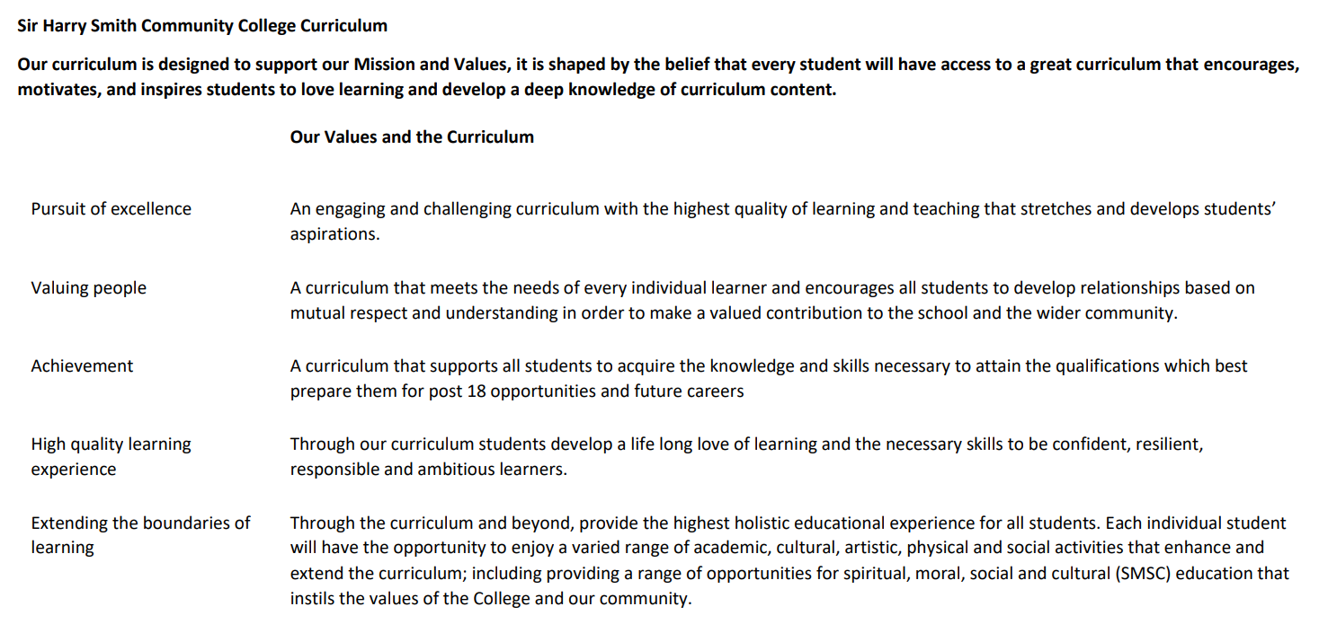

Sir Harry Smith Community College Curriculum Map SUBJECT: Maths YEAR 13 2022-23
Curriculum Intent: To ensure all pupils have the mathematical skills they need to move onto the next stage of their journey.
School Values | Curriculum Focus | Term 1 – Pure Mathematics | Term 2 – Applied Mathematics | Term 3 – Review and Exam.
High Quality Learning Experience | Literacy Skills and Key Vocabulary | The Technical language of mathematics is also accompanied by a vast range of special operations and characters too numerous to list here. The language and symbology cover several topics including:  Set Notation, Connective Symbols, Operations, Functions, Exponential and Logarithmic Functions, Trigonometric Functions, Vectors, Probability and Statistics and Mechanics. Full details are given in Appendix A of the A-Level Mathematics Specification, which can be downloaded from the AQA Website:  A-level Mathematics Specification for first teaching in 2017 (aqa.org.uk)
Pursuit of Excellence | Knowledge and Skills | The Pure Mathematics in year 13 develops and extends on that covered in year 12. We will look at advanced techniques for differentiation, including differentiation of more complex functions. We will expand our work on integration with work on Integration by parts and substitution. We will develop into solving differential equations, and the use of numerical methods for situations where calculus is not effective. We will explore Co-ordinate geometry using Parametric Equations. The work on trigonometry will be extended to introduce the Radian measure as well as the inverse Trigonometric functions and a selection of new identities that can be used to solve a range of different problems.  We will look at a range of different techniques in algebra including algebraic fractions, and long division of polynomials. We will explore the effects of change on graphs and introduce new operations such as the modulus of a function. We will build work on sequences and series looking at work on arithmetic’s and geometric series, including the sum to infinity. We will explore further work on the Binomial Expansion and see how this can be used to approximate solutions. We finish off our journey through Pure Mathematics with Proof by Contradiction. | Like in year 12, the applied section is split into Mechanics and Statistics. Mechanics includes further kinematics, modelling motion in two-dimensions. We also explore the motion of a projectile in flight, and effect of non-uniform acceleration. We move into Dynamics, the study of variable forces with respect to friction on the flat and on an inclined plane. We will use Newton’s second law in more complex situations such as weights on a pulley system. We round off mechanics with a study on moments.  In statistics we will build on work from GCSE and last year on probability and develop our efforts on the normal distribution. We will expand our work on hypothesis testing with the use of various other distribution models.  We will also look at the large data set again and see how we can make even further assessments of the data from the new skills from this year. | The final term of work in year 13 will vary by class and pupil. Teachers will revisit any topics that they feel will benefit their pupils, as well as conducting formal exam practice.
 | Subject specific pedagogy | Mathematics at Sir Harry Smith is taught following a “Teaching for Mastery” curriculum. This curriculum approach focuses on exploring depth of concepts rather than breadth. The curriculum focuses on “five big ideas” which are explored in various ways throughout the course. The five big ideas are:  Variation – Questions are asked with minimal changes, to encourage pupils to identify patterns and connections between those changes in approaches.  Representation – Different problems are expressed using symbols, pictural representations or manipulative (physical) objects such as counters. This approach helps pupils understand that the same mathematical information can be expressed in multiple ways.  Mathematical Thinking – This idea explores the structure of a question and looks at not only how a question could be answered, but also what other questions may be asked. An example of this may be a graph or chart, with discussion about what could possibly be worked out from this information. This idea also looks at connections between other topics in maths.  Fluency – This idea is about learning key facts that can be applied in situations. This could include multiplication tables, angle facts or key definitions of numbers.  Coherence – The purpose of coherence is to draw the five ideas together. Giving pupils questions that allow them to explore the skills learnt in other contexts, or in draw skills from each of the other four areas to synergise an answer.
Extending the boundaries of learning | Cultural Capital and beyond the curriculum | Pupils in year 13 will be given the opportunity to compete in the UKMT senior maths challenge. This is a national competition that allows pupils to progress through more challenging topics and skills based on their current experience. We also compete in the UKMT team challenges, when possible, which are run at local level with the best performing teams going onto subsequent rounds nationally. We also work closely with partner organisations to provide additional opportunities such as problem solving workshops and university visits.  We seek to develop the pupils socially through by encouraging a growth mindset to build resilience, and metacognition to review the thought process made during lessons and questions. We encourage social working and discussion of problems to develop answers, in turn developing self-esteem and confidence. The curriculum features a range of physical “Skills of hand” to develop co-ordination. We encourage pupils to understand and challenge assumptions and question data they may be exposed to. Mathematics is a vibrant, international and multicultural language with symbols from ancient civilisations used today as well as adopting new discoveries all the time.
Achievement | Assessment | Regular written homework based on prior exam questions or carefully selected exercises are used to monitor progress through the year. An end of term assessment is used to monitor progress and identify gaps in learning. | Regular written homework based on prior exam questions or carefully selected exercises are used to monitor progress through the year. An end of term assessment is used to monitor progress and identify gaps in learning. | A-Level Examination.
Valuing People | How our curriculum meets the needs of every individual | All pupils follow the same curriculum to ensure that all pupils have the same opportunities for success and development. Pupils’ needs are met on a pupil centred approach where teachers will carefully select strategies to help all pupils make progress. Rich problems throughout the scheme ensure that challenge is offered to all, while carefully selected supporting resources are used to support those children who need more help to access the curriculum fully. Timely intervention is offered to those pupils who need additional support through help from our team of specialist maths teaching assistants who support learners to close gaps and improve attainment.

