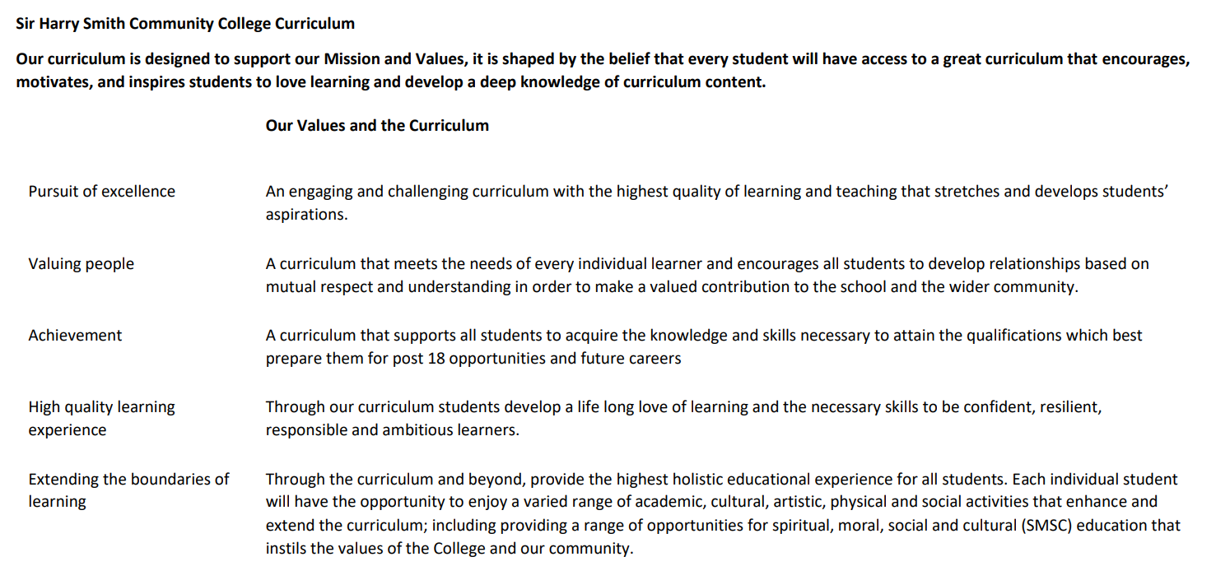

Sir Harry Smith Community College Curriculum Map SUBJECT: Geography AQA YEAR 10 2022-23
Curriculum Intent: Key Stage Four Geography builds on the knowledge learnt from Key Stage Three by continuing to focus on the three themes (Human Geography, Physical Geography and Environmental Geography). Students will enhance their understanding of relevant and appropriate examples so that students can become active citizens that are enthused by the subject and have the practical skills to play a key role in society. There are clear links to A Level courses, but the course also includes elements to support our vision of creating active citizens of the future.
School Values | Curriculum Focus | Term 1 – Urban World and Resource Management | Term 2 – Physical Landscapes (rivers and coasts) | Term 3 – Hazards (weather, tectonic and climate) and fieldwork
High Quality Learning Experience | Literacy Skills and Key Vocabulary | Urban, rural, wealth, poverty, migration, push factor, pull factor, climate, inequality, favela, squatter settlement, slum, shanty town, opportunities, challenges, sustainable, mega cities, globalisation, High Income Countries, Low Income Countries, Newly Emerging Economies, energy, renewable, non-renewable, interdependence, The Organization of the Petroleum Exporting Countries (OPEC), inter-governmental organisation, exploitation, surplus, deficit, stress, scarcity, exploitation, desertification, single use, development, Gulf States. | Igneous, metamorphic, sedimentary, weathering, erosion, mass movement, granite, chalk, boulder clay, longshore drift, stack, stump, arch, wave cut platform, groyne, sea wall, management, sustainability, conflict, stakeholders, hydrological cycle, weathering, erosion, hydraulic action, abrasion, attrition, solution, traction, saltation, suspension, v-shaped valley, floodplain, levee, gorge, waterfall, interlocking spur, meander, estuary, delta, drainage basin, confluence, tributary, watershed, social, economic, environmental. | Weather, climate, frontal, convectional, relief, greenhouse effect, enhanced greenhouse effect, antecedent, anticyclone, depression, anemometer, meteorologist, prevailing wind, El Nino, La Nina, hurricane, cyclone, typhoon, tropical storm, drought, tornadoes, wildfires, extreme weather, plate, plate boundary, constructive/divergent, destructive/convergent, conservative/transform, epicentre, focus, primary effect, secondary effect, Benioff Zone, lahars, jokulhlaup, social, economic, environmental, mitigation, adaptation, Mercalli, pyroclastic flow, Richter Scale, seismology, tsunami, collision, composite, strato, shield, relief, rehabilitation, reconstruction, prediction, monitoring, preparation, protection.
Pursuit of Excellence | Knowledge and Skills | Students will begin with understanding the differences between settlements, with a focus on the urban and rural, finishing with the process of urbanisation. Students will continue the term looking at comparative case studies between Rio de Janeiro (NEE) and London (HIC), identifying reasons for growth, opportunities, challenges and management of issues. The term will finish by investigating food, water and energy issues within the UK, before following an option energy unit looking at global issues. | Students will begin looking at physical features around the UK. The term will focus on river and coastal systems, which have been chosen instead of glacial systems. For rivers, students will identify processes and landforms, before looking at causes, effects and management of flooding. | The final term will introduce the various types of hazards. The term will be broken up with fieldwork, which will focus on a coastal area and an urban area. Students will start with tectonic hazards, focusing on the causes, effects and management. This pattern is continued for weather hazards and climate hazards. For fieldwork, students will follow a clear process outlined by the exam board; enquiry design, methodology, presentation, analysis, conclusion and evaluation. This links into their Paper 3 Examination.
 | Subject specific pedagogy | Students will be encouraged to become independent learners, and while key concepts are taught, examples should be developed in the classroom and at home. Vocabulary will be a key focus and home learning will be set regularly focussing on recall. | Students will have a greater chance to work independently, in pairs and as a group. UK examples will allow students to draw a connection to learning, and suggested independent fieldwork may be provided. There will be a continued focus on recall and developing exam skills with clear scaffolding. | Students will continue to work independently, in pairs and as a group. There is a greater practical element in the form of fieldwork which will provide practical skills for students that may be applied across other subjects.
Extending the boundaries of learning | Cultural Capital and beyond the curriculum | Examples and case studies provided will give students chance to explore the UK and further afield, using concepts from lesson in a practical way. |  | Fieldwork will allow students to experience key geographies across the UK, understand their importance on a variety of scales, but also develop their sense of purpose within the world.
Achievement | Assessment | Students will be assessed on home learning through sites such as Seneca Learning. Within class, students will have recall quizzes, guided exam practice and exam conditions topic tests. |  | Students will be assessed on home learning through sites such as Seneca Learning. Within class, students will have recall quizzes, guided exam practice and exam conditions topic tests. Students will sit a mock exam in the Summer Term covering all topics studied so far.
Valuing People | How our curriculum meets the needs of every individual | Teachers will make use of data, previous lessons and learning needs to provide for all students. Lessons will be differentiated accordingly so all students can progress. Where there are learning needs, teachers will make use of support staff and the Supportive Skills Department. All students will be included in fieldwork, including Pupil Premium. Targeted sessions based on attainment will be provided to maximise progress.  Continuous emphasis on key terminology and retrieval practice of this throughout the course. Breaking down key terms into smaller words to understand wider meanings and further extension opportunities embedded throughout.  Liaising with year leaders, Supportive Skills Department, form tutors and parents to develop a holistic understanding of our students, so that any intervention is bespoke to the individual.  Independent leaners are provided support via the uploading of relevant classwork onto TEAMs, this allows students to reflect on their learning and revisit any material they may wish to recap as part of their revision or independent learning. Students who miss lessons for various reasons are then able to complete work in preparation for future lessons.  Staff within the department continuously share good practice through regular meetings, lesson drop-ins, marking standardisation and feedback after completing various CPD courses.  Behaviour Watch and telephone calls home are used to regularly keep in touch with parents regarding behaviour for learning in lessons. Parents are contacted via email or telephone if there are any persistent issues in class or to discuss positive contributions and work from our students.

