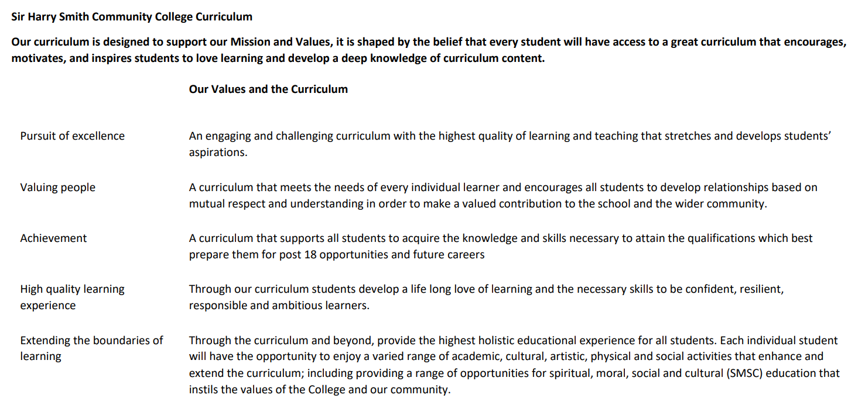

Sir Harry Smith Community College Curriculum Map SUBJECT: Computer Science YEAR 10 2022-23
Curriculum Intent: To provide students with a challenging and engaging computer science curriculum, that builds on prior learning at KS3 and Whittlesey’s local context. To develop further knowledge and understanding of computer science fundamentals and build fluency in writing coded solutions which solve real-world problems.
School Values | Curriculum Focus | Term 1 – Impact of Digital Technology and Networking | Term 2 – Network Security and Data Representation | Term 3 – Computer Hardware and Software
High Quality Learning Experience | Literacy Skills and Key Vocabulary | Cloud, Copyright, Data, DNS, Email, Encrypt, Ethical, Information, Licence, Malware, Network, Patch, Phishing, Hacking, Ransomware, Social network, Stakeholder, Web browser, Web server, Backup, Bandwidth, Client, Client-server, Collison, Domain, Fibre-optic cable, File server, File sharing, Firewall, Host, Hub, Internet, LAN, Latency, Media server, Modem, Network interface card (NIC), Peer-to-peer (P2P), Port, Router, Server, Stand alone, Switch, Traffic, Transmission media, URL, WAN, Wi-Fi, Wireless, Wireless access point, Application layer, Data link layer, Ethernet, Frequency, Channel, IP, MAC, Mesh, Star, Topology, Node, packet switching, Protocol, Transport layer. | Access rights, Anti-malware, Anti-virus, Backup, Data, DoS attack, Encryption, Firewall, Hacking, Hardware, Malware, Network, Network policy, Password, Patch, Penetration testing, Phishing, SQL, Traffic, Transmission, Virus, Web server, ASCII, Binary, Bit, Bit depth, Bit rate, Byte, Character set, Colour depth, Compression, Denary, GIF, Hertz, Hexadecimal, JPEG, Lossless, Lossy, MAC, Metadata, MP3, MPEG, PDF, Pixel, Resolution, Sample, Sample rate, Unicode. | Address bus, Arithmetic logic unit (ALU), Binary, Bus, Cache memory, Clock, Clock speed, Control Unit (CU), Core, CPU, Processor, Data, Decode, Embedded system, Execute, Fetch, General purpose computer, Paging, Hard disk drive, Hardware, Hertz, Input device, Instruction, Megahertz, Memory, Monitor, Output device, Program, RAM, Register, Secondary storage, Software, Von Neumann architecture, BIOS, Flash memory, GB, Non-volatile, Operating system, ROM, Swapping, Virtual memory, Volatile, Bit, Laser, Media, Terabyte, USB, Cloud, Compression, Page, GHz, Contiguous, Defragmentation, Device driver, Encryption, Interface, Utility, Multitasking, Software, Peripheral.
Pursuit of Excellence | Knowledge and Skills | Knowledge of ethical, legal, cultural and environmental impact of digital technology  Impacts of digital technology on wider society including:  Ethical issues  Legal issues  Cultural issues  Environmental issues  Privacy issues  Legislation relevant to computer science:  Data Protection Act 2018  Computer Misuse Act 1990  Copyright Designs and Patents act 1988  Software licences (open source and proprietary  Knowledge of networks and topologies  Types of network (LAN and WAN).  Factors that affect the performance of networks.  Different roles of computers in a client-server and a peer-to-peer network.  Hardware needed to connect stand-alone computers into a LAN (WAPs, routers, switches, NIC, transmission media).  The Internet as a worldwide collection of computer networks (DNS, hosting, cloud, web servers).  Star and mesh topologies.  Knowledge of wired and wireless networks, protocols, and layers  Modes of connection (wired and wireless).  Encryption.  IP and MAC addressing.  Standards.  Common protocols (TCP/IP, HTTP/S, FTP, POP, IMAP, and SMTP).  Concept of layers. | Knowledge of threats to computer systems and networks  Forms of attack (malware, social engineering, brute-force attacks, denial of service attacks, data interception and theft, and SQL injections).  Knowledge of how to prevent vulnerabilities  Common prevention methods (penetration testing, anti-malware software, firewalls, user access levels, passwords, encryption, and physical security.  Knowledge of units  The units of data storage (bit, nibble, byte, kilobyte, megabyte, gigabyte, terabyte, petabyte).  How data needs to be converted into a binary format to be processed by a computer.  Data capacity and calculation of data capacity requirements.  Knowledge of data storage  Numbers  Convert positive denary to binary and vice versa  Add two binary numbers  Explain overflow errors  Convert positive denary to hex and vice versa  Convert binary to hex and vice versa  Binary shifts.  Characters  Binary codes to represent characters  Character set  Relationship between the number of bits per character in a character set and the number of characters which can be represented (ASCII, Unicode).  Images  How an image is represented as a series of pixels, represented in binary  Metadata  Effect of colour depth and resolution on quality and size of image  Sound  How sound can be sampled and stored in digital form  Effect of sample rate, duration and bit depth on size and quality of file.  Knowledge of compression  The need for compression.  Types of compression (lossy and lossless). | Knowledge of the architecture of the CPU  The purpose of the CPU (FDE cycle).  Common CPU components and their function (ALU, CU, Cache, Registers).  Von Neumann architecture (MAR, MDR, PC, ACC).  Knowledge of CPU performance  How common characteristics of CPUs affect their performance (clock speed, cache size, cores).  Knowledge of embedded systems  The purpose and characteristics of embedded systems.  Examples of embedded systems.  Knowledge of primary storage  The need for primary storage.  Difference between RAM and ROM.  Purpose of ROM and RAM in a computer system.  Virtual memory.  Knowledge of secondary storage  The need for secondary storage.  Common types of storage (optical, magnetic and solid state).  Suitable storage devices and storage media for a given application.  Advantages and disadvantages of different storage devices and storage media relating to the following characteristics: capacity; speed; portability; durability; reliability; cost.  Knowledge of operating systems  The purpose and functionality of operating systems:  User interface  Memory management and multitasking  Peripheral management and drivers  User management  File management.  Knowledge of utility software  The purpose and functionality of utility software.  Utility system software:  Encryption software  Defragmentation  Data compression.
 | Subject specific pedagogy | Lead with concepts – support students in the acquisition of knowledge through use of key concepts, terms and vocabulary, providing opportunities to build a shared and consistent understanding.  Work together – collaboration is encouraged, with peer instruction and feedback. Working together stimulates dialogue, articulation of concepts and development of understanding.  Unplug, unpack, repack – new concepts introduced by unpacking complex terms and ideas in familiar contexts, then repacking new understanding into the original concept.  Add variety – activities with different levels of direction, scaffolding, and support to promote learning, ranging from highly structured to more exploratory tasks.  Thinking aloud – thinking verbally out loud to model thought process to learners.  Language and context – ensuring subject matter is contextually and culturally relevant to all students, and language/literacy is accessible and understandable for all learners.
Extending the boundaries of learning | Cultural Capital and beyond the curriculum | Students will have the opportunity to attend an enrichment computing club to allow them opportunities to develop their knowledge, understanding and skills beyond the normal taught curriculum.  All students will be enrolled onto the Inspiring Digital Enterprise Award (iDEA), where they will complete a series of challenges and learn vital skills for work and life.  Students will look at a number of historical and recent case studies of how digital technology has impacted both positively and negatively the local (Whittlesey) and wider communities, considering the following perspectives: social, cultural, moral, ethical, environmental and legal. Students will develop their oracy and literacy skills, working both independently and in small groups to discuss the case studies and their impact. | Students will have the opportunity to attend an enrichment computing club to allow them opportunities to develop their knowledge, understanding and skills beyond the normal taught curriculum.  All students will be enrolled onto the Inspiring Digital Enterprise Award (iDEA), where they will complete a series of challenges and learn vital skills for work and life.  Students will have an opportunity to develop further their understanding of network and cybersecurity, and consider how the latest threats and developments impact the way people live and work within the local (Whittlesey) and wider community. | Students will have the opportunity to attend an enrichment computing club to allow them opportunities to develop their knowledge, understanding and skills beyond the normal taught curriculum.  All students will be enrolled onto the Inspiring Digital Enterprise Award (iDEA), where they will complete a series of challenges and learn vital skills for work and life.  Students will have an opportunity to learn about John Von Neumann’s computer architecture, developed in 1945, and still used within many computer systems today.  Students will have an opportunity to learn about secondary storage and storage devices, and to develop understanding of how changes to these different technologies has had a cultural impact on how people live and work in the 21st Century.
Achievement | Assessment | Throughout the unit of work, students will receive regular oral and written feedback to address any misconceptions and enable them to move their learning forwards.  Opportunities for self and peer-assessment are embedded throughout each lesson.  Each lesson includes a formative assessment opportunity to address misconceptions from the learning.  Students complete a summative assessment at the end of the unit. Once the assessment has been marked, students will be provided with feedback to enable them to close gaps in learning from the unit.
Valuing People | How our curriculum meets the needs of every individual | All students are issued with a BBC Micro:bit upon starting the course, to enable them to work independently and freely on programming projects of their choice.  The computing curriculum builds on students’ prior knowledge, understanding and skills, and considers local context of Whittlesey to produce a challenging and engaging computing curriculum.  The computing department works closely alongside the Supportive Skills Department (SSD) to provide personalised support to those students that require it.  Students are encouraged to work at their own pace in lessons, taking the time they need to securely embed learning, we therefore place all teaching resources on the class Team so that students can go back over existing or new materials from the lesson.  Teaching staff are aware of prior attainment levels, and this is built into lesson planning the sequencing of the curriculum.  Students are supported with learning new vocabulary and developing their oracy to promote and deepen their knowledge and understanding of subject matter.  Computing department works closely with the pastoral team to develop a holistic understanding of all learners.  Students are provided with opportunities and encouraged to be independent and resilient learners, so that they are equipped and able to take ownership over their learning and progress.  Adaptive teaching to provide support to students as and when needed in order to move their learning forwards and close any gaps.

