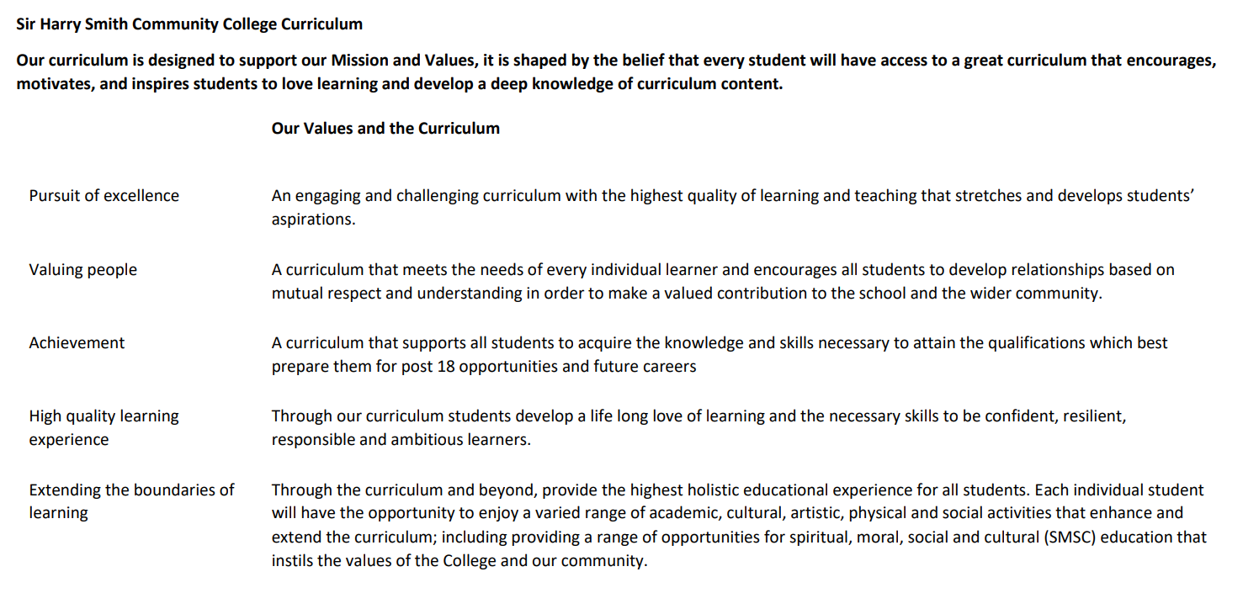

Sir Harry Smith Community College Curriculum Map SUBJECT: Physical Education 2022-23
Curriculum Intent: The Health, Physical Education and Leadership (HPEL) Department at Sir Harry Smith Community College aim to encourage and enable students to fulfil their full potential through a broad and balanced curriculum that enables them to be involved in sporting opportunities and understand how to live healthy and active lifestyles and encourage lifelong participation in sport.

We aim to give students the necessary skills, knowledge and understanding in order for them to develop a wide range of key leadership employability skills, far beyond that of ‘Just PE’. PE is about developing the physical, emotional and mental capacity of the individual and giving the students the opportunity to participate fully, both in groups and as individuals. It also encourages them to lead, to listen and to be empathetic to those around them.

School Values | Curriculum Focus | Term 1  Physical Me  Creative Me | Term 2  Healthy Me  Thinking Me | Term 3  Leading Me  Competitive Me
High Quality Learning Experience | Literacy Skills and Key Vocabulary | Physical Me  Self-motivation  Resilience  Encouraging  Commitment  Evaluation  Integrity  Creative Me  Innovation  Collaboration  Confidence  Creative  Organising | Healthy Me  Integrity  Self-management  Determination  Honesty  Positive attitude  Resilience  Self-motivation  Thinking Me  Communication  Active listening  Evaluation  Empathy  Understandable  Questioning  Collaboration  Analytical  Integrity | Leading Me  Commitment  Communication  Organising  Self-management  Evaluation  Reflective  Empathy  Active listening  Competitive Me  Collaboration  Resilience  Organisation  Communication
 |  | Year 9  Leading Me:  - Leads others with little support when organising and officiating activities.  - Provides constructive feedback to others.  - Sets realistic and challenging goals.  - Motivates and encourages good values to others.  - Shows high levels of confidence, organisation and communication when leading.  Creative Me:  - Analyse the performance of self and others creating plans to improve.  - Suggest how different tactics/ideas can be applied in activities.  - Demonstrate good levels of imagination and creativity in performances.  - Compare performances against previous ones demonstrating improvements made.  - Reflects on choices made outlining what worked, what could have been better and why.  - Plans how to make an activity easier or harder to provide challenge. | Year 9  Healthy Me:  - Understands and demonstrates the short and long term effects of exercise.  - Shows an understanding of how to improve health and fitness  - Explains the importance of a balanced lifestyle and the contribution of exercise and nutrition towards it.  - Promotes healthy active lifestyle habits.  - Understand and uses the principles of training to improve fitness.  Thinking Me:  - Uses and adapts advanced tactics, rules and ideas in different situations.  - Demonstrates effective decision making under pressure in different activities.  - Can use a variety of advanced tactics, ideas and strategies to overcome opponents.  - Reflects and acts on feedback.  - Suggest alternative ways to solve problems. | Year 9  Physical Me:  - Perform more complex skills with control, accuracy and fluency.  - Change tactics, strategies and skills to suit changing competitive situations.  - Able to choose, link and combine skills and techniques in different situations.  - Demonstrate accurate and fluent skills and techniques.  - Access a range of extra-curricular/ community opportunities to extend and develop skills and techniques.  Competitive Me:  - Follows rules and etiquette in competitive games and activities.  - Keeps trying even when they find things difficult, and they make mistakes.  - Demonstrates clear positive values.  - Manages emotions during challenging situations.  - Demonstrates self-confidence.
 | Subject specific pedagogy | Physical Me: Outwitting opponents, athletics, fitness, invasion games.  Creative Me: Dance, gymnastics, trampolining, game/activity creations. | Healthy Me: Fitness specific types of training, cunning running activities, outwitting opponents.  Thinking Me: Orienteering, OAA, Outwitting opponents, disability games. | Leading Me: Outwitting opponents, game/activity creation, problem solving activities, playground activities, fitness activities.  Competitive Me: Outwitting opponents, athletics, fitness, interform activities.
Extending the boundaries of learning | Cultural Capital and beyond the curriculum | - Clear understanding of key vocabulary.  - Extra-curricular activities.  - Trips.  - Competitions against other schools.  - National and international competitions to enthuse students. | - Clear understanding of key vocabulary.  - Extra-curricular activities.  - Trips.  - Competitions against other schools.  - National and international competitions to enthuse students. | - Clear understanding of key vocabulary.  - Extra-curricular activities.  - Trips.  - Competitions against other schools.  - National and international competitions to enthuse students.
Achievement | Assessment | Peer and self-assessment tasks.  Q and A episodes of learning.  Verbal feedback to students. | Peer and self-assessment tasks  Q and A episodes of learning.  Verbal feedback to students. | Peer and self-assessment tasks  Q and A episodes of learning.  Verbal feedback to students.
Valuing People | How our curriculum meets the needs of every individual | - Targeted support for different groups of students.  - Targeted enrichment activities. | - Targeted support for different groups of students.  - Targeted enrichment activities. | - Targeted support for different groups of students.  - Targeted enrichment activities.

