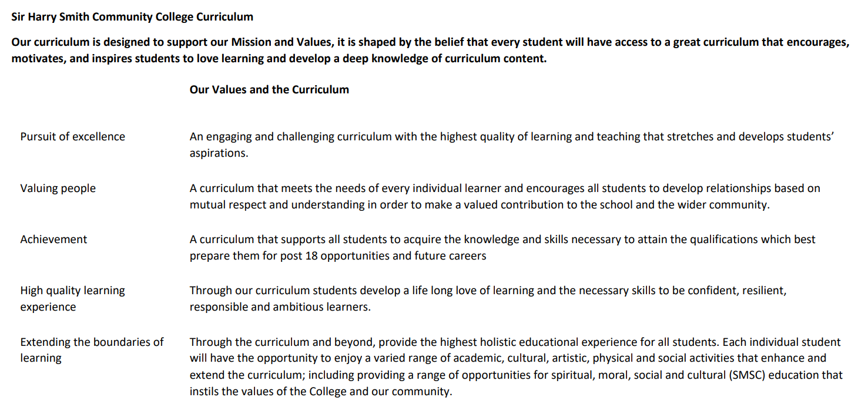

Sir Harry Smith Community College Curriculum Map SUBJECT: Maths YEAR 9 2022-23
Curriculum Intent: To ensure all pupils have the mathematical skills they need to move onto the next stage of their journey.
School Values | Curriculum Focus | Term 1 – Reasoning with Algebra and Constructions in 2 and 3 Dimensions | Term 2 – Reasoning with Number and Reasoning with Geometry. | Term 3 – Reasoning with Proportion and Revision
High Quality Learning Experience | Literacy Skills and Key Vocabulary | Gradient, Intercept, Parallel, Co-ordinate, Linear, Asymptote, Reciprocal, Perpendicular, Inequality, Variable, Rearrange, Inverse Operation, Substitute, Solve, Multiples, Factor, HCF, LCM, Verify, Proof, Binomial, Quadratic, “d, £d, Vertex, Edge, Face, Cross-Section, Plan, Perspective, Protractor, Locus, Equidistant, Perpendicular, Arc, Bisector, Congruent | Integer, rational, Irrational, Inverse Operation, Quotient, Product, Multiples, Factor, Percent, Decimal, Fraction, Equivalent, Reduce, Growth, Integer, Invest, Multiplier, Profit, Credit, Debit, Balance, Expense, Deposit, Multiplier, Per Annum, Currency, Unitary, Parallel, Perpendicular, Transversal, Sum, Conjecture, Equation, Polygon, Counterexample, Rotate, Symmetry, Regular, Invariant, Vertex, Horizontal, Vertical, Square Number, Square Root, Hypotenuse, Opposite, Adjacent. | Similar Shapes, Scale Factor, Enlarge, Corresponding, Image, Proportion, Ratio, Direct Proportion, Inverse Proportion, Convert, Mass, Origin, Volume, Substitute, Probability, Relative Frequency, Chance, Event, Biased, Quadratic, Inequality, Reciprocal, Cubic, Origin, Parabola.
Pursuit of Excellence | Knowledge and Skills | Straight Line Graphs – This topic builds on work from year 8, which plotted simple straight-line graphs. We now look at $y=mx+c$as the general form of a straight line, exploring the effect of the ‘m’ and the ‘c’ on the graph. We look at how the graph can model real life situations in simple cases.  Equations and Inequalities – Ion this block, we will revisit and extend the knowledge and skills already acquired on solving equations and inequalities. We will also learn to re-arrange formulae and how this is linked to solving equations. We will also learn the formal differences between equations, formulae, identities and expressions.  Testing Conjectures – Mathematical Reasoning is taught as a component skill throughout the course as well as explicitly in this unit of work. We will revisit some key concepts from earlier (primes, factors, multiples) which allow us to make simple conjectures and test these to see if true. We will test a range of given conjectures as well as form and test some of our own.  Three-dimensional Shapes – This will be the first time pupils have met 3-D shapes formally, so we will recap the key vocabulary. We will explore surface area and volume of 3-D figures as well as how to represent 3-D shapes using plans and elevations.  Constructions and Congruency – We will build on the work from year 7 and 8 to formally explore loci and the standard constructions using a straight edge and compass. We will also explore the meaning of congruency and apply the formal method of identifying where two triangles are congruent. | Numbers – We will develop our understanding of the number system and explore the difference between rational, irrational and real numbers. We will further develop our calculator and non-calculator skills. We shall review working with Standard Form and HCF/LCM.  Using Percentages – Following our with numbers and fractions in the previous block, we will continue our journey from year 8. We will explore reverse percentages and some repeated change problems. We will explore all elements through efficient calculator and non-calculator methods and review the use of decimal multipliers to streamline calculations.  Maths and Money – We will continue to develop the financial maths skills from previous years as well as begin looking at simple examples of tax and wages. We will expand on the use of percentages to explore the difference between both simple and compound interest.  Deduction – We will extend our use of the angle rules from previous years, as well as properties of shapes, and apply these to increasingly complex problems. This is an opportunity to explore more proofs in shapes instead of number and algebra from earlier in the year. We will also revisit the basic constructions and ensure that we are confident with these.  Rotation and Translation – Following on from line symmetry in year 8, we will now explore rotational symmetry and rotation as a transformation. We will look at translation in vector form. Pupils will compare each transformation, giving the effect of each onto the shapes.  Pythagoras Theorem – We will revise square numbers and square roots, and then move to investigate the relationships between sides of a right-angled triangle. We will also look at the converse, using Pythagoras theorem to determine if a triangle is a right angled one. | Enlargement and Similarity – We will study the fourth main transformation of enlargement and develop understanding of when shapes are similar. We will look at using similarity to find missing lengths in similar figures.  Ratio and Proportion – We will recap and build upon previous years of study to explore direct proportions and the graphs of these relationships. We will move onto inverse proportions and will begin considering algebraic representations of these. We will revisit best buy problems and unit pricing and look at alternative ways to solve these problems (such as scaling of quantities).  Rates – We will continue to develop the knowledge of inverse proportion to explore the link between Speed, Distance and Time. We will use the same techniques to explore mass, density and volume. We develop these skills further looking at flow problems such as how the shape of a tank would affect its filling profile over time.  Probability – Pupils will build on prior years and develop this to find probabilities of combined events. We will consider independent events and how to find the probabilities of these occurring together (multiplication rule) We will use a variety of diagrams such as Venn Diagrams, Sample Spaces and Tree Diagrams to calculate a range of probabilities.  Algebraic Representation – A unit predominantly concerning revision of all previous algebraic graphing techniques, as well as an introduction to solving inequalities using a graphical method.  Revision – The final block of the year (and Key Stage 3) is given over to review any areas that the teacher feels would benefit the pupils. The aim is to ensure that they are ready to commence their GCSE and make a success of Key Stage 4!
 | Subject specific pedagogy | Mathematics at Sir Harry Smith is taught following a “Teaching for Mastery” curriculum. This curriculum approach focuses on exploring depth of concepts rather than breadth. The curriculum focuses on “five big ideas” which are explored in various ways throughout the course. The five big ideas are:  Variation – Questions are asked with minimal changes, to encourage pupils to identify patterns and connections between those changes in approaches.  Representation – Different problems are expressed using symbols, pictural representations or manipulative (physical) objects such as counters. This approach helps pupils understand that the same mathematical information can be expressed in multiple ways.  Mathematical Thinking – This idea explores the structure of a question and looks at not only how a question could be answered, but also what other questions may be asked. An example of this may be a graph or chart, with discussion about what could possibly be worked out from this information. This idea also looks at connections between other topics in maths.  Fluency – This idea is about learning key facts that can be applied in situations. This could include multiplication tables, angle facts or key definitions of numbers.  Coherence – The purpose of coherence is to draw the five ideas together. Giving pupils questions that allow them to explore the skills learnt in other contexts, or in draw skills from each of the other four areas to synergise an answer.
Extending the boundaries of learning | Cultural Capital and beyond the curriculum | Pupils in year 9 will be given the opportunity to compete in the UKMT intermediate maths challenge. This is a national competition that allows pupils to progress through more challenging topics and skills based on their current experience. We also compete in the UKMT team challenges, when possible, which are run at local level with the best performing teams going onto subsequent rounds nationally.  We seek to develop the pupils socially through by encouraging a growth mindset to build resilience, and metacognition to review the thought process made during lessons and questions. We encourage social working and discussion of problems to develop answers, in turn developing self-esteem and confidence. The curriculum features a range of physical “Skills of hand” to develop co-ordination. We encourage pupils to understand and challenge assumptions and question data they may be exposed to. Mathematics is a vibrant, international and multicultural language with symbols from ancient civilisations used today as well as adopting new discoveries all the time.
Achievement | Assessment | Small end of block assessment conducted every two to three weeks quickly identify areas of strength and opportunities to improve. This is verified with a larger summative assessment covering all of the terms’ topics at the end of the term. | Small end of block assessment conducted every two to three weeks quickly identify areas of strength and opportunities to improve. This is verified with a larger summative assessment covering all of the autumn and spring topics at the end of the term. | Small end of block assessment conducted every two to three weeks quickly identify areas of strength and opportunities to improve. This is verified with a larger summative assessment covering a range of material studied throughout the year.
Valuing People | How our curriculum meets the needs of every individual | All pupils follow the same curriculum to ensure that all pupils have the same opportunities for success and development. Pupils’ needs are met on a pupil centred approach where teachers will carefully select strategies to help all pupils make progress. Rich problems throughout the scheme ensure that challenge is offered to all, while carefully selected supporting resources are used to support those children who need more help to access the curriculum fully. Timely intervention is offered to those pupils who need additional support through help from our team of specialist maths teaching assistants who support learners to close gaps and improve attainment.

