
Writing a CV

Name:
Address:
Contact numbers: (mobile / email address – make sure you use a professional email)

Personal Statement:
Write 3 or 4 sentences outlining your key skills and qualities to impress a future employer. Tailor this to the job that you are applying for and match your skills to the ones they are looking for. This will depend on the company and type of job – but some general key skills that most employers want are: good communication, being numerate, team work, able to use IT, problem solving, wanting to continue to improve and learn, reliable, punctual, able to show initiative.

Education and Training:
List your qualifications, starting with the most recent. If you are still studying for your qualifications, include the year that you are taking the exam and your predicted grades.
School attended: E,g. Sir Harry Smith Community College, Eastrea Road, Whittlesey, Cambridgeshire
Years attended: E.g. September 2005 – June 2021

Subject | Qualification type and level  (E.g. GCSE / GCE / Btec) | Date taken  E.g. June 2021 | Grade  (state if actual or predicted)
English Language | GCSE | June 2021 | 6 (predicted)

Tailor your CV to the job you are applying for, and include any courses or projects that you have worked on either within school or outside. Also include any ICT experience you have.
For example:
Microsoft Word Advanced / Intermediate / Beginner
Microsoft Excel Advanced / Intermediate / Beginner
First Aid Course (1-day course) June 2021

Employment History and Work Experience:

Always start with your most recent employment experience first. Include the name of the employer, the dates you worked for them, job title and main duties. Add any key projects you have worked on that are relevant to the job you are applying for, include details of what the key tasks were and what you learnt. Try to relate the skills and experience to the job description, job specification or what you think the employer is looking for.

Include any relevant temporary work, volunteering or charity work that you have completed such as Cadets / Duke of Edinburgh Scheme/Princes Trust/National Citizen Service.

You can also add any key projects you have worked on that are relevant to the job you are applying for, include details of what the key tasks were and what you learnt.

Include the dates that you completed the work experience or volunteering and the company name.

For example:
RSPCA Charity Shop, Peterborough
September 2019 – September 2020
Tasks included…customer service, checking and maintaining stock, handling cash.

This volunteering gave me the opportunity to experience….

As a result of this volunteering/placement I was able to broaden by knowledge and understanding of… and gain skills in… and…

Positions of Responsibility:

List positions of responsibility within and out of school. Examples can include Prefect, Youth Councillor, Captain of a sport team, Brownie or Scout Leader.

For example: Whilst at school I was a Prefect. Some of the responsibilities of this role were….

Interests and hobbies:

List hobbies and interests that demonstrate your skills.

E.g. I enjoy playing team sports such as …
I have always had an interest in …and have created …
I like organising social events and have arranged …

Additional Information:

You can include this section if you need to add anything else that you feel is relevant, such as explaining that you have a driving licence (or are learning to drive) or can speak any foreign languages.
E.g. Full driving licence

References:

It is usual to list 2 referees. At least one should be work/school related such as a teacher, form tutor, or year leader. The second referee should be someone who has know you personally for some time, but not a close family member.
You can list your referees on your CV, or just put ‘references available on request’ If you decide to include their details you should state the relationship of each referee to you – for example: Mr A Rothery, Year Leader.

* * * * * *

Additional online videos, information and templates
It is essential to have a professional CV to give to potential employers.
The videos and articles below will show you how to make your CV stand out:
How do I write a great CV and covering letter? - BBC Bitesize
What can I do now to prepare for my future? - BBC Bitesize
Ten skills you might not know you had - BBC Bitesize
Using Microsoft word – open a new word document and select resume and cover letters
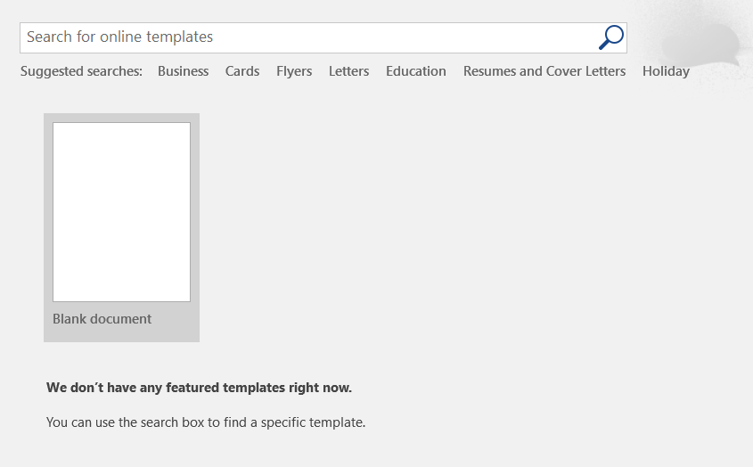

There are many templates to choose from. Pick the one that best suits your needs:
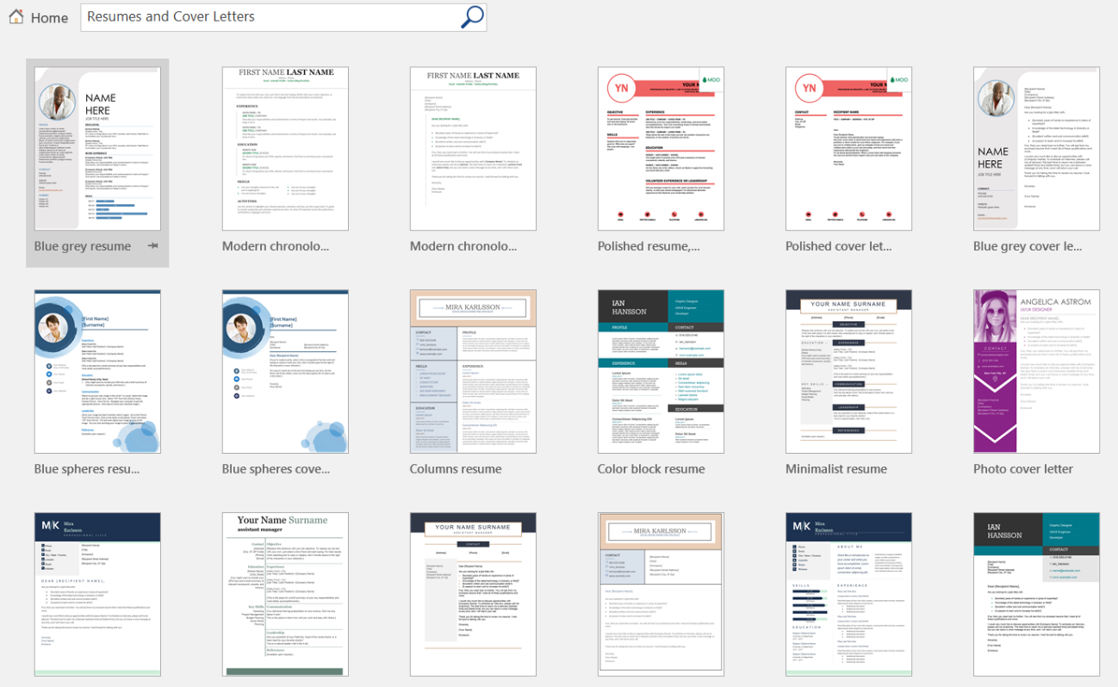

An example of a 2-page CV:
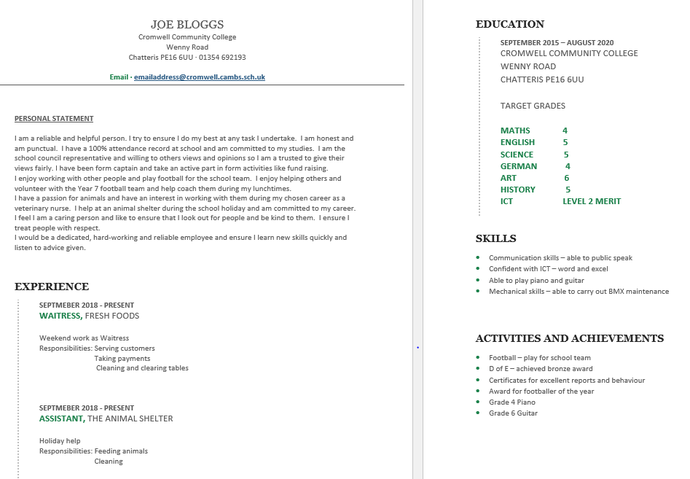

ALWAYS get someone who knows you well to proof read your CV before sending it; often people find it difficult to sell themselves and miss out personal attributes and successes. It is also important to get someone else to proof read it for errors.

