Sir Harry Smith Community College

6th Form Transition Work

English Literature

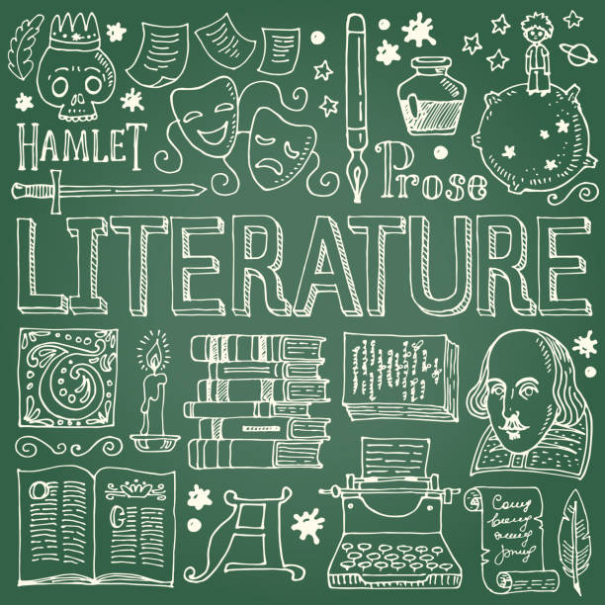

Name:________________________________

TASK LIST
The following tasks are designed to help you in your transition from GCSE to A Level English Literature. You are expected to complete all of the tasks and hand this booklet in on the first lesson back in September. If you have any questions, please speak with a member of the English Department; we are happy to help!

1. Assessment Objective Summary Activity (p.3)
2. Othello Key Word Task (p.4-5)
3. Independent Reading Task (p.6-8)
4. Choice of Essay Questions (p. 9)

FOR TEACHER USE – TRANSITION WORK FEEDBACK
TASK | WWW | EBI | Effort Grade
AO Summary Activity
Othello Key Word Task
Independent Reading Task
Choice of Essay Questions

Effort Grade Key:
4 – Excellent effort, 3 – Good effort, 2 – Satisfactory effort, 1 – Limited effort, 0 – Incomplete/minimal effort

1. Assessment Objective Summary Activity
It is important that you become familiar with the assessment objectives and use them to help you develop and improve your skills throughout the course.
AO1 | Articulate informed, personal and creative responses to literary texts, using associated concepts and terminology, and coherent, accurate written expression.
In your own words
AO2 | Analyse ways in which meanings are shaped in literary texts.
In your own words
AO3 | Demonstrate understanding of the significance and influence of the contexts in which literary texts are written and received.
In your own words
AO4 | Explore connections across literary texts.
In your own words
AO5 | Explore literary texts informed by different interpretations.
In your own words

2. Othello Key Word Task
The following words all relate to the play Othello in some way. Complete a first reading of the text and then briefly explain the connection between the term and the text.
Example:
Handkerchief –The handkerchief becomes a symbol of Othello and Desdemona’s love, but Iago uses it to create jealousy and mistrust between them.

Venice

Moor

Cyprus

Jealousy

Love

Death

Infidelity

Wife

Willow

Soliloquy

- Independent Reading Task
Choose one novel from the list to read independently over the summer.
You do not need to analyse every chapter in detail; instead, focus on developing your confidence as an independent reader. As you read, consider:
Suggested Transition Reading List
- We Have Always Lived in the Castle — Shirley Jackson
- Jane Eyre — Charlotte Brontë
- Wuthering Heights — Emily Brontë
- The Great Gatsby — F. Scott Fitzgerald
- 1984 — George Orwell
- Brave New World — Aldous Huxley
- The Bell Jar — Sylvia Plath
- Never Let Me Go — Kazuo Ishiguro
- Atonement — Ian McEwan
- Beloved — Toni Morrison
- Wide Sargasso Sea — Jean Rhys
- Dracula — Bram Stoker
- The Remains of the Day — Kazuo Ishiguro
- The Colour Purple — Alice Walker
- Purple Hibiscus — Chimamanda Ngozi Adichie
- Things Fall Apart — Chinua Achebe
- The Picture of Dorian Gray — Oscar Wilde
- The Secret History — Donna Tartt
- A Room with a View — E. M. Forster

Independent Reading Reflections:
Name of the novel:

Author:

Brief summary of the text:

Any biographical/contextual information about the author:

Which characters interest you most?

What themes or ideas seem important?

Which passages are particularly memorable?

What questions does the novel raise?

Choice of Essay Questions
Select one of the following essay questions to complete. Aim for 1000-1500 words (a couple of sides of handwritten A4):
- Read and summarise Act 1 of Othello. Copies can be collected from Mrs Tomlin.
Answer the following question:
How does Shakespeare present Iago as a manipulative character in Act 1?
- Read the opening dream sequence from Rebecca.
Answer the following question:
How does Du Maurier create a sense of unease and psychological tension in this extract?

Both texts are available online, can be borrowed from the English Department, or you may purchase your own copy (second-hand copies are fine).

