GCSE Psychology Work
The world of Psychology is vast as it works on studying the human mind and behaviour.
There are thousands of well-paid Psychology jobs, covering many different industries. This includes business, economics, health, education, sport, criminal justice and teaching. This means that there are many different career paths in Psychology that lead to different job titles.
In this task you will have the opportunity to research the different areas of Psychology and begin to think about where GCSE Psychology may take you.

Task:
Research at least three of the job titles below using the British Psychological Society Website https://careers.bps.org.uk/ and the Prospects website https://www.prospects.ac.uk/job-profiles/browse-a-to-z.

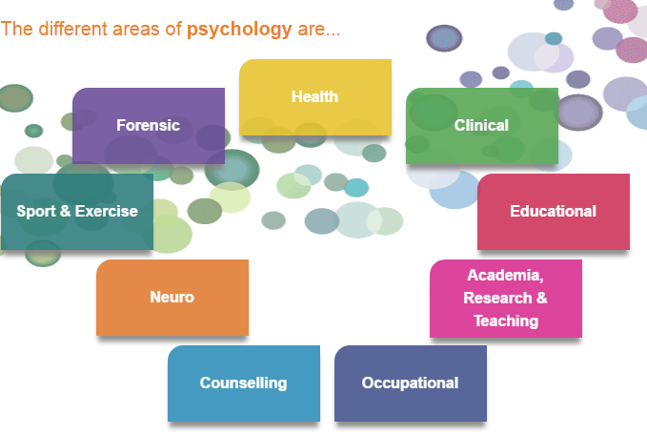
Job Titles
- Educational Psychologist
- Clinical Psychologist
- Educational Psychologist
- Occupational Psychologist
- Sports Psychologist
- Forensic Psychologist
- Researcher & Teacher
- Neuropsychologist
- Counsellor
Create a job profile using the template on the next page. Each profile should aim to answer all the questions on the template.

Template
Job Title:

Summary of role:

Qualifications and skills needed:

Where they work:

How much they get paid:

