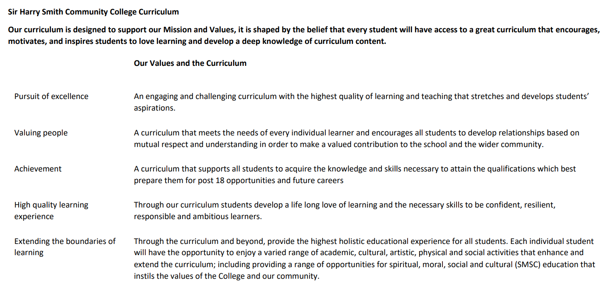

Sir Harry Smith Community College Curriculum Map SUBJECT: Science YEAR 11
Curriculum Intent: To provide a knowledge rich, spiral curriculum through inclusive science lessons that fit and expand our learner’s context in an environment that builds resilience.

School Values | Curriculum Focus | Term 1 | Term 2 | Term 3
High Quality Learning Experience | Key Vocabulary | Homeostasis & Response  central nervous system (CNS),  cerebral cortex, ciliary muscles, coordination centres, effectors, motor neurones, neurones, receptors, reflex arcs, reflexes, sensory neurone, stimuli, dialysis, thermoregulatory centre, vasoconstriction, vasodilation, adrenaline, auxin, endocrine system, follicle stimulating hormone (FSH),  glucagon, hormones, insulin, oestrogen, ovaries, ovulation, phototropism, pituitary gland, testosterone.  Organic Chemistry  alkane, alkene, cracking, distillation, double bond, fractional distillation, hydrocarbon, oxidised, saturated hydrocarbon, thermal decomposition, unsaturated hydrocarbon, viscosity,  Rf (retention factor), addition polymerisation, monomers, polymer, fermentation, functional group, homologous series, thermosetting polymer, thermosoftening polymer.  Magnetism & Electromagnets  electromagnet, electromagnetic induction, Fleming’s left-hand rule, generator effect, induced magnetism, magnetic field, magnetic field line, magnetic flux density, motor effect, solenoid, split-ring commutator, step-down transformer, step-up transformer, transformer, | Inheritance, Variation & Evolution  alleles, asexual reproduction, carriers, cystic fibrosis, dominant allele, genetic engineering, genotype, heterozygote, homozygote, meiosis, mutation, natural selection, nucleotide, phenotype, polydactyly, recessive, sex chromosomes, archaea, classification, domain, evolutionary trees, extinction, speciation, species, mutation, natural selection, selective breeding, tissue culture.  Rate of Reaction  gradient, frequency, activation energy, catalyst, closed system, concentration, pressure, collision theory, equilibrium, anhydrous, hydrated, Le Châtelier’s Principle, dynamic equilibrium, reversible reaction.  Chemical Analysis  Pure, mixture, formulation, chromatogram, Rf value (retention factor), substance, solvent, solute, splint, ions, precipitate.  Waves  amplitude, compression, echo, electromagnetic waves, frequency, longitudinal waves, mechanical wave, oscillate, primary seismic wave (P-wave), rarefaction, reflection, refraction, secondary seismic wave (S-wave), seismic waves, speed, transmission/transmitted, transverse wave, ultrasound wave, vibrate, wavelength, carrier waves, electromagnetic spectrum, ionisation, microwaves, optical fibre, radiation dose, radio waves, ultraviolet radiation (UV), wave speed.  Space (Separate Science ONLY)  Big Bang theory, black dwarf, black hole, centripetal force, cosmic microwave background radiation (CMBR), dark matter, main sequence, neutron star, protostar, red giant, red supergiant, red-shift, supernova. white dwarf. | This term focuses on what students know and remember through revision and consolidation of all content leading up to the GCSE examinations.

Pursuit of Excellence | Substantive Knowledge  COMPOSITES | An organism needs to be aware of the conditions both inside and outside of itself to keep internal conditions stable  Carbon compounds are the backbone of life on our planet and there are many different uses and reactions of carbon-based molecules  State that fractional distillation separates compounds by boiling point.  Magnetic fields can be used to produce electrical waves | The type of reproduction dictates the genetic variation of offspring and can lead to random mutations  Reactions can only proceed if the activation energy is overcome and a collision is successful, the rate of collisions can be changed  Chemical tests can be performed to determine the products of a reaction  Waves transfer energy and different waves have different useful properties  Many components exist in space such as stars, planets, and moons. Observable evidence shows how these behave
 | Substantive Knowledge  COMPONENTS  (Examples, this is not an exhaustive list) | Explain how the structure of the nervous system is adapted to its function e.g. how receptors detect stimuli  Compare the similarities and differences between a reflex action and a conscious response  Name the first 4 alkanes as, methane, ethane, propane, butane.  Know that long chain hydrocarbons are thermally decomposed into shorter more useful chains and that one of the products will always be an alkene  Explain how to see and find magnetic field lines around a bar magnet.  Describe and use Flemings left hand rule. | Recall the main differences between asexual and sexual reproduction  Use Genetic Cross diagrams to predict possible genotypes and phenotypes of offspring based on their parents’ genotypes  Explain, using collision theory, how temperature changes the rate of a reaction  Draw the representation of a reversible reaction  State what is meant by reflection and refraction  Describe how frequency affects pitch and amplitude affects volume  Explain what is meant by a protostar and how energy is released inside the sun  Explain how the velocity of a body in a circular orbit changes as the body moves around the orbit
 | Disciplinary Practices | Research using a range of media such as articles, websites, and books  Draw tables correctly for data collection during practical activities  Write a method to investigate a hypothesis  Select the correct format for presenting data  Evaluate methods and models and suggest improvements  Rearrange formulae to calculate quantities such as mass, weight, and speed  Use data to support or disprove a theory  Select the most appropriate apparatus for an experimental setup  Use keywords in context to explain scientific phenomena through extended writing tasks  Draw conclusions from evidence
Extending the boundaries of learning | Cultural Capital and beyond the curriculum | Links to scientific careers and the opportunity to speak to people working in the sector  Science club  Guest speakers and workshops
Achievement | Assessment | Assessment is carried out continuously during modules using an online formative platform.  Summative assessment is carried out twice during the academic year in the form of mock examinations.  Students complete progress tasks throughout the year which challenges their scientific literacy and formatively assesses their understanding.  Every lesson begins with retrieval practice to see what students know and remember.
Valuing People | How our curriculum meets the needs of every individual | Threshold concepts are identified for all topics.  High expectations are set for all students that they will reach these concepts.  When necessary, investigations and tasks are adapted to provide access to course content or to extend learning.

