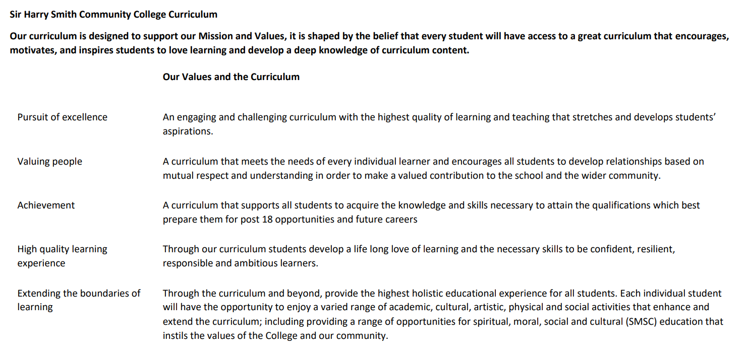

Sir Harry Smith Community College Curriculum Map SUBJECT: Maths YEAR 10 2022-23
Curriculum Intent: To ensure all pupils have the mathematical skills they need to move onto the next stage of their journey.
School Values | Curriculum Focus | Term 1 – Similarity and Developing Algebra | Term 2 – Geometry, Proportion and Proportional Change | Term 3 – Developing Data, Using Number and Expressions
High Quality Learning Experience | Literacy Skills and Key Vocabulary | Enlarge, Scale Factor, Centre of Enlargement, Similar, Congruent, Corresponding, Parallel, Constant, Cosine, Sine, Tangent, Inverse, Hypotenuse, Solution, Variable, Equation, Expression, Identity, Linear, Intersection, Inequality, Substitute, LCM, Eliminate, Expression, Coordinate, Intersection | Cardinal Directions, Angle, Bearing, Perpendicular, Parallel, Clockwise, Construct, Scale, Protractor, Circumference, Area, Diameter, Radius, Tangent, Chord, Frustrum, Hemisphere, Surface Area, Direction, Magnitude, Scalar, Column Vector, Resultant, Parallel, Ratio, Equivalent, Proportion, Integer, Fraction, Denominator, Numerator, Origin, Gradient, Exponent, Compound Interest, Depreciation, Growth, Decay, Multiplier, Equivalent, Event, Outcome, Intersection, Union, Expected Value, Universal Set, Systematic, Product, Ratio. | Population, Sample, Representative, Random Sample, Bias, Primary Data, Secondary Data, Outlier, Truncate, Round, Credit, Debit, Profit, Tax, Balance, Overestimate, Underestimate, Factor, Multiple, HCF, LCM, Arithmetic, Geometric, Sequence, Standard Index Form, Commutative, Base, Power, Exponent, Indices, Negative, Coefficient.
Pursuit of Excellence | Knowledge and Skills | Similarity - Building on their experience of enlargement and similarity in previous years, this  unit extends students‘ experiences and looks more formally at dealing with topics such as similar triangles.  Parallel line angle rules are revisited to support establishment of similarity.  Congruency is introduced through considering what information is needed to produce a unique triangle. Higher level content extends enlargement to explore negative scale factors, and also looks at establishing that a pair of triangles are congruent through formal proof.  Trigonometry - Trigonometry is introduced as a special case of similarity within right-angled  triangles. Emphasis is placed throughout the steps on linking the trig functions to ratios, rather than just functions. This key topic is introduced early in Year 10 to  allow regular revisiting e.g. when looking at bearings.  For the Higher tier, calculation with trigonometry is covered now and graphical representation is covered in Year 11.  Representing Solutions to Equations and Inequalities - Students will have covered both equations and inequalities at key stage 3, and this unit offers the opportunity to revisit and reinforce standard techniques and deepen their understanding. Looking at the difference between equations and inequalities, students will establish the difference between a solution and a solution set; they will also explore how number lines and graphs can be used to represent the solutions to inequalities. As well as solving equations, emphasis needs to be placed on forming equations from given information. This provides an excellent opportunity to revisit other topics in the curriculum such as angles on a straight line/in shapes/parallel lines, probability, area and perimeter etc. Factorising quadratics to solve equations is covered in the Higher strand here and is revisited in the Core strand in Year 11.  Simultaneous Equations - Students now move on to the solution of simultaneous equations by both algebraic and graphical methods. The method of substitution will be dealt with before elimination, considering the substitution of a known value and then an expression. With elimination, all types of equations will be considered, covering simple addition and subtraction up to complex pairs where both equations need adjustment. Links will be made to graphs and forming the equations will be explored as well as solving them. The Higher strand will include the solution of a pair of simultaneous equations where one is a quadratic, again dealing with factorisation only at this stage. | Angles and Bearings - As well as the formal introduction of bearings, this block provides a great opportunity to revisit other materials and make links across the mathematics curriculum. Accurate drawing and use of scales will be vital, as is the use of parallel line angles rules; all of these have been covered at Key Stage 3. Students will also reinforce their understanding of trigonometry and Pythagoras from earlier this year, applying their skills in another context as well as using mathematics to model real-life situations.  Working with Circles - This block introduces new content whilst making use of and extending prior learning. The formulae for arc length and sector area are built up from students’ understanding of fractions They are also introduced to the formulae for surface area and volume of spheres and cones; here higher students can enhance their knowledge and skills of working with area and volume ratios.  Higher tier students are also introduced to four of the circle theorems; the remaining theorems will be introduced in Year 11 when these four will be revisited.  Vectors - Students will have met vectors to describe translations during Key Stage 3 This will be revisited and used as the basis for looking more formally at vectors, discovering the meaning of − 𝒂 compared to 𝒂 to make sense of operations such as addition, subtraction and multiplication of vectors. This will connect to exploring ‘journeys’ within shapes linking the notation 𝐴𝐵 with 𝒃 − 𝒂 etc. Higher tier students will then use this understanding as the basis for developing geometric proof, making links to their knowledge of properties of shape and parallel lines.  Ratio and Fractions - This block builds on KS3 work on ratio and fractions, highlighting similarities and differences and links to other areas of mathematics including both algebra and geometry. The focus is on reasoning and understanding notation to support the solution of increasingly complex problems that include information presented in a variety of forms. The bar model is a key tool used to support representing and solving these problems.  Percentages and Interest - Although percentages are not specifically mentioned in the KS4 national curriculum, they feature heavily in GCSE papers and this block builds on the understanding gained in KS3. Calculator methods are encouraged throughout and are essential for repeated percentage change/growth and decay problems. Use of financial contexts is central to this block, helping students to maintain familiarity with the vocabulary they are likely to use outside school.  This block also builds on KS3 and provides a good context in which to revisit fraction arithmetic and conversion between fractions, decimals and percentages. Tables and Venn diagrams are revisited and understanding and use of tree diagrams is developed at both tiers, with conditional probability being a key focus for Higher tier students. | Delving into Data - This block builds on KS3 work on the collection, representation and use of  summary statistics to describe data. Much of the content is familiar, both from previous study within and beyond mathematics (including Geography and Science) and from everyday life. The topics have been chosen to balance consolidation of existing knowledge with extending and deepening, particularly  in terms of interpretation of results and evaluating and criticising statistical methods and diagrams. For students following Higher tier, there is additional content relating to continuous data including histograms, cumulative frequency  diagrams, box plots and associated measures such as quartiles and the  interquartile range. Again the emphasis with these topics should be on interpretation (particularly in making comparisons) and not just construction.  Non-Calculator Methods - This block revises and builds on KS3 content for calculation. Mental methods and using number sense are to be encouraged alongside the formal methods for all four operations with integers, decimals and fractions. Where possible this should be covered through problems, particularly multi-step problems in preparation for GSCE. The limits of accuracy of truncation are explored and compared to rounding, and Higher tier students will look at all aspects of irrational numbers including surds.  Types of Number and Sequences - This block again mainly revises KS3 content, reviewing prime factorisation and associated number content such as HCF and LCM. Sequences is extended for Higher Tier to include surds and finding the formula for a quadratic sequence.  Indices and Roots - This block consolidates the previous two blocks focusing on understanding powers generally, and in particular in standard form. Negative and fractional indices are explored in detail. Again, much of this content will be familiar from KS3, particularly for Higher tier students. To consolidate the index laws, these can be revisited in the next block when simplifying algebraic expressions.  Manipulating Expressions - This final block of year 10 builds on the Autumn term learning of equations and inequalities, providing revision and reinforcement for Foundation tier students and an introduction to algebraic fractions for those following the Higher tier. This also allows all students to revise fraction arithmetic to keep their skills sharp. Algebraic argument and proof are considered, starting with identities and moving on to consider generalised number.
 | Subject specific pedagogy | Mathematics at Sir Harry Smith is taught following a “Teaching for Mastery” curriculum. This curriculum approach focuses on exploring depth of concepts rather than breadth. The curriculum focuses on “five big ideas” which are explored in various ways throughout the course. The five big ideas are:  Variation – Questions are asked with minimal changes, to encourage pupils to identify patterns and connections between those changes in approaches.  Representation – Different problems are expressed using symbols, pictural representations or manipulative (physical) objects such as counters. This approach helps pupils understand that the same mathematical information can be expressed in multiple ways.  Mathematical Thinking – This idea explores the structure of a question and looks at not only how a question could be answered, but also what other questions may be asked. An example of this may be a graph or chart, with discussion about what could possibly be worked out from this information. This idea also looks at connections between other topics in maths.  Fluency – This idea is about learning key facts that can be applied in situations. This could include multiplication tables, angle facts or key definitions of numbers.  Coherence – The purpose of coherence is to draw the five ideas together. Giving pupils questions that allow them to explore the skills learnt in other contexts, or in draw skills from each of the other four areas to synergise an answer.
Extending the boundaries of learning | Cultural Capital and beyond the curriculum | Pupils in year 10 will be given the opportunity to compete in the UKMT intermediate maths challenge. This is a national competition that allows pupils to progress through more challenging topics and skills based on their current experience. We also compete in the UKMT team challenges, when possible, which are run at local level with the best performing teams going onto subsequent rounds nationally.  We seek to develop the pupils socially through by encouraging a growth mindset to build resilience, and metacognition to review the thought process made during lessons and questions. We encourage social working and discussion of problems to develop answers, in turn developing self-esteem and confidence. The curriculum features a range of physical “Skills of hand” to develop co-ordination. We encourage pupils to understand and challenge assumptions and question data they may be exposed to. Mathematics is a vibrant, international and multicultural language with symbols from ancient civilisations used today as well as adopting new discoveries all the time.
Achievement | Assessment | Small end of block assessment conducted every two to three weeks quickly identify areas of strength and opportunities to improve. This is verified with a larger summative assessment covering all of the terms’ topics at the end of the term. | Small end of block assessment conducted every two to three weeks quickly identify areas of strength and opportunities to improve. This is verified with a larger summative assessment covering all of the autumn and spring topics at the end of the term. | Small end of block assessment conducted every two to three weeks quickly identify areas of strength and opportunities to improve. This is verified with a larger summative assessment covering a range of material studied throughout the year.
Valuing People | How our curriculum meets the needs of every individual | All pupils follow the same curriculum to ensure that all pupils have the same opportunities for success and development. Pupils’ needs are met on a pupil centred approach where teachers will carefully select strategies to help all pupils make progress. Rich problems throughout the scheme ensure that challenge is offered to all, while carefully selected supporting resources are used to support those children who need more help to access the curriculum fully. Timely intervention is offered to those pupils who need additional support through help from our team of specialist maths teaching assistants who support learners to close gaps and improve attainment.

