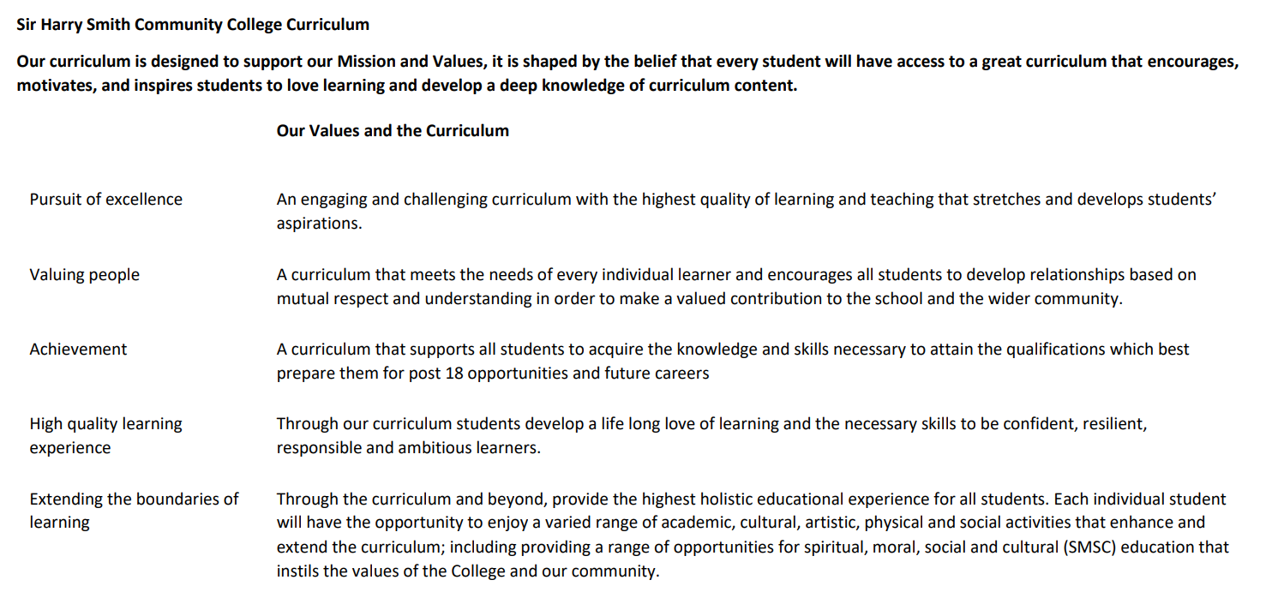

Sir Harry Smith Community College Curriculum Map SUBJECT: French YEAR 10 2022-23
Curriculum Intent: to introduce students to the French language, so that they are able to communicate with others and share basic information about their own lives. They will gain an insight to the differences between their own country’s traditions and how the same celebrations are different in another culture. This aids students to appreciate their own culture, as well as improving cross cultural understanding, thus having an international awareness. To gain confidence in speaking and understanding another language and develop literacy and communication skills in their own and another language. Preparing students for the wider world of work or study.
School Values | Curriculum Focus | Term 1 – me, my family and relationships, where I live, school, health, sports and instruments | Term 2 – hobbies, TV, film, food and drink, celebrations & festivals | Term 3 – holidays, future plans
High Quality Learning Experience | Literacy Skills and Key Vocabulary | Introduction to the course  Describing people both physically and as personalities  Friendship qualities  Relationships within your family  Describing where you live. your town, area and climate  Daily routine  School  Comparatives  School rules  School exchange  Healthy living / lifestyle  Revision of sport  Revision of music instruments  Present tense – regular & irregular verbs  Adjectives and agreement  Reflexive verbs  Pronoun « y »  Négatives  Past perfect tense  Comparative adjectives  Imperfect tense  Il faut & il est interdit de  Recognition of the imperative  Future tense  Faire + de, jouer + à, jouer + de  Depuis + present tense | Sport  Life on line  Books and reading  Tv programmes  Actors and films  Food and drink  Special occasions  Family celebrations & traditions  Formal language  Smoking, alcohol & drugs  Present tense regular and irregular verbs  Adjectives and agreement  Reflexive verbs  Negatives  Past tenses : perfect & imperfect  Depuis + present tense  Comparatives  Direct object pronouns le, la, les  Superlative adjectives  Partitive article  Pronoun « en »  Tu versus vous  Venir de + infinitive construction | Holidays  Future plans after school  Revision of present, past: perfect & imperfect, future: near & simple, tenses  On peut+ infinitive construction  Conditional tense  Pluperfect tense  Reflexive verbs in the present and past tenses  Après avoir + Past participle construction  Avant de + infinitive construction  Recognising the subjunctive  Direct object pronouns  Indirect object pronouns  Qui, que & dont
Pursuit of Excellence | Knowledge and Skills | Students will learn vocabulary and short phrases in a number of ways  - listening  - repeating  - listening and reading comprehensions  - translations both into and from English and the Target Language  - looking at how language is formed into a sentence and the grammatical elements needed e.g. verb, subject  - writing with a scaffold and freely.  - This will be supported with online games and recap and retrieval activities and student led activities  Students should be able to  - Describe people physically and personality wise  - Explain what makes a good friend, using modal verb structure  - Explain how they get on with members of their families and justify why this is the case, as well as describe other people’s relationships and give opinions and reasons for this. This could be completed in the present or past tense and look at how things have changed and why  - Understand, recognise and use regular and irregular present tense verbs  - Describe your town, saying what there is and is not and give opinions, be able to do the same for someone else  - Discuss the climate of your region and compare it to another area  - Talk about the activities available in your area and offer opinions for yourself and others  - Use reflexive verbs to discuss their own daily routine and that of others in the present and past tenses  - Talk about school subjects, in present, past and future tenses, including opinions, justifications  - Discuss the differences between the French & British school systems e.g. uniform  - Describe a typical school day, including clock times and days, in present, past and future tenses  - Use a variety of different verbs, conjunctions, time phrases to make work fluent, interesting and engaging for the speaker or reader.  - Use modal verbs to say what must, should happen or ask what you or another person may do, regarding school rules  - how to attempt a photocard tasks  - how to attempt general conversation questions  - how to attempt 4 sentence tasks  - how to attempt 40 word tasks  - how to attempt 90 word tasks  - how to attempt French to English Translations  - how to attempt English to French Translations | Students will learn vocabulary and short phrases in a number of ways  - listening  - repeating  - listening and reading comprehensions  - translations both into and from English and the Target Language  - looking at how language is formed into a sentence and the grammatical elements needed e.g. verb, subject  - writing with a scaffold and freely.  - This will be supported with online games and recap and retrieval activities and student led activities  Students should be able to  - Talk about different sports activities they and other participate in  - Express who and when they do these activities  - Pass opinions on the different activities and share other peoples views  - Know about sporting activities across France and what favourite sports are  - Talk about what activities they do on line in the present, past and future tenses  - Discuss reading and how it has affected their life throughout  - Look at how reading habits have / are changing in today’s technological world  - Understand discuss and represent data from surveys  - Talk about their own tv preferences and those of others  - Discuss what they watch, when and where and share their own opinions and those of others  - Talk about different films, including likes and dislikes  - Talk about the Cannes film festival and be aware of some famous French actors / actress  - To use comparative and superlative adjectives to compare famous people and events  - Recognise everyday food and drink items  - Talk about their daily food and drinks, explaining likes and dislikes and justifying these as appropriate, as well as doing the same for others  - Use the partitive article  - Know different amounts and types of shop  - have a dialogue in a shop  - understand and discuss how festivals and traditions in French speaking countries differ to our own  - use different register depending on who they are communicating with  - recognise, understand and discuss the different health issues caused by smoking, alcohol and drugs  - attempt a role play task  - Work through examples and practise photocard tasks  - Work through examples and practise general conversation questions  - Work through examples and practise 4 sentence task  - Work through examples and practise 40 word tasks  - Work through examples and practise 90 word tasks  - Work through examples and practise French to English Translations  - Work through examples and practise English to French Translations | Students will learn vocabulary and short phrases in a number of ways  - listening  - repeating  - listening and reading comprehensions  - translations both into and from English and the Target Language  - looking at how language is formed into a sentence and the grammatical elements needed e.g. verb, subject  - writing with a scaffold and freely.  - This will be supported with online games and recap and retrieval activities and student led activities  Students should be able to  - Recognise different countries  - Say where they go on holiday how long for, how they travel and with whom  - Express opinions about holidays – both positive and negative and be able to justify these views.  - Understand and discuss the view and justifications of others  - talk about they types of activities different locations offer and what they and others think about this  - talk about their dream holiday, including details about where they would go, stay, who they would go with, what they would do and how they think it would be  - talk about past holiday experiences and opinions, for themselves and others  - book a holiday  - recognise and book different room combinations and facilities  - talk about travelling necessities and what they do, have in the past or will in the future pack  - talk about holiday disasters they or others have experienced  - talk about their personal future plans regarding marriage and children  - There will be a unit of time set aside to prepare students for speaking examinations during this term  - Work through examples and practise a role play task  - Work through examples and practise photocard tasks  - Work through examples and practise general conversation questions  - Work through examples and practise 4 sentence task  - Work through examples and practise 40 word tasks  - Work through examples and practise 90 word tasks  - Work through examples and practise French to English Translations  - Work through examples and practise English to French Translations
 | Subject specific pedagogy | Students will encounter  - recap and retrieval activities e.g. 5 a day, boggle, vocabulary races  regular revisiting and exposure to vocabulary and structures embeds knowledge  - student led activities, where they can talk to the teacher and others e.g. tarsea, one pen one dice, speed dating  Specific grammar teaching of  - present, past: perfect & imperfect, future and conditional tenses  - adjective agreements  - pronoun “y”  - negative structure  - pronouns il / elle  - modal verb + infinitive structure  - Reflexive verbs  - Comparative adjectives  - Imperative (to recognise)  - Faire + de  - Jouer + à  - Jouer + de  - Depuis + present tense | Students will encounter  - recap and retrieval activities e.g. 5 a day, boggle, vocabulary races  regular revisiting and exposure to vocabulary and structures embeds knowledge  - student led activities, where they can talk to the teacher and others e.g. tarsea, one pen one dice, speed dating  Specific grammar teaching of  - present, past: perfect & imperfect, future and conditional tenses  - adjective agreements  - negative structure  - depuis + present tense  - partitive article du, de la, des, de l’  - pronoun « en »  - question forms « tu » and « vous »  - venir de + infinitive construction  - comparative adjectives  - superlative adjectives | Students will encounter  - recap and retrieval activities e.g. 5 a day, boggle, vocabulary races  regular revisiting and exposure to vocabulary and structures embeds knowledge  - student led activities, where they can talk to the teacher and others e.g. tarsea, one pen one dice, speed dating  Specific grammar teaching of  - present, past: perfect & imperfect, future and conditional tenses  - pluperfect tense  - reflexive verbs in the present and past tenses  - adjective agreements  - negative structure  - depuis + present  - tu and vous forms  - comparative adjectives  - superlative adjectives  - recognition of the subjunctive  - direct object pronouns  - indirect object pronouns  - qui, que, dont
Extending the boundaries of learning | Cultural Capital and beyond the curriculum | All students will have the opportunity to take part in the European Day of Languages celebrations and tasks. | Students will be offered the opportunity to take part in the French trip to Paris in February  Opportunity to support or lead in the craft club | Cinema trip to Wildwood  Opportunity to support or lead in the craft club
Achievement | Assessment | - Baseline test in listening, reading and writing  - Speaking assessment describing a photo on the topic of holidays  - Speaking Assessment answering questions on school  - Written pieces will be completed through out the term on various topics of varying lengths  - Translations from French to English and English to French | - Listening and reading assessment on two of the topics we have studied so far  - Speaking assessment role play  - Written pieces will be completed through out the term on various topics of varying lengths  - Translations from French to English and English to French | - Listening and reading assessment  - Speaking exam, including all three elements  - Writing assessment  - Written pieces will be completed through out the term on various topics of varying lengths  - Translations from French to English and English to French
Valuing People | How our curriculum meets the needs of every individual | We have high expectations for all of our students and work in a step by step progression, building up from simple words to units of language and sentences before adding in more complicated constructions. We also offer some favourite, well known books in the library in German to encourage students to read for pleasure in German. | We have high expectations for all of our students and work in a step by step progression, building up from simple words to units of language and sentences before adding in more complicated constructions. We also offer some favourite, well known books in the library in German to encourage students to read for pleasure in German. | We have high expectations for all of our students and work in a step by step progression, building up from simple words to units of language and sentences before adding in more complicated constructions. We also offer some favourite, well known books in the library in German to encourage students to read for pleasure in German.

