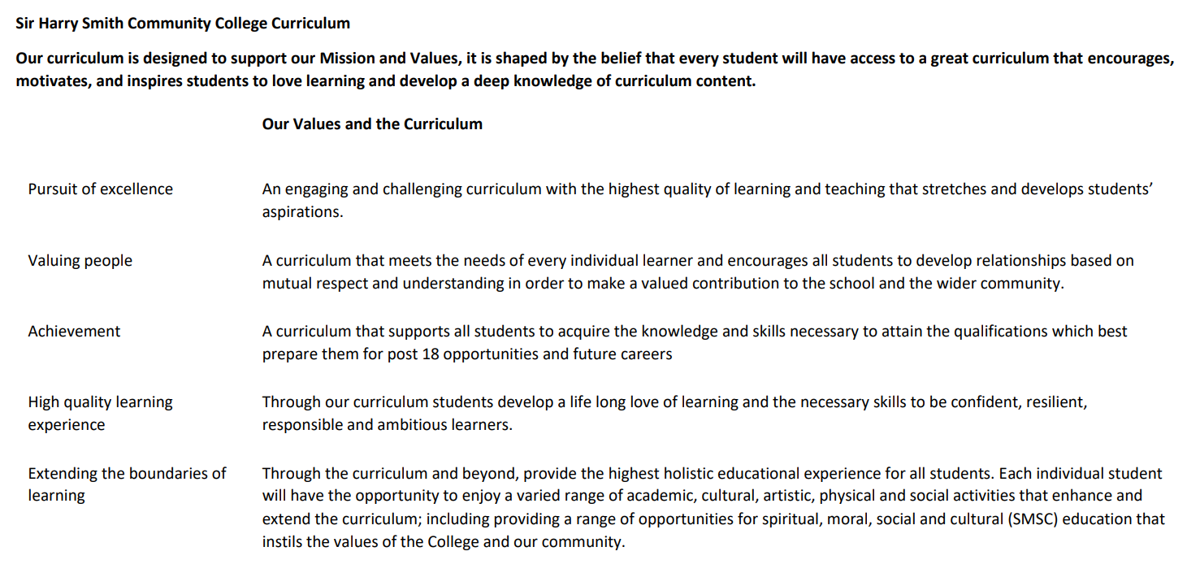

Sir Harry Smith Community College Curriculum Map SUBJECT: Health & Social Care YEAR 13 2022-23
Curriculum Intent: BTEC National Level 3 Extended Certificate in Health and Social Care. This is a vocational subject aimed to prepare students for further studies in a wide range of job roles and qualifications. 2023 Certification
The BTEC National in Health and Social Care is a vocational qualification that will help prepare students for a wide range of careers or for further study on a range of degree programmes.
There are many roles available in the Health and Social Care sector which provide varied opportunities to make a difference to people’s lives in a positive way – and the demand for skilled people is growing. Working in the Health and Social Care professions can also offer students the opportunities to work in different parts of the country and overseas.
BTEC National Level 3 Extended Certificate in Health and Social Care, offers a wide range of topic units, which help students to gain skills that will be valuable in when working or carrying out further studies in Health and social care related fields. Students will learn about the human body and how it changes over time. What it means to work in the Health and social are sector and what skills and behaviours you will need to demonstrate considering legislation, procedures/policies, ethical dilemmas, equality, patient centred care, Multi-disciplinary Team Working and Confidentiality.
Students who have completed this course hear at SHSCC have gone on to apprenticeships as nursing practitioners in a range of different fields such as Paediatrics and Oncology. Students have also gone on to study Social Work, Primary Teaching, Midwifery at University
School Values | Curriculum Focus | Term 1 – Unit 2 – Working in Health and Social Care | Term 2 – Unit 5 - Meeting Individual Care & Support Needs | Term 3 – Completing Unit 5
High Quality Learning Experience | Literacy Skills and Key Vocabulary | Command words; Identify, Explain, Describe, Discuss  Topic keywords; Legislation, Policies, Responsibilities, Doctors, Nurses, Midwives, Healthcare Assistants, Social Workers, Occupational Therapists, Youth Workers, Care Managers Assistants, Support Workers, Supporting, Recovery, Adaptations, Anti-Discrimination, Equality, Empowerment, Whistleblowing, Safeguarding, Confidentiality, Respect, Vulnerable, Partnership, Advocate, Monitoring, Referral, Physical Disability, Sensory Disability, Learning Disability, Multidisciplinary, Accountable, Dignity, Individualised, Belief, Culture, Provision | Command words; explain, Assess, Analyse, Evaluate, Justify  Topic keywords; promoting anti-discrimination, Ethical issues, Preventing, Provision, Benefits, Personalisation, Overcoming, Challenges/Barriers, Support, Equality, Communication, Multidisciplinary, Diversity, Relationships, Impact, Responsibilities, Confidentiality, Multiagency, Legislation, Codes of Practise, Attachment, Empathy, Emotional resilience, triangle of care, Consequentialism, Deontology, Principalism, Virtue, | Students will respond to the feedback provided by their teacher on the assessment criteria they have met. This will be over 15 working days. Once the student has handed their assignments in for the resubmission they have affectively completed the course.
Pursuit of Excellence | Knowledge and Skills | Students will work through the unit 2 Working in Health and Social Care content during lessons. This will cover the job roles and responsibilities, how the different roles work together in multidisciplinary teams. The different types of care settings, who works in them and how standards are maintained. They will also cover how the sector is monitored, to make sure service users are treated with respect, dignity, empowered and not discriminated against. They will be asked to carry out independent research tasks around topics, produce their own notes and carry out revision in lesson and in their independent study time.  The unit is examined, it is divided into 4 sections, each section starts with a case study that could be real life followed by 4 questions. Section A is always on Ill health, Section B is about learning disabilities, Section C covers Physical and sensory disabilities and Section D either early years or later adulthood. The four questions will always start with the command words Identify, Describe, Explain and Discuss. | Students will start Unit 5 after they have completed unit 14. This unit is designed to be delivered last and uses knowledge that students have gained throughout the units previously covered, alongside some new topics/concepts (Synoptic).  Students are given case studies of 2 individuals, they will need to use their situation in context to explain equality, diversity, the personal attributes needed of the H&SC professionals, the ethical principles that surround the case study, strategies used in the multidisciplinary teams to communicate, maintain confidentiality while providing care that is planned for the individual (personalised).
 | Subject specific pedagogy | Students will carry out individual research on a variety of topics related to working in Health and Social Care to extend the information or apply context to the basic information they have been provided on the topic. Group discussions will be used to share knowledge and understanding of the lesson content. Where possible events that have occurred and changed the way the Health and social sector operates will be used, for example, Victoria Climbie and Baby P for communication within a multidisciplinary team. Winterbourne view for how care settings are monitored, safeguarding and whistleblowing. How the murders of Jessica Chapman and Hollie Wells brought about changes in the vetting of staff who work with vulnerable people. | Students use knowledge gained in previous units and apply it to the case studies in the correct context. They will need to make their own decisions about which legislations, Acts, Procedures, Theories or strategies are appropriate for the situation in the case study and justify why they have made these conclusions.  The pass criteria will require an explanation of these points, the merit criteria will show the explanation being developed by the student to show their ability to Assess and Analyse. Finally to achieve the Distinction criteria the students will need to evaluate and justify the success of promoting anti-discriminatory practise while planning and providing care for the individuals in the case study.
Extending the boundaries of learning | Cultural Capital and beyond the curriculum | Students could watch documentaries such as;  Midwives – series 2, episode 2 a rare look inside an NHS delivery unit  Inside the care crisis with Ed Balls  Protecting our children – social work  The health effect – inequalities  Panorama – Winterbourne view  Documentaries available on iPlayer;  Freddie Flintoff; Living with Bulimia  Strictly Amy; Chron’s and me | The following documentaries are good for gaining an understanding of why legislation/policies/whistleblowing and other changes happen in H&SC  Panorama Winterbourne view  Assisted Death & the Value of Life: Crash Course Philosophy #45 Crash course psychology  Prejudice and discrimination #30 Crash Course Psychology  My Mind and Me | Newsbeat Documentaries  BBC iplayer – Ellie Simmonds a world without dwarfism, or a world without down syndrome  Driven; the Billy Monger story  Ethical cases that have been in the news  Ashya King  Charlie Guard  Archie Battersbee
Achievement | Assessment | This unit will be externally examined in May of year 12. The students will complete past exam papers and a mock exam within the lesson once the content has been completed in April/May.  The exam is out of 90 marks and takes 90 minutes.  Students must achieve a Nearly Pass (N) in this exam to Pass the course overall. Students will have an opportunity to resit the exam if needed.  If students decide to resit the exam to try and achieve a higher grade and then achieve a lower grade, the higher grade will stand.  Makes up 33% of final grade. | Students are expected to use lesson and personal study time to complete 2 assignments to a deadline. They are given feedback which identifies what they have achieved, using the assignment assessment criteria. They will be given 15 working days to improve their work using this feedback.  This unit is internally assessed by the class teacher, a sample from the group is internally moderated following the BTEC protocol on both submissions. This unit will be externally moderated by the exam board.  Makes up 25% of final grade | Final assessment is compromised of  Unit 1 = 25% examined in year 12  Unit 2 = 33% examined in year 13  Resit opportunities available for both exam units 1 and 2  Unit 14 = 17% internally assessed in year 12  Unit 5 = 25% internally assessed in year 13
Valuing People | How our curriculum meets the needs of every individual | All students are provided with the lesson content online via TEAMS, Microsoft onedrive and in the lesson.  Example answers and exemplar work is shared  PLC’s are provided with unit content, keywords, assessment criteria and a progress tracker  All content is discussed in a real-world context  Revision guides are provided.  Revision cards and work booklets can be provided for students who need more support with structure.  The course is modular, external and internal assessment are used twice a year to test the content the student has just covered | All students are provided with the lesson content online via TEAMS, Microsoft onedrive and in the lesson.  Example answers and exemplar work is shared  PLC’s are provided with unit content, keywords, assessment criteria and a progress tracker  All content is discussed in a real-world context  Students will need to use their knowledge from previous topics to complete the 2 assignments. They will need to consider the impact of a wide range of issues that affect health and social care services while ensuring everyone is treated equally despite their situation.

