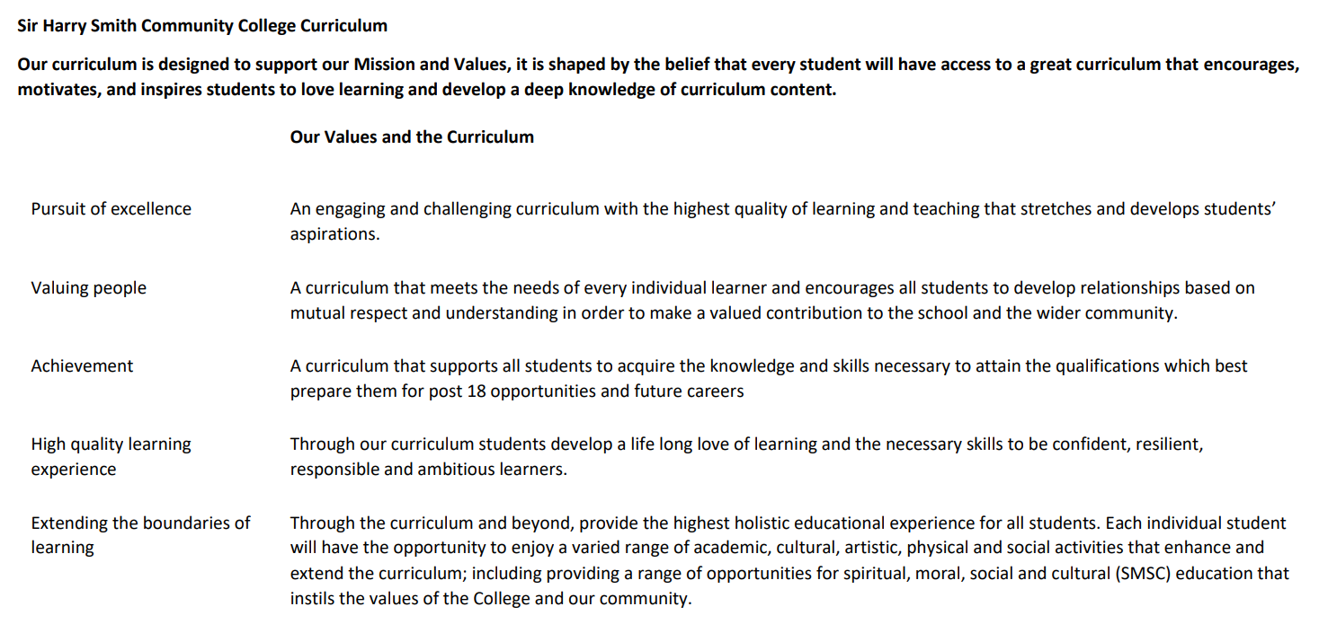

Sir Harry Smith Community College Curriculum Map SUBJECT: Religion, Philosophy and Ethics YEAR 9 2022-23
Curriculum Intent: Curriculum Intent: For our students to develop a knowledge of the religious diversity and appreciation of cultural diversity within the UK and Global Community. To encourage skills of empathy, understanding, analysis and evaluation of philosophical and ethical ideas. To prepare students for the future study of GCSE and A Level Religious Studies.
School Values | Curriculum Focus | Term 1 – Ethics B | Term 2 – Philosophy: War and Peace | Term 3 – Buddhism A
High Quality Learning Experience | Literacy Skills and Key Vocabulary | Contraception, tsunami, poverty, oppression, injustice, discriminate, ethnicity, donor, addiction, drug abuse, dominion, stewardship, beasts of burden. | War, peace, refugee, just war, jihad, conflict, prisoner of war, Geneva convention, holy war, pacifism, conscientious objection. | Buddha, Dharma, Middle Way, enlightenment, Theravada, Mahayana, samsara, karma, bhikkhu, monastic.
Pursuit of Excellence | Knowledge and Skills | - Animal rights  - Drugs and religion  - Medical ethics  - Poverty  - Attitudes to victims of natural disasters  - Has religion passed its sell by date?  - Is sport like a religion? | - Reasons for war and conflict  - Why is there conflict in the Holy Land?  - Just war and Jihad  - Pacifism  - Case studies on recent wars  - Conscientious objectors. | - Life of Buddha  - Different groups of Buddhists  - The Four Noble Truths  - The Noble Eightfold Path  - Karma and Samsara  - The Sangha and Monastic Life
 | Subject specific pedagogy | Debate and discussion  Current affairs  Challenging stereotypical views  Scriptural analysis  Critical thinking and evaluation. | Debate and discussion  Current affairs  Challenging stereotypical views  Scriptural analysis  Critical thinking and evaluation. | Debate and discussion  Current affairs  Challenging stereotypical views  Scriptural analysis  Critical thinking and evaluation.
Extending the boundaries of learning | Cultural Capital and beyond the curriculum | Reflection on topical current debates in society. Consideration of how society should treat those who suffer injustice. Current news stories and recent events. Reflection on the value of religion verses humanism. | Reflection on topical current debates in society. Consideration of how society should treat those who suffer injustice. Current news stories and recent events. Case study on war in Ukraine. | Buddhist artefacts and displays. Appreciation of diversity and culture. Current news stories about Buddhism and sacrificial living.
Achievement | Assessment | Baseline multiple choice tests  TEAMS assessment.  Book check.  Teacher feedback and Q&A. | Baseline multiple choice tests  Group presentations on a specific war.  TEAMS assessment.  Teacher feedback and Q&A. | Baseline multiple choice tests  End of unit assessment
Valuing People | How our curriculum meets the needs of every individual | Adaptation of resources for all students with SEN.  Variety of choice of task for all students.  Visual and video resources to embed learning.  Individual resource booklet for all students.  Stretch and challenge tasks for more able students.  Writing frames and key term activities to support extended writing for all students. | Adaptation of resources for all students with SEN.  Variety of choice of task for all students.  Visual and video resources to embed learning.  Individual resource booklet for all students.  Stretch and challenge tasks for more able students.  Writing frames and key term activities to support extended writing for all students. | Adaptation of resources for all students with SEN.  Variety of choice of task for all students.  Visual and video resources to embed learning.  Individual resource booklet for all students.  Stretch and challenge tasks for more able students.  Writing frames and key term activities to support extended writing for all students.
School Values | Curriculum Focus | Term 4 – Christianity C | Term 5 – Humanism | Term 6 – Buddhism B
High Quality Learning Experience | Literacy Skills and Key Vocabulary | Apocrypha, atheist, authoritative, congregation, free will, Gospels, infallible, liberal, militants, New Testament, Old Testament, ordained, patriarchal, pilgrimage, sanctity of life, secular, spiritual gifts, Ten Commandments. | Evolution, human nature, potential, atheist, humanist, autonomy, secularism, ethics, freedom of expression, human rights, mortality, materialism. | Vihara, stupa, ahimsa, metta, karuna, pilgrimage, dharma wheel, lotus, triratna, wesak, parinivana, kathina, Dalai Lama.
Pursuit of Excellence | Knowledge and Skills | - What is the Bible?  - Is Britain a Christian country?  - Prayer and publicity  - Should women lead the church?  - Slavery and the Crusades  - What is the “problem of evil?”  - What is charismatic Christianity?  - The persecution of Christians | - Human beings (human evolution, nature, and potential)  - Understanding the world (science and reason)  - The one life (freedom and happiness)  - Humanist ethics (empathy and the impact of our actions)  - Society (actions, goals, and responsibility) | - Buddhist temples around the world  - Daily life and moral code  - Significant Buddhist places  - The life of the Dalai Lama  - Symbolism in Buddhism  - Buddhist festivals.
 | Subject specific pedagogy | Debate and discussion  Current affairs  Challenging stereotypical views  Scriptural analysis  Critical thinking and evaluation. | Debate and discussion  Current affairs  Challenging stereotypical views  Scriptural analysis  Critical thinking and evaluation. | Debate and discussion  Current affairs  Challenging stereotypical views  Scriptural analysis  Critical thinking and evaluation.
Extending the boundaries of learning | Cultural Capital and beyond the curriculum | Christian artefacts and displays  Modern news stories about Christianity in the news.  Gender equality and reflection on whether the church should allow female leaders.  Personal reflection upon the issue of if Britain is a Christian country and what are Christian moral values. | Personal reflection on atheist and humanist perspectives on our purpose in life.  Consideration of whether students see themselves as humanist.  Understanding of alternative perspectives to traditional religious ideas. | Buddhist artefacts and displays.  Personal reflection on ideas of ahimsa and do no harm principles.  Personal reflection on what it means to treat everyone with metta (loving kindness) and karuna (compassion).  Consideration of living an alternative lifestyle of veganism and meditation.  Opportunity for class meditation.
Achievement | Assessment | Baseline multiple choice tests  TEAMS online test.  Teacher feedback and Q&A.  Bookcheck. | Baseline multiple choice tests  Extended writing on humanist views.  Teacher feedback and Q&A. | TEAMS online test.  Teacher feedback and Q&A.
Valuing People | How our curriculum meets the needs of every individual | Adaptation of resources for all students with SEN.  Variety of choice of task for all students.  Visual and video resources to embed learning.  Individual resource booklet for all students.  Stretch and challenge tasks for more able students.  Writing frames and key term activities to support extended writing for all students. | Adaptation of resources for all students with SEN.  Variety of choice of task for all students.  Visual and video resources to embed learning.  Individual resource booklet for all students.  Stretch and challenge tasks for more able students.  Writing frames and key term activities to support extended writing for all students. | Adaptation of resources for all students with SEN.  Variety of choice of task for all students.  Visual and video resources to embed learning.  Individual resource booklet for all students.  Stretch and challenge tasks for more able students.  Writing frames and key term activities to support extended writing for all students.

