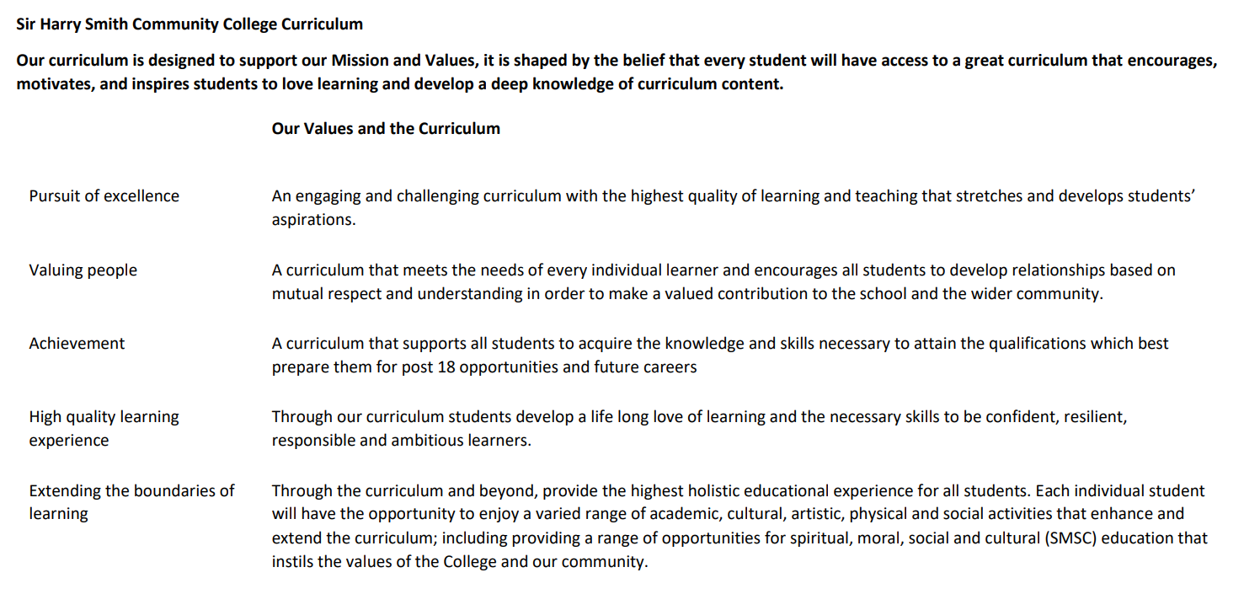

Sir Harry Smith Community College Curriculum Map SUBJECT: Religion, Philosophy and Ethics YEAR 8 2022-23
Curriculum Intent: Curriculum Intent: For our students to develop a knowledge of the religious diversity and appreciation of cultural diversity within the UK and Global Community. To encourage skills of empathy, understanding, analysis and evaluation of philosophical and ethical ideas. To prepare students for the future study of GCSE and A Level Religious Studies.
School Values | Curriculum Focus | Term 1 – Christianity B  History of Christianity | Term 2 – Judaism B | Term 3 – Islam B – The Five Pillars of Islam
High Quality Learning Experience | Literacy Skills and Key Vocabulary | Denomination, doctrine, evangelism, disciple, gentiles, catacombs, matyr, creed, heresy, scriptures, confessional, penance, transubstantiation, pope, cardinals, conclave, excommunicated, indulgences, protestant, reformation. | Covenant, circumcision, pesach, shema, mezuzah, shabbat, bar mitzvah, bat mitzvah, menorah, star of David, hanukkah, shin, mitzvot. | Five pillars, shahadah, zakar, salah, hajj, Ramadan, ihram, Makkah, Muhammad, Medinah.
Pursuit of Excellence | Knowledge and Skills | - What was lifelike for the early church?  - The Great Schism and the Catholic Church  - The Reformation and the beginnings of the Anglican Church | - Founding fathers of Judaism – Abraham  - Founding fathers of Judaism – Moses  - Jewish symbolism  - The Jewish moral code – Mitzvot. | - Shahadah – The First Pillar  - Salah – The Second Pillar  - Zakah – the Third Pillar  - Sawm – the Fourth Pillar  - Hajj – the Fifth Pillar.
 | Subject specific pedagogy | Debate and discussion  Current affairs  Challenging stereotypical views  Scriptural analysis  Critical thinking and evaluation. | Debate and discussion  Current affairs  Challenging stereotypical views  Scriptural analysis  Critical thinking and evaluation. | Debate and discussion  Current affairs  Challenging stereotypical views  Scriptural analysis  Critical thinking and evaluation.
Extending the boundaries of learning | Cultural Capital and beyond the curriculum | Trip to Lincoln Cathedral.  Reflection on the history and growth of Christianity.  Reflection on the diversity of belief within the modern Christian church.  Christian artefacts and displays. | - Jewish artefacts and displays  - Pesach plate  - Menorah  - Mezuzah  - Jewish music and songs  - Cultural benefits of community and traditions.  - Encouraging understanding of different cultures and traditions. | - Muslim artifacts and displays  - Reflection on following the Five Pillars as a modern British Muslim  - Reflection on the spiritual benefits of fasting and pilgrimage  - Current news stories regarding Hajj.
Achievement | Assessment | Baseline multiple choice tests  Extended writing on the Reformation.  Teacher feedback and Q&A. | Baseline multiple choice tests  Book check  Teacher feedback and Q&A. | Baseline multiple choice tests  TEAMS assessment  Teacher feedback and Q&A
Valuing People | How our curriculum meets the needs of every individual | Adaptation of resources for all students with SEN.  Variety of choice of task for all students.  Visual and video resources to embed learning.  Individual resource booklet for all students.  Stretch and challenge tasks for more able students.  Writing frames and key term activities to support extended writing for all students. | Adaptation of resources for all students with SEN.  Variety of choice of task for all students.  Visual and video resources to embed learning.  Individual resource booklet for all students.  Stretch and challenge tasks for more able students.  Writing frames and key term activities to support extended writing for all students. | Adaptation of resources for all students with SEN.  Variety of choice of task for all students.  Visual and video resources to embed learning.  Individual resource booklet for all students.  Stretch and challenge tasks for more able students.  Writing frames and key term activities to support extended writing for all students.
School Values | Curriculum Focus | Term 4 – Hinduism A | Term 5 & 6 Philsophy A
High Quality Learning Experience | Literacy Skills and Key Vocabulary | Brahman, Trimurti, reincarnation, atman, moksha, mandir, puja, | Philosophy, design argument, first cause, morality, atheist, omnipotent, omniscient, evil, suffering, immortality.
Pursuit of Excellence | Knowledge and Skills | - Hindu beliefs about God  - Karma and rebirth  - Hindu worship  - Four stages of life | - Argument for the existence of God from design.  - Argument for the existence of God from first cause.  - Argument for the existence of God from morality.  - Arguments against the existence of God  - The problem of evil and suffering.  - Is immortality possible?
 | Subject specific pedagogy | Debate and discussion  Current affairs  Challenging stereotypical views  Scriptural analysis  Critical thinking and evaluation. | Debate and discussion  Current affairs  Challenging stereotypical views  Scriptural analysis  Critical thinking and evaluation.
Extending the boundaries of learning | Cultural Capital and beyond the curriculum | Hindu artefacts and displays. Personal reflection on the afterlife, dualism and reincarnation. Personal reflection on the stages of our lives and rites of passage. | Debate and discussion  Current affairs  Challenging stereotypical views  Scriptural analysis  Critical thinking and evaluation.
Achievement | Assessment | Baseline multiple choice tests  TEAMS assessment  Book check | Extended writing on the existence of God.  Teacher feedback and Q&A
Valuing People | How our curriculum meets the needs of every individual | Adaptation of resources for all students with SEN.  Variety of choice of task for all students.  Visual and video resources to embed learning.  Individual resource booklet for all students.  Stretch and challenge tasks for more able students.  Writing frames and key term activities to support extended writing for all students. | Adaptation of resources for all students with SEN.  Variety of choice of task for all students.  Visual and video resources to embed learning.  Individual resource booklet for all students.  Stretch and challenge tasks for more able students.  Writing frames and key term activities to support extended writing for all students.

