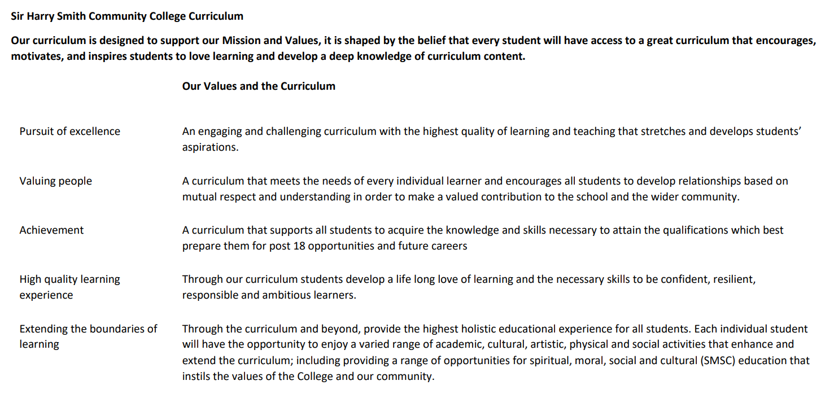

Sir Harry Smith Community College Curriculum Map SUBJECT: Geography YEAR 8 2022-23
Curriculum Intent: Key Stage Three Geography builds on the knowledge learnt from Key Stage Two by dividing the subject into three themes (Human Geography, Physical Geography and Environmental Geography) and developing relevant and appropriate examples so that students can become active citizens that are enthused by the subject and have the practical skills to play a key role in society. Key Stage Three Geography has clear links to the current GCSE and A Level courses, but also includes elements to support our vision of creating active citizens of the future.
School Values | Curriculum Focus | Term 1A – Urbanisation | Term 1B – Inequality and Newly Emerging Economies | Term 2A – Rivers and flooding
High Quality Learning Experience | Literacy Skills and Key Vocabulary | Urban, rural, wealth, poverty, migration, push factor, pull factor, climate, inequality, favela, squatter settlement, slum, shanty town, opportunities, challenges, sustainable, mega cities, globalisation, High Income Countries, Low Income Countries, Newly Emerging Economies. | Wealth, poverty, development, development indicator, High Income Countries, Low Income Countries, Newly Emerging Economies, under-developed, standard of living, quality of life, statistic, physical, human, environmental, economic, social, sustainable, stakeholder, distribution, diversity, exploitation, infant mortality, polarisation, multi-lateral aid, bi-lateral aid, subsistence farming, squatter settlements, favela, BRICS, MINTS. | Hydrological cycle, weathering, erosion, hydraulic action, abrasion, attrition, solution, traction, saltation, suspension, v-shaped valley, floodplain, levee, gorge, waterfall, interlocking spur, meander, estuary, delta, drainage basin, confluence, tributary, watershed, social, economic, environmental, management, sustainability.
Pursuit of Excellence | Knowledge and Skills | Students will reinforce their understanding from Year 7 Settlement, building on key themes by providing specific examples. Students will investigate major cities and mega cities of the world, understanding why migration occurs between rural and urban areas and the impact of this. Students will investigate squatter settlements of the world and understand how these could be managed and how conflict could be resolved. | In this topic, students will focus on Brazil as a Newly Emerging Economy and a BRIC. This will allow students to understand inequality within a country; with a focus on the causes, impacts and management. Students will complete this topic by looking at sustainable solutions and whether they could be applied to other Newly Emerging Economies. | Students will reinforce their understanding of the hydrological cycle before exploring the landforms and processes within a drainage basin. Students will investigate the causes, effects (UK case study) and management of flooding.
 | Subject specific pedagogy | Students will have chance to work independently, as a pair and as a group to build up the knowledge to make an informed decision for managing urban areas. Students are encouraged to become critical thinkers, developing their skills of evaluation, especially when considering the future and sustainability. | Students will continue to use the skills and knowledge learnt in the first half term and Year 7 by becoming decision makers. Students will be encouraged to make use of research (e.g. documentaries) to support their learning, and will have a clear link with home learning. | Decision making is evident in this topic, and could be applied to a local area within the Fens. Students are being encouraged to think about local geographies to maintain their curiosity and enthusiasm. Students will also be able to recall elements from the Year 7 Geology topic.
Extending the boundaries of learning | Cultural Capital and beyond the curriculum | Students will be set regular home learning in order to consolidate and challenge their learning. Students are continuing their journey to becoming active citizens, understanding their role and making appropriate decisions. | Home learning will continue to stretch and challenge students. Students are encouraged to broaden their understanding with a range of examples, being directed to documentaries and research. SMSC – challenging stereotypes and supporting citizens of the world. Careers – job types/economic sectors. | Students will continue to complete regular home learning, with a potential to investigate other topics related to water as a resource. This will bring links to other topics through the idea of water security and management. Students continue to develop their role as decision makers. Chance for students to complete independent fieldwork for a local river system.
Achievement | Assessment | Students will complete a decision making exercise, justifying a chosen option for managing squatter settlements. Students will be assessed through their book work on content and skills, but also through regular home learning. There will be a chance to peer review extended writing. |  | Students will be assessed through extended writing, justifying selected management strategies. There will be an element of peer or self review.
Valuing People | How our curriculum meets the needs of every individual | Learning aims to draw links and build on students’ understanding. Tasks are differentiated clearly so students can understand the theory and application, including decision making skills.  Students will be have the chance to build on existing knowledge from term 1A and Year 7 so they can be challenged and progress. Decision making is clearly structured, and is now becoming part of a routine across Key Stage Three. Students have a varied understanding of the world around them; we aim to make connections on a variety of scales to ensure students can understand their purpose and value in society. Tasks are differentiated accordingly to access the required knowledge and skills, ensuring all learning needs are provided for, including and not limited to Pupil Premium and EAL students. Teachers will make use of the Supportive Skills Department and the associated staff. Home learning gives the chance to extend and challenge all learners.  Continuous emphasis on key terminology and retrieval practice of this throughout the course. Breaking down key terms into smaller words to understand wider meanings and further extension opportunities embedded throughout.  Liaising with year leaders, Supportive Skills Department, form tutors and parents to develop a holistic understanding of our students, so that any intervention is bespoke to the individual.  Independent leaners are provided support via the uploading of relevant classwork onto TEAMs, this allows students to reflect on their learning and revisit any material they may wish to recap as part of their revision or independent learning. Students who miss lessons for various reasons are then able to complete work in preparation for future lessons.  Staff within the department continuously share good practice through regular meetings, lesson drop-ins, marking standardisation and feedback after completing various CPD courses.  Behaviour Watch and telephone calls home are used to regularly keep in touch with parents regarding behaviour for learning in lessons. Parents are contacted via email or telephone if there are any persistent issues in class or to discuss positive contributions and work from our students. |  | There is a focus on the UK for this topic, which allows for connections to the Fenland area. Students will be able to apply their knowledge to structured decision making exercises, and will be able to communicate clearly through structured tasks.

Sir Harry Smith Community College Curriculum Map SUBJECT: Geography YEAR 8 2022-23
Curriculum Intent: Key Stage Three Geography builds on the knowledge learnt from Key Stage Two by dividing the subject into three themes (Human Geography, Physical Geography and Environmental Geography) and developing relevant and appropriate examples so that students can become active citizens that are enthused by the subject and have the practical skills to play a key role in society. Key Stage Three Geography has clear links to the current GCSE and A Level courses, but also includes elements to support our vision of creating active citizens of the future.
School Values | Curriculum Focus | Term 2B – Weather and climate | Term 3A – Cold environments and glaciation | Term 3B – Oil rich nations
High Quality Learning Experience | Literacy Skills and Key Vocabulary | Weather, climate, frontal, convectional, relief, greenhouse effect, enhanced greenhouse effect, antecedent, anticyclone, depression, anemometer, meteorologist, prevailing wind. | Biome, ecosystem, food chain, food web, producer, consumer, decomposer, carnivore, herbivore, omnivore, climate, latitude, adaptation, opportunities, challenges, conflict, conservation, glacier, moraine, arête, drumlin, pyramidal peak, governance, regulate, unique, territory, treaty | Energy, renewable, non-renewable, interdependence, The Organization of the Petroleum Exporting Countries (OPEC), inter-governmental organisation, exploitation, surplus, deficit, stress, scarcity, exploitation, desertification, single use, development, Gulf States
Pursuit of Excellence | Knowledge and Skills | Students will begin by understanding the differences between weather and climate. This is followed by exploring pressure systems and the various types of rainfall. Students will finish by linking into the UK and the systems that affect us. | Students will begin by looking at the processes and landforms related to glaciation. The topic continues with an in-depth focus on Antarctica. Within this case study, students will reinforce their understanding of ecosystems and adaptations. Students will complete the topic by looking at the issues and management. | Students will understand where oil comes from, how it is distributed globally and why it is important to us. Students will understand different types of energy and that oil brings conflict. Students will look at a case study to understand the issues and management of this resource (Middle East or Russia).
 | Subject specific pedagogy | Students will apply theory to the local area, utilising fieldwork equipment to investigate the weather locally and to complete a microclimate investigation; using clear lines of enquiry. | Students will return to the idea of decision making, working independently, in pairs and as a group. Students will use a wide range of resources, building on the skills developed to make a decision. | Students will use all the skills and knowledge learnt in the last two academic years to apply to a decision making exercise. Students will be encouraged to look at human, physical and environmental geographies in this final topic. Themes should be treated independently and interdependently.
Extending the boundaries of learning | Cultural Capital and beyond the curriculum | Fieldwork will allow students to become more familiar with equipment but also the school site/Whittlesey. These skills can be transferred to other subjects where practical skills are required. | There are few glacial landscapes locally but use UK landscapes to build knowledge. Draw attention to The British Antarctic Survey and their base in Cambridge alongside the Polar Museum. Home learning will encourage students to investigate further. | Students are becoming active and conscious citizens of the world. They will develop an idea about ethical resources (to be explored further in Year 9), which allows them to make informed decisions.
Achievement | Assessment | There is chance to conduct formative and summative assessments at this point. Assessment should also consider application of fieldwork methods. | Antarctica decision making exercise – students will have chance to answer short exam questions on glaciation and Antarctica, followed by a longer exam question looking at evaluating several options.0 | Students will have an end of year test in the third term to inform progress. This is in line with the Progress Check dates and may fall before May Half Term. Assessment will include a mixture or short and long exam style questions, and may include practical elements focussing on numeracy, fieldwork and map skills.
Valuing People | How our curriculum meets the needs of every individual | Learning aims to draw links and build on students’ understanding. Tasks are differentiated clearly so students can understand the theory and application, including decision making skills.  Students will be have the chance to build on existing knowledge from term 1, 2 and Year 7 so they can be challenged and progress. Decision making is clearly structured, and is now becoming part of a routine across Key Stage Three. Students have a varied understanding of the world around them; we aim to make connections on a variety of scales to ensure students can understand their purpose and value in society. Tasks are differentiated accordingly to access the required knowledge and skills, ensuring all learning needs are provided for, including and not limited to Pupil Premium and EAL students. Teachers will make use of the Supportive Skills Department and the associated staff. Home learning gives the chance to extend and challenge all learners.  Continuous emphasis on key terminology and retrieval practice of this throughout the course. Breaking down key terms into smaller words to understand wider meanings and further extension opportunities embedded throughout.  Liaising with year leaders, Supportive Skills Department, form tutors and parents to develop a holistic understanding of our students, so that any intervention is bespoke to the individual.  Independent leaners are provided support via the uploading of relevant classwork onto TEAMs, this allows students to reflect on their learning and revisit any material they may wish to recap as part of their revision or independent learning. Students who miss lessons for various reasons are then able to complete work in preparation for future lessons.  Staff within the department continuously share good practice through regular meetings, lesson drop-ins, marking standardisation and feedback after completing various CPD courses.  Behaviour Watch and telephone calls home are used to regularly keep in touch with parents regarding behaviour for learning in lessons. Parents are contacted via email or telephone if there are any persistent issues in class or to discuss positive contributions and work from our students. |  | Students have the chance to round up their learning across the year and review their progress. Students will complete an evaluation of the year which will allow the department to develop the curriculum and meet the needs of future Year 8s and the current Year8s as they move into Year 9.

