Design a School Task
This task will help you to learn some key terms that we use in sociology and to think about one of our key topics in year 10: education. This can be do ne on lined paper or on the computer.
Task 1: Key Terms
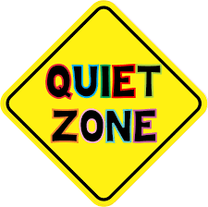
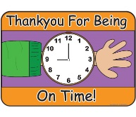
Norms: Norms are the unwritten rules we have in society. For example, say please and thank you is a norm. It is not against the law to not say please and thank you but it is an unwritten rule that we should. Some other examples are:
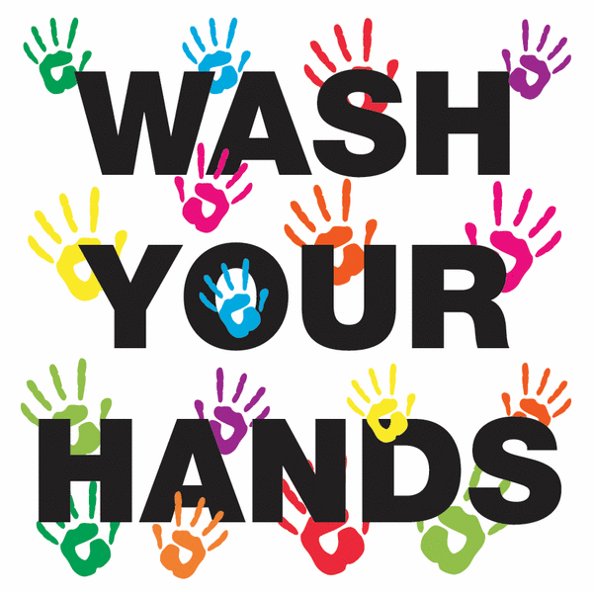
- Don’t talk in the cinema
- Wash your hands after going to the toilet
- Be on time when you are meeting someone
Think of some more norms:
__________________________________________________________________________________________________________________________________________________________________________________________________________________________________________________________________________________________________________________________________________________________________________________________________________________________

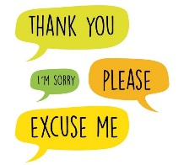
Norms help us know how to behave in society. They are based on values. Values are things that we, as a society, think are important. For example, cleanliness is a value because we feel it is important to be clean. Some examples of values are:
- Politeness
- Wealth
- Education
Think of some more values:
__________________________________________________________________________________________________________________________________________________________________________________________________________________________________________________________________________________________________________________________________________________________________________________________________________________________
Socialisation: this means how we learn norms and values. We don’t just know how to behave and what the unwritten rules of society are. We learn them from our families, schools, the media, our peers etc. For example, you may be grounded if you do something bad. On the other hand, your parents might smile at you if you do something helpful. This shows you how to behave.
How do you think our families socialise us? In other words, how do they teach us norms and values?
__________________________________________________________________________________________________________________________________________________________________________________________________________________________________________________________________________________________________________________________________________________________________________________________________________________________

TASK 2: Imagine that we could re-design schools. What do you think the ideal school is?
Answer the following questions in as much detail as you can:

1. Would we have to pay for your school? Why/why not?
THINK: Do people who go to schools they pay for have the same experience as those who don’t?
2. Would you have a uniform? Why/why not?
THINK: What is the point of wearing a uniform?
3. What rules would you have in your school and why?
THINK: What is the point of the rules we have in schools. E.g. be on time for lessons, don’t chew gum?
4. What would be the punishment for breaking rules and why?
THINK: what is the point of punishment?
5. What values would you want students to learn that aren’t on the national curriculum? For example, time keeping, politeness, cleanliness etc.
THINK: What do we learn at school, apart from academic things?
6. What subjects should we have?
THINK: which subjects are important for children to leave school with the right amount of knowledge and skills?
7. Currently, girls do better than boys in their GCSEs, people from disadvantaged backgrounds do worse and some ethnic groups do better than others. What would you school do to help the results become more equal?
THINK: What do schools do to help certain groups of people who might be disadvantaged? What could they do better?

