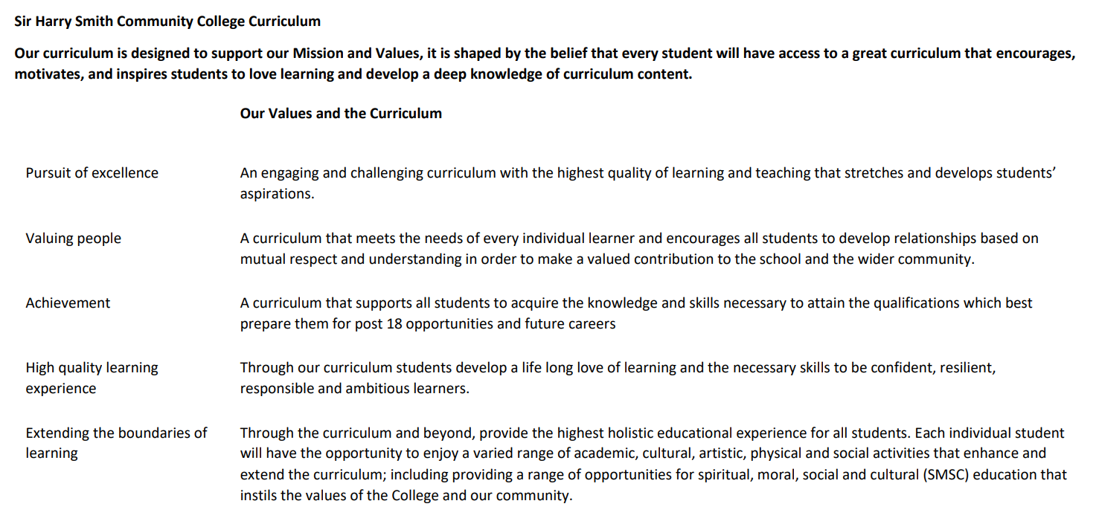

Sir Harry Smith Community College Curriculum Map SUBJECT: English YEAR 10 2022-23
Curriculum Intent:
English aims to develop independent learners with cultural and emotional understanding of the world they live in, gained through the study of a range of texts. The curriculum is designed and delivered to promote intellectual curiosity amongst all students. We aim for our learners to be able to confidently communicate, both verbally and in writing, in a range of forms, purposes, genres and to a range of audiences. Our learners should be asking and answering new questions which they have engaged with through a wide range of whole texts studied. Etymology is considered in order to promote wider vocabulary and appreciation of the history of the English Language. In English we always aim to encourage a love of reading which develops articulate and analytical students with a wide range of vocabulary, including subject terminology, to allow them to become life-long learners.
School Values | Curriculum Focus | LITERATURE PAPER 1  19th Century Novel and Shakespeare | LITERATURE PAPER 2  Modern Text | LITERATURE PAPER 2  Poetry Anthology and Unseen Poetry
High Quality Learning Experience | Literacy Skills and Key Vocabulary | analytical sentences  thesis statements  multi paragraph outlines  paragraph cohesion  paragraph coherence  comparative sentences  supporting details  embedded quotations  expanding sentences  multiple interpretations  succinct use of expert vocabulary | analytical sentences  thesis statements  multi paragraph outlines  paragraph cohesion  paragraph coherence  comparative sentences  supporting details  embedded quotations  expanding sentences  multiple interpretations  succinct use of expert vocabulary | analytical sentences  thesis statements  multi paragraph outlines  paragraph cohesion  paragraph coherence  comparative sentences  supporting details  embedded quotations  expanding sentences  multiple interpretations  succinct use of expert vocabulary
Pursuit of Excellence | Knowledge and Skills | Knowledge of how historical, social and political contexts impact reception and understanding of texts. Understanding and appreciation of significant works and literary traditions that inform British heritage. Literature is taught as a pedagogical tool or an instrument for understanding and questioning the world around us.  The plot and characters of A Christmas Carol or The Strange Case of Dr Jekyll and Mr Hyde.  The context of the text.  Themes: poverty, inequality, religion, crime and punishment, betrayal, fate vs free will, power and persuasion, charity, kindness, death  Form and genre: bildungsroman, novella, protagonist/hero, melodramatic, satire, vulnerable society, social criticism  Language and structural devices: dramatic irony, symbolism, repetition, emotive language, sensory language, imagery, dialogue Rhetoric (inc. ethos, logos and pathos)  -  The plot and characters of Macbeth. The context and real story behind Macbeth.  Themes: war, betrayal, fate vs free will, power and persuasion  Form and genre: tragedy, tragic protagonist/hero, fatal flaw (hamartia), pride (hubris), release of emotions (catharsis), Aristotle, Machiavellian villains  Language and structural devices: dramatic irony, symbolism, repetition, emotive language Rhetoric (inc. ethos, logos and pathos), asides and soliloquies | Knowledge of how historical, social and political contexts impact reception and understanding of texts.  Understanding and appreciation of significant works and literary traditions that inform British heritage. Literature is taught as a pedagogical tool or an instrument for understanding and questioning the world around us.  The plot and characters of Blood Brothers or An Inspector Calls.  The context of the text.  Themes: poverty, inequality, religion, crime and punishment, betrayal, fate vs free will, pride, power and persuasion, violence, charity, kindness, death, manipulation, the role of women, responsibility, generation divide, class system, war.  Form and genre: play, crime thriller, morality plays, protagonist/hero, dramatic irony, melodramatic, satire, vulnerable society, social criticism, tragedy, tragic protagonist/hero, fatal flaw (hamartia), pride (hubris), release of emotions (catharsis), Aristotle  Language and structural devices: dramatic irony, symbolism, repetition, emotive language, imagery, dialogue Rhetoric (inc. ethos, logos and pathos) | Knowledge of how historical, social and political contexts impact reception and understanding of texts. Understanding and appreciation of significant works and literary traditions that inform British heritage. Literature is taught as a pedagogical tool or an instrument for understanding and questioning the world around us.  The plot and characters in the poems from the AQA Poetry Anthology- Power and Conflict Collection.  The context of the texts.  Themes: poverty, inequality, religion, crime and punishment, betrayal, fate vs free will, pride, power and persuasion, violence, charity, kindness, death, manipulation, the role of women, humankind vs nature, power over people, identity, war as futile, war as a duty, the effects of war on people and family  Form and genre: poetry, vulnerable society, social criticism, tragedy, injustice, conflict, memory,  Language and structural devices: stanza, rhyme, rhyme scheme, rhythm, blank verse, imagery, metaphor, personification, zoomorphism, repetition, alliteration, listing, rhetorical questions, connotation, symbolism, enjambement, caesura, plosives, fricatives.
 | Subject specific pedagogy | Reading and discussing a range of texts, both fiction and non-fiction to explore writers’ methods and develop a critical appreciation and response to the writers’ skills. We embed opportunities to engage with texts of their own choice and through both complete texts and extracts studied in lesson to pique interest, we encourage pupils to explore Literature further to embed their love of learning.  Pupils will write some shorter and some extended pieces of work with focus on form, purpose, audience, structure and genre. Pupils are encouraged to work on extending vocabulary and developing uses of varied punctuation, sentence forms, paragraph lengths, following the example of the professional authors whose work has been studied. Pupils’ love of learning is reinforced though positive feedback.  Student will show their understanding and knowledge of texts through: group discussion, paired work, presentations to class or dramatic pieces.  Jerome Bruner, Lev Vygotsky, Jean Piaget, Benjamin Bloom, Paolo Freire, David Stevens, Lauren Berlant, James M. Clark and Allan Paivio, and others, have all influenced our pedagogy. | Reading and discussing a range of texts, both fiction and non-fiction to explore writers’ methods and develop a critical appreciation and response to the writers’ skills. We embed opportunities to engage with texts of their own choice and through both complete texts and extracts studied in lesson to pique interest, we encourage pupils to explore Literature further to embed their love of learning.  Pupils will write some shorter and some extended pieces of work with focus on form, purpose, audience, structure and genre. Pupils are encouraged to work on extending vocabulary and developing uses of varied punctuation, sentence forms, paragraph lengths, following the example of the professional authors whose work has been studied. Pupils’ love of learning is reinforced though positive feedback.  Student will show their understanding and knowledge of texts through: group discussion, paired work, presentations to class or dramatic pieces.  Jerome Bruner, Lev Vygotsky, Jean Piaget, Benjamin Bloom, Paolo Freire, David Stevens, Lauren Berlant, James M. Clark and Allan Paivio, and others, have all influenced our pedagogy. | Reading and discussing a range of texts, both fiction and non-fiction to explore writers’ methods and develop a critical appreciation and response to the writers’ skills. We embed opportunities to engage with texts of their own choice and through both complete texts and extracts studied in lesson to pique interest, we encourage pupils to explore Literature further to embed their love of learning.  Pupils will write some shorter and some extended pieces of work with focus on form, purpose, audience, structure and genre. Pupils are encouraged to work on extending vocabulary and developing uses of varied punctuation, sentence forms, paragraph lengths, following the example of the professional authors whose work has been studied. Pupils’ love of learning is reinforced though positive feedback.  Student will show their understanding and knowledge of texts through: group discussion, paired work, presentations to class or dramatic pieces.  Jerome Bruner, Lev Vygotsky, Jean Piaget, Benjamin Bloom, Paolo Freire, David Stevens, Lauren Berlant, James M. Clark and Allan Paivio, and others, have all influenced our pedagogy.
Extending the boundaries of learning | Cultural Capital and beyond the curriculum | Beyond the curriculum opportunities are provided to develop cultural capital through:  Macbeth Performance  Visiting Professionals talks for Enrichment  Debate club | Beyond the curriculum opportunities are provided to develop cultural capital through:  Poetry Live  Recommended performances Blood Brothers, Inspector Calls  Visiting Professionals talks for Enrichment  Debate club | Beyond the curriculum opportunities are provided to develop cultural capital through:  Poetry Live  Visiting Professionals talks for Enrichment  Debate club
Achievement | Assessment | Practice paragraphs  End of unit essay response  Mock exam | Practice paragraphs  End of unit essay response  Mock exam | Practice paragraphs  End of unit essay response  Mock exam
Valuing People | How our curriculum meets the needs of every individual | Students are assessed regularly throughout the year both formally, and informally, in classwork, assessments and mock exams, with targets specially for reading specific skills. Students are given opportunities to positively apply their targets to their work allowing them to progress.  GCSE texts are taught to all pupils.  Scaffolding (including task planners where appropriate), planning, modelling and challenging are used to make the learning accessible to all pupils. In addition, the assessments and classwork are used to help identify pupils in need of additional support to encourage ambition and aspiration for all.  In the library there are texts available for secondary reading to provide challenge and revision guides are widely available to all pupils.  Reading challenge tasks ensure that students continue to be thoughtful in their approach and execution of their work. Students receive individual targets, appropriate to their needs, and reflection time in order to consider their own personal progress.  Individual additional reading needs are identified on a regular basis and additional targeted intervention supports each students’ progress.  Where PP and SEN students have historically received support from SSD we have sought out staff guidance on bespoke differentiation techniques.  Liaise with PP, LAC officer on assigning and monitoring targets both academic and pastoral. Liaise with LAC officer, parents/guardians to aid attendance at workshops. | Students are assessed regularly throughout the year both formally, and informally, in classwork, assessments and mock exams, with targets specially for reading specific skills. Students are given opportunities to positively apply their targets to their work allowing them to progress.  GCSE texts are taught to all pupils.  Scaffolding (including task planners where appropriate), planning, modelling and challenging are used to make the learning accessible to all pupils. In addition, the assessments and classwork are used to help identify pupils in need of additional support to encourage ambition and aspiration for all.  In the library there are texts available for secondary reading to provide challenge and revision guides are widely available to all pupils.  Reading challenge tasks ensure that students continue to be thoughtful in their approach and execution of their work. Students receive individual targets, appropriate to their needs, and reflection time in order to consider their own personal progress.  Individual additional reading needs are identified on a regular basis and additional targeted intervention supports each students’ progress.  Where PP and SEN students have historically received support from SSD we have sought out staff guidance on bespoke differentiation techniques.  Liaise with PP, LAC officer on assigning and monitoring targets both academic and pastoral. Liaise with LAC officer, parents/guardians to aid attendance at workshops. | Students are assessed regularly throughout the year both formally, and informally, in classwork, assessments and mock exams, with targets specially for reading specific skills. Students are given opportunities to positively apply their targets to their work allowing them to progress.  GCSE texts are taught to all pupils.  Scaffolding (including task planners where appropriate), planning, modelling and challenging are used to make the learning accessible to all pupils. In addition, the assessments and classwork are used to help identify pupils in need of additional support to encourage ambition and aspiration for all.  In the library there are texts available for secondary reading to provide challenge and revision guides are widely available to all pupils.  Reading challenge tasks ensure that students continue to be thoughtful in their approach and execution of their work. Students receive individual targets, appropriate to their needs, and reflection time in order to consider their own personal progress.  Individual additional reading needs are identified on a regular basis and additional targeted intervention supports each students’ progress.  Where PP and SEN students have historically received support from SSD we have sought out staff guidance on bespoke differentiation techniques.  Liaise with PP, LAC officer on assigning and monitoring targets both academic and pastoral. Liaise with LAC officer, parents/guardians to aid attendance at workshops.

