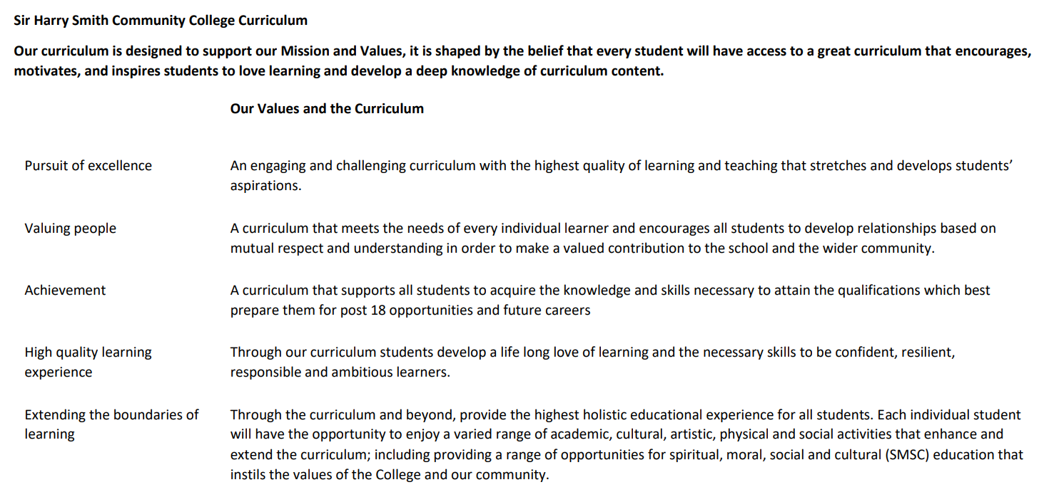

Sir Harry Smith Community College Curriculum Map SUBJECT: History YEAR 12 2022-23
Curriculum Intent:
We follow the OCR specification at A-level. The curriculum aims to build upon the knowledge and skills students gained at GCSE, while developing as historians through indepth investigations into the causes, events and consequences of the British Civil Wars/Revolution, and the Russian revolution and subsequent emergence of totalitarianism in the Soviet Union.
School Values | Curriculum Focus | Term 1 – OCR GCE History | Term 2 – OCR GCE History | Term 3 – OCR GCE History
High Quality Learning Experience | Literacy Skills and Key Vocabulary | Duma, Tsar, Absolutist, Puritan, Constitution. Students/parents should refer to the OCR specification for a full breakdown of the key terms they are required to know. In addition, teachers will be able to provide individualised feedback. | Tsar, Menshevik, Bolshevik, Arminianism. Students/parents should refer to the OCR specification for a full breakdown of the key terms they are required to know. In addition, teachers will be able to provide individualised feedback. | Stalin, Trotsky, Communism, Dictatorship, Interregnum. Students/parents should refer to the OCR specification for a full breakdown of the key terms they are required to know. In addition, teachers will be able to provide individualised feedback.
Pursuit of Excellence | Knowledge and Skills | The Early Stuarts and the English Revolution 1603–1660 / Russia 1894–1941 | The Early Stuarts and the English Revolution 1603–1660 / Russia 1894–1941 | Revision of key topics in The Early Stuarts and the English Revolution 1603–1660 / Russia 1894–1941  Students begin studying for their coursework.
 | Subject specific pedagogy | Reading, note taking, discussion, debates, source analysis, essay writing, analysis of historical interpretations | Reading, note taking, discussion, debates, source analysis, essay writing, analysis of historical interpretations | Reading, note taking, discussion, debates, source analysis, essay writing, analysis of historical interpretations
Extending the boundaries of learning | Cultural Capital and beyond the curriculum | Students will gain an indepth understanding of the causes, events and consequences of the English Revolution, helping students to understand the evolution of our parliamentary system. Students will also understand the causes, events and consequences of the Russian revolution and the establishment of Communism in Russia, helping to understand much about Russia in the modern day. | Students will gain an indepth understanding of the causes, events and consequences of the English Revolution, helping students to understand the evolution of our parliamentary system. Students will also understand the causes, events and consequences of the Russian revolution and the establishment of Communism in Russia, helping to understand much about Russia in the modern day. | Students will gain an indepth understanding of the causes, events and consequences of the English Revolution, helping students to understand the evolution of our parliamentary system. Students will also understand the causes, events and consequences of the Russian revolution and the establishment of Communism in Russia, helping to understand much about Russia in the modern day.
Achievement | Assessment | Regular, timed essays – at least two per half term for each unit. | Regular, timed essays – at least two per half term for each unit. | Regular, timed essays – at least two per half term for each unit.  Mocks exams – full Paper 1 and Paper 2 exams.  Beginning coursework.
Valuing People | How our curriculum meets the needs of every individual | Students will be supported to access the demands of A-level History by receiving the resources they need – free textbooks are provided for every student to ensure all can access the curriculum, and all students are given free access to History Today. G&T students are supported by provision of extensive independent study resources, such as a wide variety of books to borrow, podcasts and films. Lower ability and SEND students are supported through extensive modelling/scaffolding and feedback of essays to enable students to improve. In addition, we explicitly teach note taking and independent study skills to enable students to succeed.

