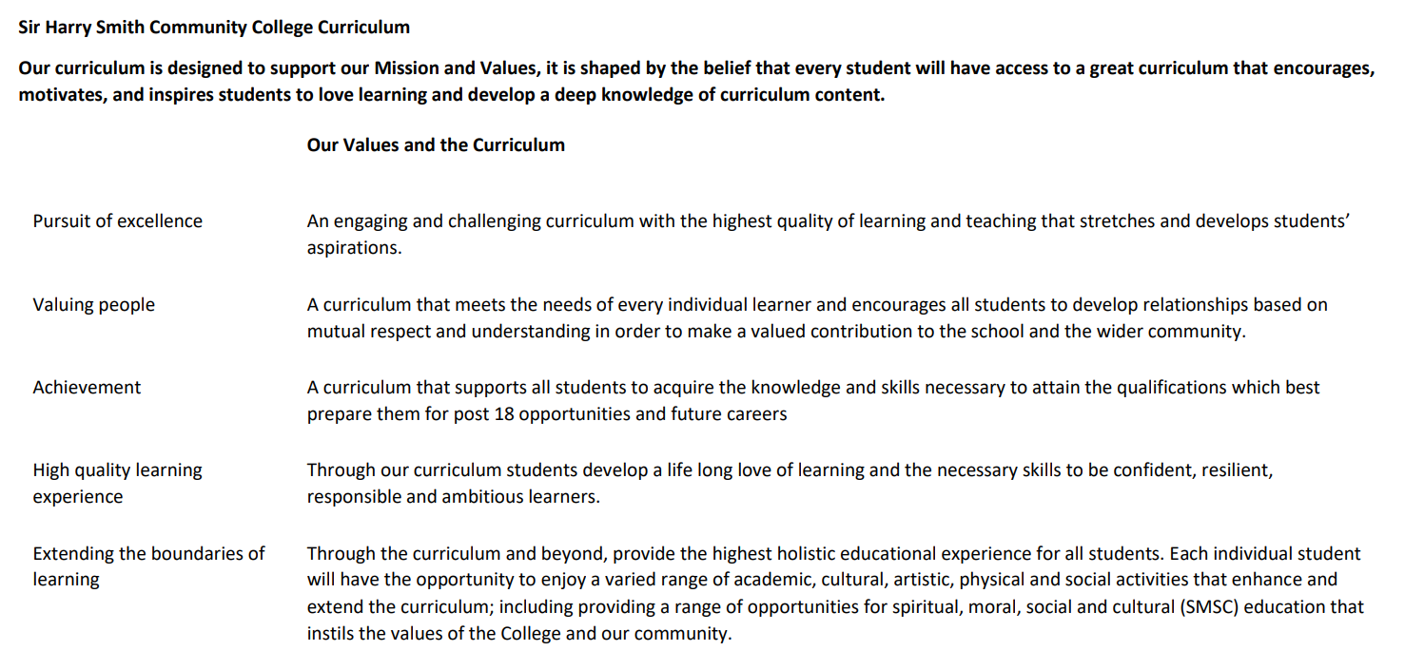

Sir Harry Smith Community College Curriculum Map SUBJECT: French YEAR 11 2022-23
Curriculum Intent: to introduce students to the French language, so that they are able to communicate with others and share basic information about their own lives. They will gain an insight to the differences between their own country’s traditions and how the same celebrations are different in another culture. This aids students to appreciate their own culture, as well as improving cross cultural understanding, thus having an international awareness. To gain confidence in speaking and understanding another language and develop literacy and communication skills in their own and another language. Preparing students for the wider world of work or study.
School Values | Curriculum Focus | Term 1 – future Plans and environment & mock preparation | Term 2 – speaking mock, world of work, technology | Term 3 – exam technique, practising for speaking exam
High Quality Learning Experience | Literacy Skills and Key Vocabulary | Future plans after school  Our planet  Looking at world problems affecting us all  How to protect our environment  Volunteering / charity work  Community projects – local, national & international  Near and simple future tenses  Understanding the subjunctive  Conditional tenses  Direct object pronouns  Indirect object pronouns  Qui, que, dont  Revision of present, past: perfect & imperfect, future: near & simple, conditional tenses  Making connections between word types  Modal verbs  Conjunctions  Comparatives  Superlatives  Forming questions  Numbers, dates  Mock preparation | Job and work preferences  Career choices  Applying for jobs  Looking at job adverts  Looking at someone else’s career path  Social media and technology at home and in school  radio  Revision of masc & fem nouns  Revision of jobs and no use of article  Revision of:  conditional tense  Superlatives – the best, the worst  present, past: perfect & imperfect, future: near & simple tenses – regular and irregular verbs  direct object pronouns  Comparative adjectives  modal verbs  conjunctions  numbers  question forming  Thorough revision of the types of speaking tasks: role play, photocard and general conversation topic questions  Thorough revisions of the types of writing tasks: 4 sentences, 40 words, 90 words and 150 words  Practise of different types of listening and reading tasks highlighted as possible issues during mock exams | Thorough revision of present, past: perfect and imperfect, conditional, future tenses  Thorough revision of the types of speaking tasks: role play, photocard and general conversation topic questions  Thorough revisions of the types of writing tasks: 4 sentences, 40 words, 90 words and 150 words  Practise of different types of listening and reading tasks highlighted as possible issues during mock exams
Pursuit of Excellence | Knowledge and Skills | Students will learn vocabulary and short phrases in a number of ways  - listening  - repeating  - listening and reading comprehensions  - translations both into and from English and the Target Language  - looking at how language is formed into a sentence and the grammatical elements needed e.g. verb, subject  - writing with a scaffold and freely.  - This will be supported with online games and recap and retrieval activities and student led activities  Students should be able to  - talk about their personal future plans regarding marriage and children  - Identify the different types of environmental issues that are in school  - Look at possible solutions to school issues and discuss how these could come into being  - Look at environmental issues on a world stage  - Discuss how they affect everyone’s lives and what kind of action can be taken to stop / prevent / slow down the impact of this  - Express views on ethical shopping and sustainability  - Investigate forms of charity work, both on a local, national and international stage  - Talk about the types of charity work you may consider doing  - Understand and discuss a charitable event  - Discuss sports events or festivals that you may have attended, attend or will attend in the future  - Exam preparation for listening, reading and writing | Students will learn vocabulary and short phrases in a number of ways  - listening  - repeating  - listening and reading comprehensions  - translations both into and from English and the Target Language  - looking at how language is formed into a sentence and the grammatical elements needed e.g. verb, subject  - writing with a scaffold and freely.  - This will be supported with online games and recap and retrieval activities and student led activities  Students should be able to  - Talk about jobs that they may have, other people in their family have, they have done in the past or will / would like to do in the future  - Speak or write in a logical way using sequencers to add to fluency  - Understand someone else’s career path and be able to report back what they have found out  - Understand adverts for different jobs  - Apply or attend an interview for different types of part time / holiday jobs  - Talk about what social media and technology can be used for in their daily life  - How often they and other people use technology – may be comparisons to past usage as a child or usage of a parent / grandparent  - Discuss the advantages and disadvantages of using social media and technology  - Exam preparation for the speaking exam with lots of practise for role plays, photocards and general conversation questions  - Exam preparation for translations especially English to German and German to English  - Revision of key vocabulary and phrases that cause issues / confusion in exams  - Extensive revision of types of listening and reading exercises that show up a weakness in exam conditions  - Exam practise of writing tasks of all sorts – 4 sentences, 40 words, 90 words and 150 words | Students will feel confident to approach all elements of their exams:  Listening, they will be well practised in a variety of different types of exercise across the full range of topics  Reading, they will be well practised in a variety of different types of exercise across the full range of topics. They will also practise translating from German into English in a range of different formats – e.g.1 pen, 1 dice, tarsea, missing words, missing letters  Speaking, they will be well practised in all 3 tasks: role play, photocard and general conversations questions  Writing, they will be well practised in all tasks necessary for their tier of examination:  4 sentences, 40 words, 90 words and translation form English into French  OR  90 words, 150 words and translation from English into French
 | Subject specific pedagogy | Students will encounter  - recap and retrieval activities e.g. 5 a day, boggle, vocabulary races  regular revisiting and exposure to vocabulary and structures embeds knowledge  - student led activities, where they can talk to the teacher and others e.g. tarsea, one pen one dice, speed dating  Specific grammar teaching of  - Future tenses: near & simple  - Understanding subjunctive  - Revision of the conditional tense  - Direct object pronouns  - Indirect object pronouns  - Qui, que, dont  - Making connections between word types  - Modal verbs  - Revision of present, past: perfect & imperfect tenses  - Comparative adjectives  - Superlative adjectives  - conjunctions  - Forming questions  - Numbers and dates | Students will encounter  - recap and retrieval activities e.g. 5 a day, boggle, vocabulary races  regular revisiting and exposure to vocabulary and structures embeds knowledge  - student led activities, where they can talk to the teacher and others e.g. tarsea, one pen one dice, speed dating  Specific grammar teaching of  - nouns – masc & fem versions  - jobs – no article  - conjunctions  - intensifiers  - present, past: perfect & imperfect, future: near & simple, conditional tenses  - comparative adjectives  - superlative adjectives  - conjunctions  - forming questions  - numbers and dates  - modal verbs  - opinions  - justifications | Students will encounter  - past papers  - example exercises from past papers  - sample questions  - sample answers  - mark schemes  - annotated answers  - marked work  Specific Grammar revision of  - present tense  - past perfect tense  - past imperfect tense  - future tense  - conditional tense  - Nouns and genders  - Adjective agreement  - conjunctions  - opinions  - justifications  - Numbers  - intensifiers  - comparatives  - Superlatives  - Modal verbs  - Reflexive verbs  - Time phrases
Extending the boundaries of learning | Cultural Capital and beyond the curriculum | All students will have the opportunity to take part in the European Day of Languages celebrations and tasks. | Students will be offered the opportunity to take part in the French trip to Paris in February  Opportunity to support or lead in the craft club
Achievement | Assessment | - Mock exams in listening, reading, writing  - Speaking practise assessment tasks will be incorporated in to lessons  - Written pieces will be completed through out the term on various topics of varying lengths  - Translations from French to English and English to French | - Mock speaking exam  - End of course exams in listening, reading and writing | Final GCSE exams:  Listening  Speaking  Reading  writing
Valuing People | How our curriculum meets the needs of every individual | We have high expectations for all of our students and work in a step by step progression, building up from simple words to units of language and sentences before adding in more complicated constructions. We also offer some favourite, well known books in the library in German to encourage students to read for pleasure in German. | We have high expectations for all of our students and work in a step by step progression, building up from simple words to units of language and sentences before adding in more complicated constructions. We also offer some favourite, well known books in the library in German to encourage students to read for pleasure in German. | We have high expectations for all of our students and work in a step by step progression, building up from simple words to units of language and sentences before adding in more complicated constructions. We also offer some favourite, well known books in the library in German to encourage students to read for pleasure in German.

