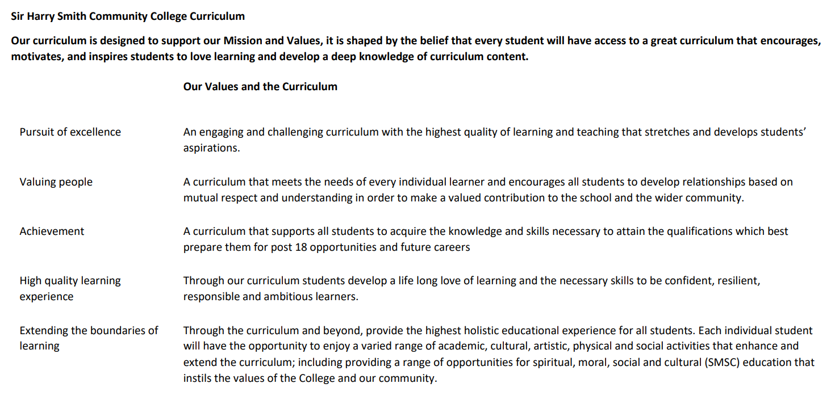

Sir Harry Smith Community College Curriculum Map SUBJECT: Art YEAR 8 2022-23
Curriculum Intent:
Statement of Intent:
To engage, inspire and challenge pupils, equipping them with the knowledge and skills to experiment, invent and create their own works of art, craft and design. To not only teach students to become technically proficient but to enable them to adopt a creative approach to how they use materials. To enable students to break boundaries and become playful and enjoy the journey of discovery.
We want to foster an environment where all students know their opinions are valid. Where the same students believe in their opinions and can confidently put these forwards, accepting others viewpoints, beliefs and reasons. For them to appreciate their own place in the art world and to know how art as a whole has a cultural impact far beyond Galleries, Museums and textbooks.
Student’s horizons will be broadened to help realise the huge possibility of careers in the art community. Being able to join the dots from the tasks and projects in KS3, 4 and 5 and seeing how these relate to careers within the creative industries. Developing a love of learning in art that inspires further practice at KS4, 5 and further education. We want students to know the validity and possibility of being an artist or designers and creatives. Having confidence that it isn’t just something other people do, raising their aspirations that it could include them.
To maintain good working relationships between staff, students and parents. Continue to work in partnership with others such as the Methodist Church, Whittlesey Festival organisers and the community. For students to develop relationships based on mutual respect and understanding. Students will learn to discuss, resolve, compromise and empathise within a safe environment.
We want to develop students to be independent learners to be self-motivated and take their love of art beyond the class room. To be playful, inventive and creative with their work and to enjoy the rewards of experimenting with and pushing media, materials and practices.

School Values | Curriculum Focus | Term 1 – Pixar Mythological Creature Project | Term 2 – Pop Art: Andy Warhol/ Marvel Superhero project. | Term 3 – Art Deco
High Quality Learning Experience | Literacy Skills and Key Vocabulary | Literacy skills:  - To be able to analyse their own work.  - To be able to evaluate other’s work.  - To be able to talk and write about, composition, mood, meaning and the formal elements.  Vocabulary:  Texture, Pattern, Line, Form , colour, Value, Tone, Scale, Graduation, Impasto. Balance, Proportion, Landmark, Composition, Pigment, Complimentary, Contrasting, Harmonising, Analogous, Monochromatic. Blended, legend, Atmosphere, Mood, Surface, Highlights, Shadow. | Literacy skills:  - To be able to analyse their own work.  - To be able to evaluate other’s work.  - To be able to talk and write about, composition, mood, meaning and the formal elements.  Vocabulary:  Texture, Pattern, Line, Form , colour, Value, Tone, Scale, Graduation, Impasto. Balance, Proportion, Composition, Pigment, Complimentary, Contrasting, Harmonising, Analogous, Monochromatic. Blended, legend, Atmosphere, Mood, Surface, Highlights, Shadow. | Literacy skills:  - To be able to analyse their own work.  - To be able to evaluate other’s work.  - To be able to talk and write about, composition, mood, meaning and the formal elements.  Vocabulary:  Art Deco, Art Nouveau  Texture, Pattern, Line, Form , colour, Value, Tone, Scale, Balance, Symmetry, Proportion, Composition, Pigment, Wedging, rolling, carving, joining, drying, finishing and glazing.  Leather hard, Raw materials, Bisque, Plastic, fire, Kiln. Glaze, Stoneware, Earthenware, Porcelain, Modelling,  Slip, Scoring,
Pursuit of Excellence | Knowledge and Skills | Knowledge:  Students will gain knowledge of Pixar and the design processes that go into a multibillion dollar movie company. They will gain knowledge of how practitioner develop ideas and characters and how this relates to tangible aspects of year 8 art. Raising aspirations for what can be achieved through the study of art and design.  Students will learn about the artist, illustrator and puppet maker Brian Froud. They will learn about his life and understand about his design process and its connection to the natural world.  Students will learn how to respond to art and to consider elements of the work. Students will talk and write about what they think.  Students gain knowledge of the creative industries and how these fit into the art world they are studying.  Students will study Arthur Rackham, learning about his life and how this fed in to his illustrative work.  Students will learn about the formal elements of art. Line, Form, Texture, Pattern, Colour and Value. This topic will focus mainly on Form, Texture, Tone and surface.  Skills:  Drawing, Mark Making, Proportion, shading, Colour mixing, Paintbrush control. Watercolour techniques, Pen washes, artist research, working to a brief. | Knowledge:  Students will learn about Pop Art and significant artists that contributed to the art movement; Andy Warhol and Roy Lichtenstein.  Students will learn to recognise popular art from this period.  Students will understand the characteristics of art from this movement.  Students will learn about the artist Andy Warhol and will learn what his work looks like. They will then create a series of works inspired by his soup cans.  Students will learn about the artist Roy Lichtenstein and will have their ideas about stealing ideas in art challenged. Students will learn about the rise of Marvel Comics and the artists that made it successful.  Students will learn how to design a superhero outfit in a pop art style including the logo and mask. Through this process students will be asked to develop their ideas rather than use the first design they draw.  Students will be introduced to onomatopoeia in art and create their own.  Students will learn more about facial proportion when they complete their comic book portrait.  Skills:  Proportion, Measuring, Blending  Drawing, Shading, Layering colour, Painting, Collage, Pen work, Printing, | Knowledge: Art Deco  Students will learn about the Art Deco movement. They will learn to recognise paintings, sculpture, architecture, furniture, jewellery from the Art Deco Movement. They will understand how the movement fits into history.  Students will know and understand the basic elements of clay. How to manipulate clay. In the process of designing and creating an Art Deco inspired clay tile students will understand about different types of clay and their properties. Students will know the difference between Earthenware and Stoneware clay.  They will learn about the different stages of clay: raw, slip, plastic. Leather, dry, bisque and glazed.  Skills:  Wedging, rolling, carving, joining, drying, finishing and glazing. Understanding the elements of the clay and manipulating it a the right stage. (ie, Leatherhard)
 | Subject specific pedagogy | Activities that students will undertake:  Creative Thinking/ Independent work/ Group work/ Team work/  Analysis and Evaluation/ Peer Assessment/ Self-Assessment/ Practical work/ Experimenting/ Development work.  Making links to real practitioners with in the creative industries we aim to foster a love making that is underpinned by exploration of idea and media. We model techniques to demonstrate the standard to aim for. We link the knowledge to the practical application of each topic
Extending the boundaries of learning | Cultural Capital and beyond the curriculum | Students can attend art club that will further stretch and challenge their skills.  We run an Art Arts Award which is well attended every Tuesday. There are several art exhibitions a year where students can show their work.  There is an opportunity to attend an arts trip to a gallery, exhibition or sculpture park.  Students have the opportunity to exhibit at the Whittlesey Festival where their work can be seen by the entire community. This is also a competition with prizes.  A selection of student’s work is exhibited at the expressive arts evening.
Achievement | Assessment | Assessment:  This topic has individual success criteria based on the knowledge and skills taught. This topic has individual success criteria based on the knowledge and skills taught. Students are made aware in advance of the success criteria and given feedback on how to improve against this criteria.  Before each data drop we assess student’s overall progess on four areas. (See Below)  AO1 - Show you can analyse and evaluate your own and others artist’s work. Create and develop your own artwork inspired by that artist. Show progress with your ideas.  AO2 – Create work using lots of different media, materials, techniques and ways of working. Improve your artistic skills and ideas as you explore.  AO3 – Record ideas and observations relevant to the topic by drawing, taking photos, collecting images and writing. Work should be presented well and artwork should demonstrate ability.  AO4 – Create a final artwork that you have been planning. You should show skill in the formal elements such as line, value, shape, form, texture, pattern and colour.
Valuing People | How our curriculum meets the needs of every individual | Meeting Needs:  All students will participate in the learning through experimental and practical tasks.  Students who struggle with drawing or other skills or learning are supported with help-sheets / templates so they can develop other skills without being hindered. We are quick to respond to students who require additional adjustments to access the learning. Individual feedback is given regularly.  We provide word banks and sentence starters and support with how to write evaluations and analysis to every student.  We motivate and reward progress and effort each lesson by awarding positive slips on BW in line with the behaviour policy. We also award an Artist of the Week Certificate every lesson. This will also mean the student will be given an Gold on BW. Students are always keen to attain the certificate.

