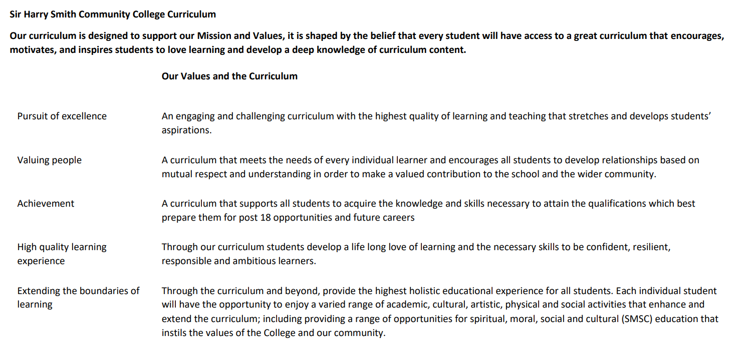

Sir Harry Smith Community College Curriculum Map SUBJECT: Science YEAR 8
Curriculum Intent: To provide a knowledge rich, spiral curriculum through inclusive science lessons that fit and expand our learner’s context in an environment that builds resilience

School Values | Curriculum Focus | Term 1 | Term 2 | Term 3
High Quality Learning Experience | Key Vocabulary | How Science Works  Hypothesis, variable, line of best fit, data, audience, evidence, peer review, bias, benefit, reasoning, model, theory, argumentation  Forces  Contact, non-contact, newton, Hookes’ law, deformation, pivot, moment, pressure, fluid, upthrust, stress  Matter  Element, atom, compound, molecule, formula, polymer, synthetic, periodic table, alkali metals, halogens, noble gases, inert  Organisms  Gas exchange, respiration, diaphragm, drug, alcohol, passive smoking, depressant, stimulant, nutrient, digestion, villi, bacteria, enzyme | Electromagnets  Magnet, field, pole, solenoid, magnetise, circuit breaker, loudspeaker  Energy  Work, deform, lever, thermal store, thermometer, conduction, convection, radiation, insulator  Reactions  Reactant, product, conserved, combustion, fuel, thermal decomposition, conservation, endothermic, exothermic, chemical bond  Ecosystems  Aerobic, anaerobic, respiration, oxygen debt, fermentation, biotechnology, photosynthesis, chlorophyll, stomata, nitrates, phosphates, fertiliser | Waves  Compression, rarefaction, longitudinal, transverse, electromagnetic spectrum, radiation, transmission, superimpose  Earth  Atmosphere, greenhouse effect, climate change, carbon cycle, natural resources, ore, recycling  Genes  Evolution, fossil, natural selection, peer review, extinction, competition, survival, endangered, conservation, inherited, characteristics, DNA, genes, alleles, dominant, recessive, genetic modification

Pursuit of Excellence | Substantive Knowledge  COMPOSITES | Use data and evidence to inform theory  Link forces to pressure  Have a working knowledge that the periodic table is an organised picture of the elements based on properties  Explain what the human body requires to stay healthy | Explain the behaviour of magnets and how they can be used to generate electricity  Use knowledge of energy to reduce transfers  Bonds are broken and made in a chemical reaction  Describe how plants and animals get the energy they need to grow and develop | Compare transverse and longitudinal waves  Human activity affects the earth  The way animals and plants look now is based on random mutations
 | Substantive Knowledge  COMPONENTS  (Examples, this is not an exhaustive list) | Decide on data to be collected based on independent and dependant variables  Forces can deform objects through compression or tension  The turning force around a pivot is called moment and the further from the pivot a force is applied the greater the moment  Define element, mixture, and compound  Count the number of atoms of an element in a chemical formula  The percentage of oxygen we exhale is less than we inhale, and the percentage of CO₂ increases in exhaled air  Describe enzymes as special proteins that break down molecules | Describe how magnetic field lines tell you about direction and strength of the magnetic field  Describe how to make an electromagnet  Work is a calculation to show how much energy has been transferred and it equals force x distance  Movement of particles transfers thermal energy in objects  The number of atoms on each side of a chemical equation must be the same  Molecules can broken down using heat. This is thermal decomposition.  Compare aerobic and anaerobic respiration.  Describe how plants use minerals for healthy growth and explain why we use fertilisers. | Describe a sound wave as a series of compressions and rarefactions caused by a vibration  Draw and label a transverse wave with wavelength, amplitude, peak and trough  The greenhouse effect keeps the earth warm when gases absorb radiation  Reactivity determines how we decide which method to use to extract a metal  Describe the theory of natural selection  Explain how factors can lead to the extinction of a species  Describe the relationship between DNA, genes and chromosomes
 | Disciplinary Practices | Research using a range of media such as articles, websites, and books  Draw tables correctly for data collection during practical activities  Write a method to investigate a hypothesis  Select the correct format for presenting data  Evaluate methods and models and suggest improvements  Rearrange formulae to calculate quantities such as mass, weight, and speed  Use data to support or disprove a theory  Use keywords in context to explain scientific phenomena through extended writing tasks  Draw conclusions from evidence
Extending the boundaries of learning | Cultural Capital and beyond the curriculum | Links to scientific careers and the opportunity to speak to people working in the sector  Science club  Guest speakers and workshops
Achievement | Assessment | Assessment is carried out continuously during modules using an online formative platform.  Summative assessment is carried out twice during the academic year  Students complete 10 progress tasks throughout the year which challenges their scientific literacy and formatively assesses their understanding.
Valuing People | How our curriculum meets the needs of every individual | Threshold concepts are identified for all topics.  High expectations are set for all students that they will reach these concepts.  When necessary, investigations and tasks are adapted to provide access to course content or to extend learning.

