PE DEPARTMENT
HOME SCHOOLING BOOKLET
YEAR 9 INTO 10 PREPARATION FOR CAMBRIDGE NATIONALS LEVEL 1/2 SPORT STUDIES

NAME________________________________________________

UNIT 1 –RO51
This unit is made up of the following Learning outcomes.

This booklet will take you through the first learning outcome.

LO1- UNDERSTAND THE ISSUES WHICH AFFECT PARTICIPATION IN SPORT

Try to complete as many of the tasks as possible and read around the topics by researching for yourself. This will show your independent work and help you gain more knowledge of the subject.
As this Unit is examined it will be vitally important for you to have a good understanding.

Learning Outcome 1 - Understand the issues which affect participation in sport

This learning outcome is all about you understanding the issues that can affect the amount of people participating in sport.
- You need to understand what stops people from participating (BARRIERS)
- You need to understand how we can remove the barrier and find SOLUTIONS to participation.
- You need to be able to understand WHY PEOPLE WANT TO TAKE PART IN SPORT
- You need to know WHAT MAKES A SPORT POPULAR/UNPOPULAR and HOW YOU CAN INCREASE THE POPULARITY OF IT.
USER GROUPS
To make it as simple as possible we create user groups of people who want to take part in sport. A demographic.
- This makes it easy to identify a group of people who all face the same/similar barriers to taking part in sport.
- It also allows you to find similar solutions to these barriers for the same collective group.

Task 1
A social/User group is a collection of people who interact with each other and share similar characteristics. E.g. Teenagers, Ethic Minorities, Children.

Identify on the pictures below the social/user groups that may have issues getting into sport.
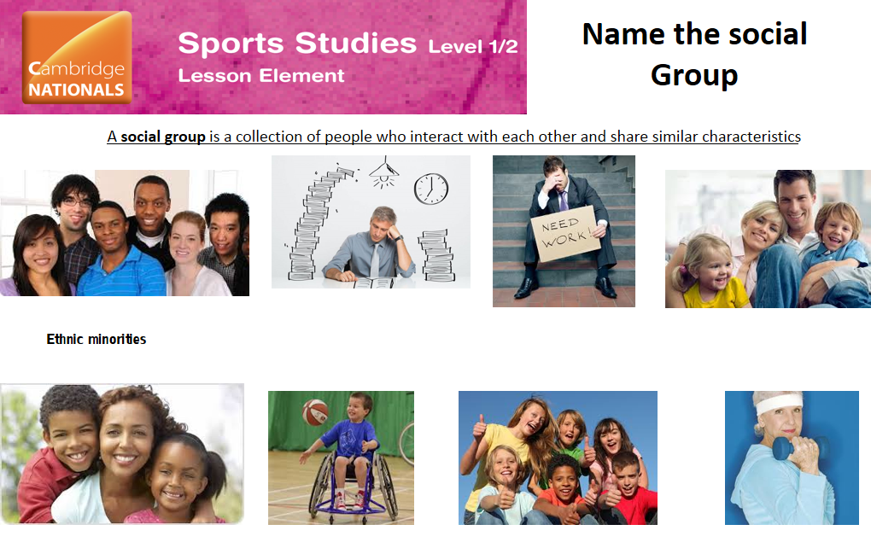
Use the table of user groups below to check your answers.

TABLE OF SOCIAL/USER GROUPS
ETHNIC MINORITIES | WORKING PEOPLE
UNEMPLOYED/ECONOMICALLY DISADVANTAGES | DISABLED PEOPLE
TEENAGERS | CHILDREN
SINGLE PARENTS | FAMILIES WITH YOUNG CHILDREN
RETIRED PEOPLE/OVER 50’S

Task 2

Give a description of each user group in the table below.

BARRIERS

Task 3
Now that we have identified the social/user groups we need to discuss the barriers that stop them from participating in sport.
1.TEENAGERS:

2. ETHNIC MINORITIES:

3.CHILDREN:

4. SINGLE PARENTS

5. RETIRED PEOPLE/OVER 50’S

Either discuss with somebody at home or investigate/think for yourself what barriers each of the following user groups will have that may stop them from taking part in sport.
You may note that some may be the same. Write these in the table below.

Task 4
Using the BARRIERS listed below, create mini mind maps of all the BARRIERS that might affect each of the GROUPS (add your own arrows).
- Lack of time ie too many other things to do with their time.
- Other commitments ie other things that have to be done first, may then lead to lack of time to play sport.
- Lack of disposable income ie can’t afford the price of the activity and perhaps the equipment that is needed to do it.
- Lack of access ie can’t get transport to or into the building where the activity is.
- Lack of role models ie no one to look up to who would inspire them to take part in sport
- Lack of provision ie not many/any activities that would suit that group of people
- Lack of awareness of what is available ie do they know what is available for them? If not they won’t take part.
- Stereotyping ie simplistic and perhaps biased view of some sports suiting certain groups and so no encouragement to take part.
MINDMAP OF USER GROUPS AND THEIR BARRIERS
ETHNIC MINORITIES | WORKING PEOPLE
UNEMPLOYED/ECONOMICALLY DISADVANTAGES | DISABLED PEOPLE
MINDMAP OF USER GROUPS AND THEIR BARRIERS
TEENAGERS | CHILDREN
SINGLE PARENTS | FAMILIES WITH YOUNG CHILDREN
RETIRED PEOPLE/OVER 50’S

SOLUTIONS TO THE BARRIERS

Task 5
Research what each of the following mean.
Solutions
- Provision of suitable sessions that meet user needs

- Concessionary pricing

- Targeted advertising

- Programming of sessions

- Ramps and hoist equipment.

Task 6
Offer a solution to each barrier below… (write in full sentences using the barrier within your answer).
- Teenager that can’t manage to access the closest sport centre which is two miles away.

- Single parent who works full time who wants to play sport more.

- Retired female who wants to join a gym but only has a pension.

- Disabled person who wants to play sport but is unable to at a local leisure centre.

- Someone from an ethnic group who wants to do sport but doesn’t know anyone else who does it or plays professionally.

Task 7
A local sports centre has facilities for football, swimming, badminton and fitness training. In each of the following case studies there are barriers to participation for different people that might use the centre. Can you identify the barriers and propose ways that the sports centre management might remove or reduce the impact of these barriers?

Case Study One
Melanie is a single parent. She works full-time and spends a lot of her income on childcare and running the home. She has some time available in the evenings and occasionally she could get a family relation to look after her two children if required, although they could not do this on a regular basis.
What are the potential barriers?
.......................................................................................................................................................................
.......................................................................................................................................................................
.......................................................................................................................................................................
.......................................................................................................................................................................
.......................................................................................................................................................................
.......................................................................................................................................................................
......................................................................................................................................................................
......................................................................................................................................................................
.......................................................................................................................................................................
......................................................................................................................................................................
......................................................................................................................................................................
What solutions would you propose to remove or reduce the impact of these barriers?
.......................................................................................................................................................................
......................................................................................................................................................................
...................................................................................................................................................................... .......................................................................................................................................................................
.......................................................................................................................................................................
.......................................................................................................................................................................

Case Study Two
Waqar lives with his partner and works in an office in the city. He travels to work by train every day, leaving the house at 7.00 a.m. and not returning until 7.00 p.m. His partner complains that she rarely sees him these days. For the last few years he has played five-a-side football with his friends two nights a week. However he has recently given this up as he is too tired after work. He has noticed that he has gained weight recently.

What are the potential barriers?
.......................................................................................................................................................................
.......................................................................................................................................................................
....................................................................................................................................................................... .......................................................................................................................................................................
.......................................................................................................................................................................
....................................................................................................................................................................... .......................................................................................................................................................................
.......................................................................................................................................................................
....................................................................................................................................................................... .......................................................................................................................................................................
.......................................................................................................................................................................
.......................................................................................................................................................................
What solutions would you propose to remove or reduce the impact of these barriers?
.......................................................................................................................................................................
.......................................................................................................................................................................
....................................................................................................................................................................... .......................................................................................................................................................................
....................................................................................................................................................................... .......................................................................................................................................................................
.......................................................................................................................................................................
.......................................................................................................................................................................

Factors that have an Impact on the popularity of a sport

Task 8
Draw lead lines to match the factors listed with the pictures.

Task 9
Investigate the media and sport. Below are some prompts as to what you can find out.
- What sports are shown the most on TV?
- What channels are they shown on? Terrestrial or satellite?
- What sports are on popular satellite channels vs lessor known channels?
- What other areas of the media report on sport?
- What sports does it mainly report about?
- Is there a gender gap in the reporting of sport in the media?
- How does this affect the popularity of sport?

Task 10
Look at the table below. Describe what it shows.
Explain why this information is important if you wish to find ways to increase the popularity of a sport.
Choose a sport from the table and suggest ways in which you could improve the popularity of this sport.

Task 11
Answer the following question in full sentences.
- Football clubs now have a number of youth teams. How can this impact on popularity?

- Why might people living in the city of London find it difficult to get involved in water skiing?

Task 12
Create a poster that includes:
- A list of the sports/activities that are provided in your area.

- What is available for you to do?
- Are there a lot of opportunities? Lots of clubs?
- Or is there a lack of opportunities?
- What could be done to increase the popularity of some of the sports in your area?

NEW EMERGING SPORTS
TASK 13
Look at the slide below. Suggest why ultimate Frisbee and handball have become popular more recently.

TASK 14
Create a Mind Map using all the information you think you have learnt so far on this Learning Outcome. Add as much detail to the headings as you can,
Key areas to include are:
- User groups
- Barriers
- Solutions to barriers
- Factors that have an Impact on the popularity of a sport
- How you can increase the popularity of a sport
- New and emerging sports in the UK.

