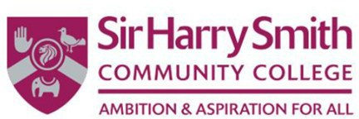 | Sixth Form Application Form 2023  INTERNAL
 | To be completed by all students wanting to study at Sir Harry Smith Community College Sixth Form. Please complete as fully as possible in black ink.

Student Details
Students Name: Form Group:
Student Destinations
Please indicate whether Sir Harry Smith is your FIRST or RESERVE choice Post 16 destination First Choice Reserve choice

Please list any other schools/further education colleges which you are intending on applying and your preferred study
programme A Levels BTEC
Other School

Do you have an idea of the career path or job you would like to do in the future?

Please indicate your current performance predicted grade and your target grade of the subjects you are currently studying below:
Subject CPP Target

Please note: Entry requirements to study A Level qualifications at Sir Harry Smith Sixth Form are 7 grade 5s at GCSE or equivalent qualifications.
Students wanting to study vocational qualifications may receive a contextualised offer.

Subjects
If selecting the Sport Diploma (equivalent to two A Levels), you must select the Sport Extended Certificate. Please
circle or highlight the 3 or 4 subjects you would like to study.
 | Vocational Qualifications | A Level Qualifications
 |  | Sociology | Computer Science
 | Health and Social Care | History | Art
 | Enterprise & Entrepreneurship |  | English Literature
 | Sport Extended Certificate
 |  | Business | Psychology
 |  | EPQ | Physics
 |  | Product Design | Biology
 | Children’s Play, Learning & |  | Geography
 |  |  | Further Maths
Please note that these choices are not binding and are subject to conditions of entry. Offers made to students are made according to these predictions and may be withdrawn if predicted grades are not met. Courses will run subject to student numbers
Supplementary information to support your application
Please provide any experience of work that you have taken part in (Part-time or voluntary)

Please include details of any activities you take part in on a regular basis

Please provide any further information that you feel would support your application

I confirm that the information contained in this application is accurate
Student Date

Parent Date
