International Cuisines

What is a cuisine?
- A “Cuisine” is a style of food characteristic to a particular country or region.
- So the foods from Chinese cuisine are very different to those from Mediterranean cuisine.
Below are pictures from 2 different country’s cuisines. Can you name them?
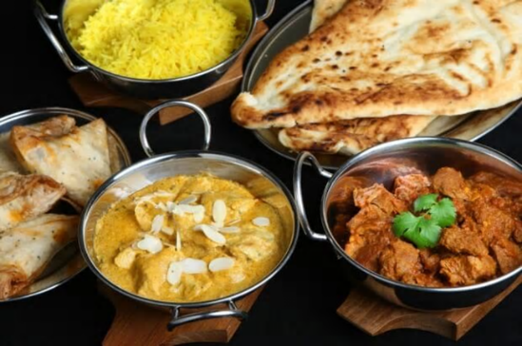
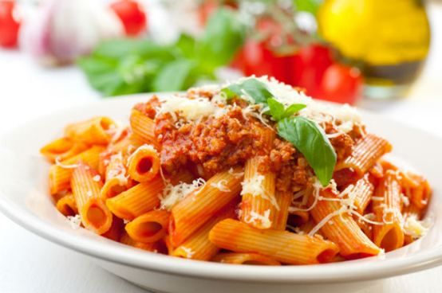

- …………………………………………………… 2. …..…………………………………………………..

Extension Task
Explain what it was about the style/ingredients of each dish that brought you to this conclusion.
………………………………………………………………………………………………………………………………………………………………………………………………………………………………………………………………………………………………………………………………………………………………………………………………………………………………………………………………………………………….……………..

During your GCSE course you will learn about Traditional British cuisine and cuisines from other countries.

Classic British cuisine also has its own style. Dishes can be from a particular region like Haggis from Scotland or Welsh cakes from Wales. Or they can be from a particular Town or County eg Yorkshire pudding or Bakewell tarts.
Come up with your own list of traditional / classic British recipes and as an extension add which region / Town / county they were originally made in.

1)………………………………………………………………..…….. 2)..…..…..…………….……………………………………………………

3)………………………………………………………………..…….. 4)..…..…..…………….……………………………………………………

5)………………………………………………………………..…….. 6)..…..…..…………….……………………………………………………

Cooking Equipment
In order to make the traditional dishes the kitchens in Britain would usually have certain pieces of equipment. These would include roasting tins for meat and vegetables, pie dishes, casserole dishes, frying pans and cake tins.

Different countries use different types / pieces of equipment in order to make their traditional recipes. A classic example would be pasta machines which Italians use to make some types of pasta.
Fill in the blanks in the table below, you may need to do a bit of research on the internet to find these out. The first has been done for you.

Country / Cuisine Type | Cooking Equipment Used
Britain | Roasting Tins
 | Chop sticks
India
 | Wok
France
 | Paellera

Why don’t we all eat the same thing?
The foods we eat are affected by a lot of factors these include:
- What ingredients are available and grow well eg islands / coastal countries catch fish
- Tradition
- Religious beliefs eg some cannot eat meat
- Temperature / climate

Research & Practical Tasks
- Investigate 2 different country’s cuisines (other than British) and produce a short report for each.
- Each report should explain whether there are different regions and what ingredients they use frequently in their cooking. You could use a map to help you with this.
- Also include the famous dishes and equipment that are associated with these cuisines.
- Produce a table of 10 dishes which you would find in each country, along with a picture of the dish and an explanation of the ingredients it contains and why they are used.
- Finally, make 1 of the dishes from each of your lists. Remember to take a picture to show how it turned out.

Below is an example of what I would expect to see:

Italian Cuisine
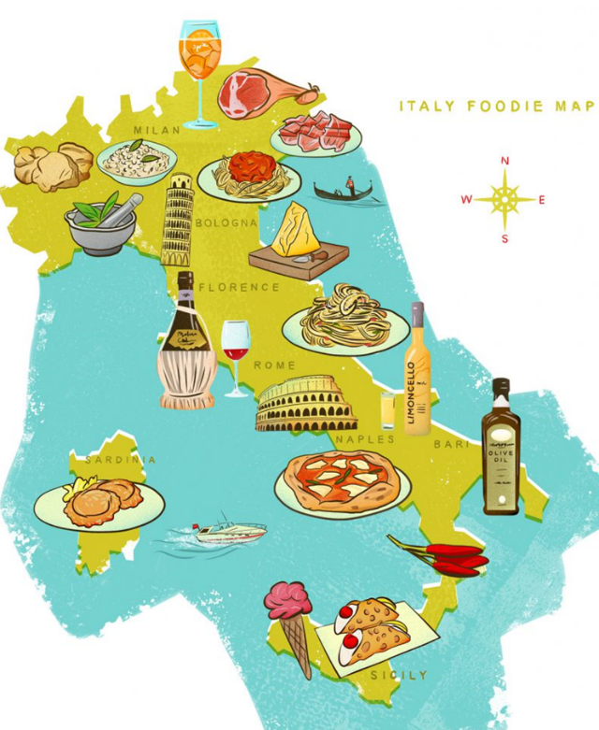
Typical foods made or grown in Italy
Bread – ciabatta
Gnocchi – potato dough
Olives – eaten fresh or preserved or oil
Tomatoes – cooked in sauces
Pasta – usually fresh, 100’s of different shapes
Arborio rice – for risotto
Fruit & Veg – eg lemons
Cheeses – mozzarella, ricotta, parmesan
Regions of Italy
Italy’s different regions have different climates. This affects what is grown and cooked there.
The North is cooler, rice is grown and more animals reared. Meat and cheese are more common in recipes here.
The South is hotter so more tomatoes, olives and lemons used.

Cooking Methods & Equipment
The 2 main cooking methods are boiling (pasta / gnocchi / sauces) and baking (pizza / bread).
Pasta & gnocchi are staple foods and need specific equipment: Pasta machine, large pasta pan, gnocchi board.

Typical Italian Dishes

Name of Dish | Picture | Why is it Italian?
- Cheese & Spinach Ravioli | 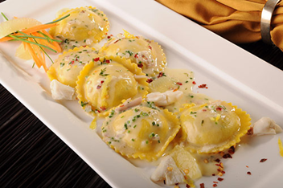 | Contains ravioli which is a type of pasta. Pasta is a staple food in Italy. The cheese used is ricotta which is an Italian soft cheese.
- Vegetable Calzone | 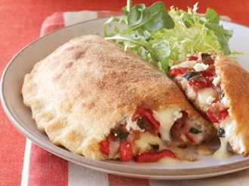 | A calzone is a folded pizza which is common in Italy. The filling includes tomatoes and mozzarella cheese, both of which are produced and used widely in Italy. The mozzarella is traditionally made from buffalo milk.
3.
4.
5.
6.
7.
8.
9.
10.

