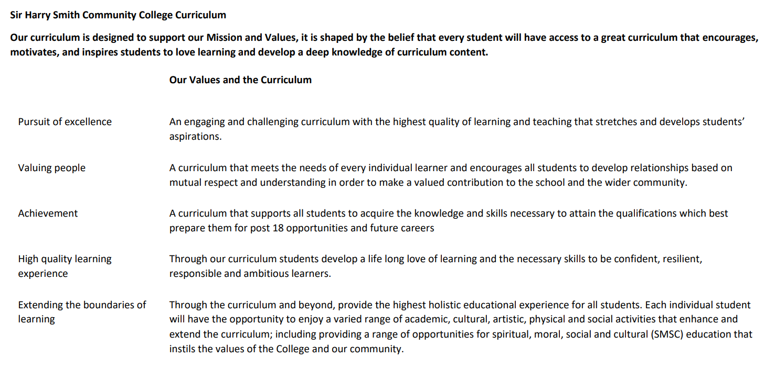

Sir Harry Smith Community College Curriculum Map SUBJECT: Applied Science YEAR 13 2022-23
Curriculum Intent: To provide a knowledge rich, spiral curriculum which gives students the skills to develop, rehearse and apply they’re scientific knowledge, whilst also developing a curiosity of the universe.

School Values | Curriculum Focus | Term 1 – [Unit 18 Microbiology, Unit 21 Product testing techniques] | Term 2 – [Unit 2 Laboratory techniques] | Term 3 – [Revision for resists if required, final amendments to coursework and moderation. ]
High Quality Learning Experience | Literacy Skills and Key Vocabulary | Pathogen, agar, autoclave, inoculating loop, incubator, antibiotic, resistance, MRSA, natural selection, bactericidal, bacteriostatic.  Legislation, product, consumer, safety, pharmacopoeia, quantitative, in vitro, in vivo, titration, extraction, reagent, analyte, indicator, immiscible, impurity, insoluble, soluble, chromatography, retention factor,
Pursuit of Excellence | Knowledge and Skills | Unit 18  LO1 1 Be able to classify and identify microorganisms.  LO2 Understand the use of microorganisms in agriculture.  Unit 21  LO1 Understand the influence of regulatory bodies on development of consumer products  LO2 Understand how product testing determines the development of consumer products | Unit 18  LO3 Be able to use microbiology in food production.  LO4 Understand the action of antimicrobials on microorganisms.  Unit 21  LO3 Be able to use quantitative titration techniques on consumer products  LO4 Be able to use extraction and separation techniques on consumer products
 | Subject specific pedagogy | -Practical investigations.  -Field trips.  -External speakers.  -Modelling
Extending the boundaries of learning | Cultural Capital and beyond the curriculum | Field trip applying sampling and analytical techniques.  Field trip to laboratories in and around Cambridge.
Achievement | Assessment | Internally assess Unit 18 by easter holidays year 2.  Internally assess Unit 21 by easter holidays year 2.
Valuing People | How our curriculum meets the needs of every individual | Wider reading available to go beyond the curriculum.  Teaching and learning is differentiated to help meet the needs of learners.  Various online platforms to help learners who fall behind or who are struggling.

