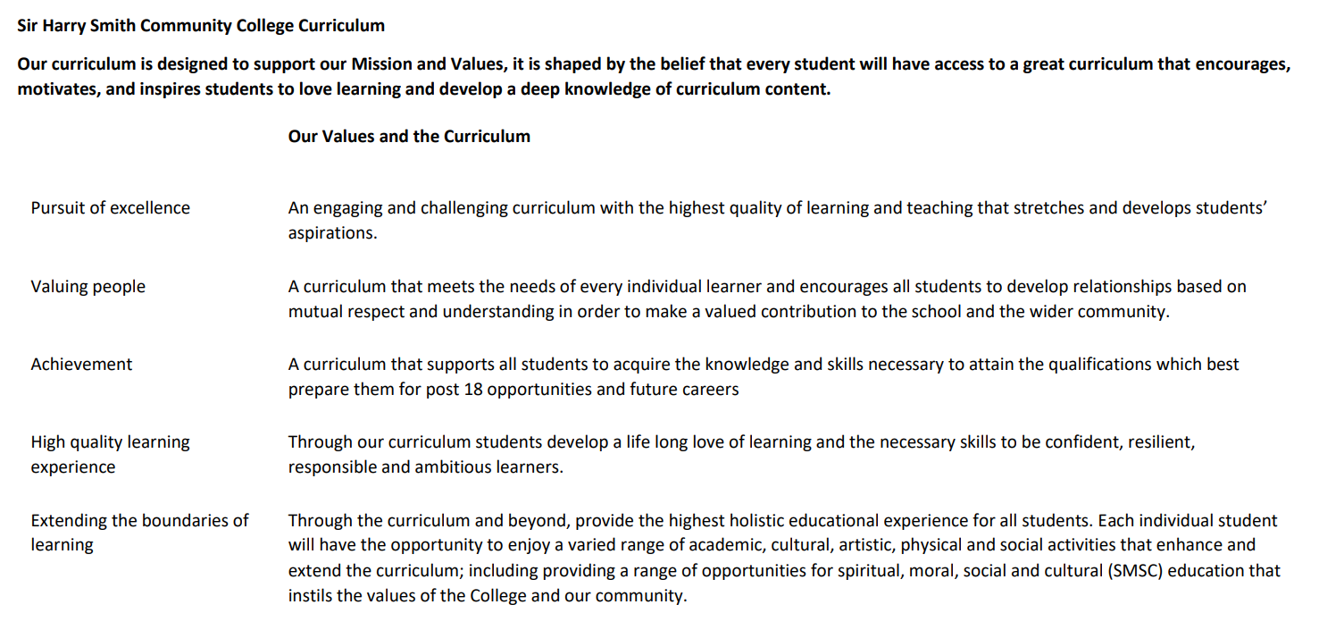

Sir Harry Smith Community College Curriculum Map SUBJECT: A-Level Psychology YEAR 12 2022-23
Curriculum Intent: To offer students a unique opportunity to study human behaviour from different perspectives, so that students can develop a deeper understanding of the origins of behaviour. By the end of their time with us, we hope that students can apply their knowledge to wider society in terms of treatment, prevention and support for those who need it most.
School Values | Curriculum Focus | Term 1 – Research Methods, Approaches and Attachment | Term 2 – Memory and Psychopathology | Term 3 – Biopsychology and Social Influence
High Quality Learning Experience | Literacy Skills and Key Vocabulary | Hypothesis, Variables, Experimental Design, Correlational Research, Data Collection, Quantitative and Qualitative Methods, Inferential Statistics, Descriptive Statistics.  Humanistic, Biological, Cognitive, Psychodynamic, Behaviourism and Learning Approaches. Theories of Attachment, Bowlby, Ainsworth, Types of Attachment, Cross-Cultural Variations. | Multi-Store Model of Memory, Types of Long-Term Memory, Working Memory Model, explanations for forgetting, improving the accuracy of eyewitness testimony.  Definitions of abnormality, characteristics of OCD and depression, behavioural approach to explaining and treating phobias, cognitive approach to explaining and treating depression, biological approach to explaining and treating OCD. | Types of conformity, Zimbardo, Explanations for obedience and conformity, Asch’s Research, Milgram’s Research, resistance to social influence, minority influence, processes involved in social change.  Divisions of the nervous system, structure and functions of neurons and endocrine system, fight or flight response, localisation of function in the brain, ways of studying the brain, biological rhythms.
Pursuit of Excellence | Knowledge and Skills | How do psychologists ensure research is scientific?  Processes involved in conducting research and understanding whether results are significant. Analytical skills, designing own research, correlational research, variables and experimental processes, inferential statistics.  Which of the five main approaches best explains human behaviour?  Assess five approaches and compare approaches in terms of their similarities and differences in extended writing essay | How do we retain information and how can eyewitness testimony be improved?  Examine different models of memory and assess the usefulness of eyewitness testimony in courts  Why do people develop OCD, Phobias and Depression and how can we treat them?  Assess different theories of mental health problems and their respective treatments. | Which factors influence human behaviour the most when exploring obedience and conformity?  Outline different theories of social influence and examine research evidence.  Which areas of the brain are responsible for which behaviour?  Identify different regions of the brain, assess the usefulness of brain plasticity in neurodegeneration and explore different areas of the central nervous system and their functions.
 | Subject specific pedagogy | Continuous retrieval practice using mini-white boards and low stakes assessments to check and correct misconceptions. Interleaved practice is embedded throughout to continuously revisit previous topics, aiding in memory recall. Dual coding, metacognition and growth mindset.
Extending the boundaries of learning | Cultural Capital and beyond the curriculum | Attachment egg project which encourages students to apply their knowledge of attachment types in a project which is then presented to peers at the end.  Research methods project to conduct own research with a testable hypothesis, write a research report and then present findings to peers. | Opportunities for further readings and work by Elizabeth Loftus to extend knowledge of eyewitness testimony and its relevance in court.  Exploration of case studies specifically linked to different mental health problems and how attitudes towards mental health have changed. | Developing a practical understanding of how influential social influence work has been in society, specifically within prison reform.  Opportunities to research individuals with neurodegenerative disorders to better understand localisation and plasticity.
Achievement | Assessment | Transition work to be submitted at the start of Year 12. Baseline assessment is completed within the first two weeks of Year 12.  End of unit assessments which consistently refer to research methods and regular timed responses to extended writing questions, as well as low stakes retrieval practice quizzes using mini-white boards and online software. | End of unit assessments which consistently refer to research methods and regular timed responses to extended writing questions, as well as low stakes retrieval practice quizzes using mini-white boards and online software. | End of unit assessments which consistently refer to research methods and regular timed responses to extended writing questions, as well as low stakes retrieval practice quizzes using mini-white boards and online software.  End of Year 12 mock period on Paper 1 and Paper 2.
Valuing People | How our curriculum meets the needs of every individual | Continuous emphasis on key terminology and retrieval practice of this throughout the course. Breaking down key terms into smaller words to understand wider meanings and further reading opportunities embedded throughout (e.g. subscription to Psychology Review, Psychology Digest).  Students will receive regular feedback in numerous forms which will enable students to track their own progress and identify gaps in knowledge, misconceptions or issues with extended writing structuring.  Transition work is created for both students who have completed the GCSE and those who have not. Students complete different tasks based on previous subject knowledge. This aims to develop foundation knowledge of research methods and approaches for non-GCSE students and extend research methods knowledge of GCSE students.  Liaising with year leaders, student support department, form tutors and parents to develop a holistic understanding of our students, so that any intervention is bespoke to the individual.  Independent leaners are provided support via the uploading of relevant classwork onto TEAMs, this allows students to reflect on their learning and revisit any material they may wish to recap as part of their revision or independent learning. Students who miss lessons for various reasons are then able to complete work in preparation for future lessons.  Staff within the department continuously share good practice through regular meetings, lesson drop-ins, marking standardisation and feedback after completing various CPD courses.  BehaviourWatch and telephone calls home are used to regularly keep in touch with parents regarding behaviour for learning in lessons. Parents are contacted via email or telephone if there are any persistent issues in class or to discuss positive contributions and work from our students.  Previous sixth form students are invited into the college who have gone on to study a social science at degree level or equivalent to provide career prospects, revision strategies and examples of good practice with our sixth form students.

