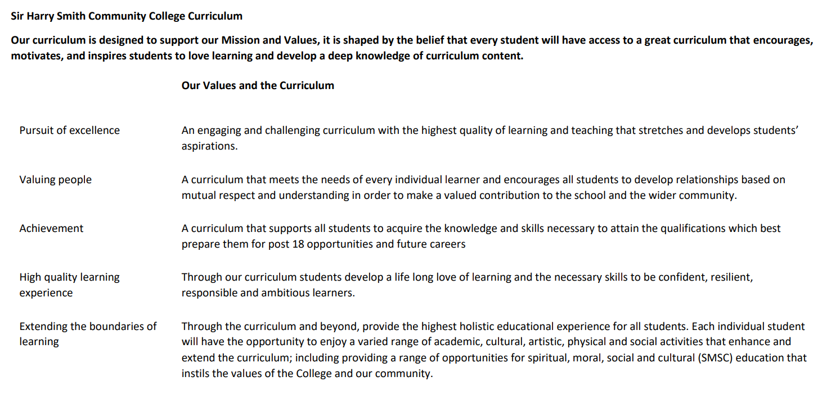

Sir Harry Smith Community College Curriculum Map SUBJECT: Childrens’Play Learning and Development YEAR 12 2022-23
Curriculum Intent: BTEC National Level 3 Extended Certificate in Children’s Play Learning and Development is a vocational course involving 50 hours of work experience.
A BTEC National in Children's Play, Learning and Development offers you the opportunity to study a broad range of early years related topics, which will be relevant in many different vocational settings. Once you have completed your studies, you will be able to apply for a wide variety of jobs, including supporting and supervised roles in children's day nurseries, schools, pre-schools, children's centres and with childminders. This qualification is also designed to support progression to higher education when taken as part of a programme of study that includes other appropriate BTEC Nationals or A Levels
BTEC National qualifications are also awarded UCAS points, which can be used to apply for university courses. You may consider university courses in subjects such as: Primary School Teaching, Children's Nursing, Midwifery, Nursing Children with Physical, Mental or Learning Difficulties and Psychology with Child Development
Whatever the route or eventual outcome, BTEC National Children's Play, Learning and Development learners can be assured of a varied and interesting programme of study, leading to a satisfying and worthwhile career where caring for children is the main focus.
In your course, you will be studying a number of different units. BTEC National Children's Play, Learning and Development courses comprise mandatory and optional units. Core units give you the opportunity to develop the skills that employers and educators within the sector consider to be essential. You will be taught how children develop and learn, and you will find out about the importance of play to their overall development. Emphasis is placed on the key role that early years’ professionals can play in supporting children's development in a range of areas, including literacy and numeracy.
School Values | Curriculum Focus | Term 1 – Unit 1  Children’s Development | Term 2 – Unit 2  Development of Children’s Literacy and Numeracy Skills | Term 3 – Unit 5  Keeping Children Safe
High Quality Learning Experience | Literacy Skills and Key Vocabulary | Command Words: Describe, Discuss, Evaluate, Analyse, Assess, Explain, Identify, Outline, Give, List, Which  Topic keywords; Growth, Development, Physical, Cognitive, Language, Non-Verbal, Literacy, Self-Esteem, Self-Concept, Attachment, Emotional, Social, Gross Motor Skills, Fine Motor Skills, Genes, Atypical Development, Global Development, Reflexes, Developmental Norm, Environment, Biological, Nutritional, Imagination, Innate, Communication, Problem Solving, Observe, Reinforcement, Gestures, Morality, Behaviour, Influence, Modelling, Empowering, Transition, Sympathy and Empathy, | Command Words: Activity, Early Years Theory, Resources, Activity Plan, Recommendations, References  Topic keywords; Speech, Communication, Language, Verbal, Non-Verbal, Acquisition, Phonology, Syntax, Semantics, Receptive, Expressive, Cognitive, Conductive Hearing Loss, Interaction, Observation, Referral, Pronunciation, Sequence, Parentese, Environment, Symbols, Phonemes, Graphemes, Segment, Synthetic Phonics, Rhyme, Recognition, Stimulating, Auditory Discrimination, Repetition, Modelling, Interactive, Reinforcing, Commentary, Numeracy, Counting, Prediction, Multilingual, Consistent, Physiotherapist, Speech and Language Therapist, Educational Therapist, Portage Worker | Command Words: Evaluate, Analyse, Explain, Reflect, Demonstrate, Assess  Topic keywords; Safe, Secure, Responsibilities, Welfare, Promote, Regulations, Legislation, Guidance, Safeguarding, Environment, Hazardous,, Accidents, Safe Recruitment, Statutory, Resources, Equipment, Child-Centered, Reporting, Observation, Supervision, Register, Modelling, Whistleblowing, Assessing. Risk, Infection, Decontamination, Immunisation, Prevention, Hygiene, Abuse, Neglect, Injury, Domestic, Indicators. Vigilant, Impact, Independent, Active Listening, Empower, Disclose (Disclosure, Discloses), Confidentiality, Investigation, Anaphylaxis, Evacuation, Unauthorised, Reassure, Emergency,
Pursuit of Excellence | Knowledge and Skills | Students work through the exam content starting with  - the principles of growth and development and how they are applied from birth up to seven years and 11 months.  - Physical development from birth to seven years 11 months  - Cognitive, language and communication development.  - Theories of social and emotional development  They learn to identify the key points from a case study and relate them to the question topic. identify what questions are asking them to do from the command words.  The exams are made up of a range of different questions from multiple choice through to essay style questions. Students receive practice and support in answering exam questions using mark schemes, exemplar answers and feedback. | Students work through the set task content starting with;  - Stages of speech, communication and language development and its link to overall domains of development.  - Supporting children’s literacy and numeracy skills through speech, communication and language development  - Approaches to the varied needs of individual characters  Students learn how to structure their answers.  They are using a real world case study with everyday scenarios that reflect common issues within nursery’s that affect children’s development. | Students produce 3 assignments using lesson time and their private study time to complete the following assignments using information they research and reference/evidence from their work expereince.  Assignment 1 – Work experience based using policies and procedures from the nursery.  - Investigate legal responsibilities and approaches to health and safety in early years settings  - Explore procedures for prevention and control of infection in early years settings.  Assignment 2 – Case study based  - Examine how early years professionals safeguard children and respond to concerns that a chid has been abused.  Assignment 3 – Work experience based using plans and reflections of activities you have produced and carried out with the children.  - Demonstrate how to recognise and assess hazards and risks to children and respond to emergencies in an early years setting
 | Subject specific pedagogy |  | Students will work through the content for the Set Task and will be set independent research tasks to read around the topics, as well as looking at educational resources in the lessons. Students will need to revisit their Unit 1 knowledge of theorists and apply them to the tasks.  At the end of learning aims they are set an assessment using activities that only relate to the learning aim content.  This follows the set task structure of  - Responding to an OFSTED report making reference to a relevant theory/theorist  - An individual case study for one child with a specific learning issue within the nursery. Using references to a relevant theory/theorist to justify your strategy  - Planning 2 activities that could be done within the nursery to support an area of either Literacy, Numeracy or communication. Using reference to a relevant theory/theorist to justify your plans. | Students will carry out work experience and research independently to complete the assignments, they are all given information to complete a very basic assignment. It is up to the students to carry out research independently and combine this with relevant experiences from their work experience to produce personal assignments that demonstrate reflection, assessment and evaluation.  Assignment 1 – Work experience based using policies and procedures from the nursery.  Assignment 2 – Case study based  Assignment 3 – Work experience based using plans and reflections of activities you have produced and carried out with the children.
Extending the boundaries of learning | Cultural Capital and beyond the curriculum | The website simply psychology is an excellent resource for reading about the educational theorists needed for the exam.  Early years foundation stage framework can be downloaded from the gov.uk website. This is the framework that all early years settings follow  The National Society for Protection of Children have an informative website covering a range of topics  The St. Johns Ambulance website carries some excellent information on paediatric first aid. It is worth spending time reading the different pages on this site | Early years foundation stage framework can be downloaded from the gov.uk website. This is the framework that all early years settings follow  The website simply psychology is an excellent resource for reading about the educational theorists needed for the set task.  Work experience is an excellent way to extend understanding of child development  Research into Makaton and British sign language would benefit understanding about communication where a child is experiencing difficulties.  You tube currently carries a documentary; Brain Matters/Early Childhood Development. Which is useful to this unit. | Early years foundation stage framework can be downloaded from the gov.uk website. This is the framework that all early years settings follow  The National Society for Protection of Children have an informative website covering a range of topics  The St. Johns Ambulance website carries some excellent information on paediatric first aid. It is worth spending time reading the different pages on this site  Documentaries available on you tube provide insight into some of the wider problem’s issues within the topics; Britain’s hidden children’s homes - BBC Newsnight  Crimes That Shook Britain S03E01 Victoria Climbe  The BBC website carry a Timeline of events in the Victoria Climbe case and separately for the Baby P case. These are useful for understanding the processes that were followed and how they failed
Achievement | Assessment | This unit will be externally examined in January of year 12. The students will complete past exam papers and a mock exam within the lesson once the content has been completed in December.  The exam is out of 90 marks and takes 105 minutes.  Students must achieve a Nearly Pass (N) in this exam to Pass the course overall. Students will have an opportunity to resit the exam if needed.  If students decide to resit the exam to try and achieve a higher grade and then achieve a lower grade, the higher grade will stand.  Makes up 33% of final grade | This unit is an externally assessed set task in. the students will complete this in May of year 12. The students will complete set tasks and a mock set task within the lesson once the content has been completed in April/May.  The set task is marked out of 90 marks. Two days before the set task the exam board will release a case study for a nursery. Students then have 3 supervised hours to produce 3 pages of notes to take in to the set task. The notes will be collected in by the teacher and given back to the students to use in the set task. The students have 3 hours to complete 3 tasks under supervision.  Students must achieve a Nearly Pass (N) in this exam to Pass the course overall. students will have an opportunity to resit the exam if needed.  If students decide to resit the set task to try and achieve a higher grade and then achieve a lower grade, the higher grade will stand.  Makes up 33% of final grade | Students are expected to use lesson and personal study time to complete 2 assignments to a deadline. They are given feedback which identifies what they have achieved, using the assignment assessment criteria. They will be given 15 working days to improve their work using this feedback.  This unit is internally assessed by the class teacher, a sample from the group is internally moderated following the BTEC protocol on both submissions. This unit will be externally moderated by the exam board.  Makes up 16% of final grade
Valuing People | How our curriculum meets the needs of every individual | All students are provided with the lesson content online via TEAMS, Microsoft onedrive and in the lesson.  Example answers are shared.  PLC’s are provided with unit content, keywords and a progress tracker.  Revision guides are provided.  The course is modular, external and internal assessment are used twice a year to test the content the student has just covered | All students are provided with the lesson content online via TEAMS, Microsoft onedrive and in the lesson.  Example answers are shared.  PLC’s are provided with unit content, keywords and a progress tracker.  Revision guides are provided.  The course is modular, external and internal assessment are used twice a year to test the content the student has just covered | Students benefit from experiencing the activities discussed in lesson on their work experience. This engages and reinforces the content with the students. It supports them in linking the different concepts together.  All students are provided with the lesson content online via TEAMS, Microsoft onedrive and in the lesson.  Example answers and exemplar work is shared  PLC’s are provided with unit content, keywords, assessment criteria and a progress tracker  All content is discussed in a real-world context

