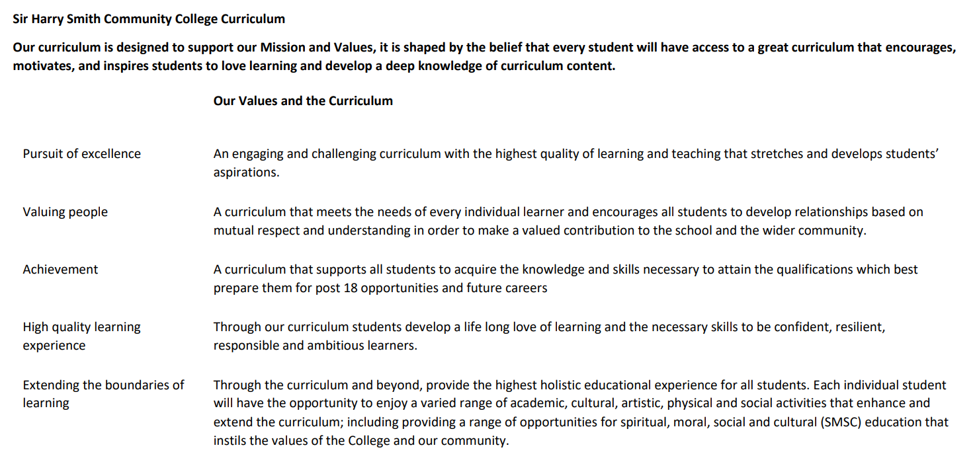

Sir Harry Smith Community College Curriculum Map SUBJECT: Drama YEAR 9 2022-23
Curriculum Intent:
I wanted to develop a language that felt accessible and honest. I wanted to share a process that would take people past their perceived limitations."
Scott Graham, Artistic Director of Frantic Assembly

Our long-term aims and intentions in Drama are:
- To build personal skills, and attitudes learned in Drama which will be used to facilitate success in other areas of the curriculum and in the world of work and beyond: communication, trust, teamwork, collaborative problem solving, adaptability, negotiation, self – management and resilience.
- To use the skills taught in Drama to explore the world and what matters to them, as well as gaining an appreciation of the contribution the Arts makes to all our lives: intercultural sensitivity and social influence.
- To develop relationships based on mutual respect and understanding: learning to discuss, resolve, compromise and empathise within a safe environment.
- To embed opportunities for all leaners within the curriculum and beyond such as: Arts Award, Competitions, and Annual Productions enhancing skills such as: creative imagination, leadership confidence and autonomy.
- To sustain good relationships across partnerships between parents, primary schools, outside Arts agencies such as 20TwentyProductions and the wider community.
- To develop Skills and Techniques in Creating, Performing and Responding to maximise toolkit for all students to prepare for industry futures should they wish to continue that flight path.
- To develop a knowledge and understanding of a range of Theatre styles and Practitioners that have made an impact on the industry through history and understand the way that Theatre has developed through time.
- To enjoy drama and develop a passion for at least one of the following roles in the industry: designer, devisor, director, performer, choreographer and a stage manager with knowledge of how these skills can be used in future career paths whether they chose to work within the industry or not.

School Values | Curriculum Focus | Term 1 – Blood Brothers | Term 2 – Industry Professionals/ Theatre Practitioners | Term 3 – Devising Drama
High Quality Learning Experience | Literacy Skills and Key Vocabulary | Live Theatre/ Willy Russell/ Cyclical Structure/ Musical Theatre/ Non Naturalistic/ Naturalistic/ Script/ Monologues/ Storyline/ Themes and Issues/ Social, Historical and Cultural Context/ Time Period 60’s – 80’s/ Character Profiles/ Costume Designs/ Monologue/ Duologue/ Social Class/ | Designer/ Director/ Performer/ Devisor/ Choreographer/ Lyricist/ Light and Sound Designer/ Set Designer/ Semiotics/ Light and Sound Cue Sheet/ Vision/ Colour Connotations/ Wings/ Apron/ Threads/ Back Drop/ Projections/ Gobos/ Gels/ Barn doors/ Door Flat/ Spotlight/ Follow Spot/ Period/ Moving Head Light/ Fresnel/ Strobe/ Lasers/ Hazer/ Frosting/ Social Class/ Hair and Make-up/ Flood Lights/ Mood and Atmosphere/ Pyrotechnics/ Sound Scape/ Ambient Noise/ Entrances and Exits/ Ground Plan/ Composite Setting Practitioners/ Artaud/ Brecht/ Frantic Assembly/ Conventions/ Aims and Intentions/ Style/ Genre. | Stimulus/ Devise/ Create/ Plan/ Structure/ Storyline/ Research/ Initial Ideas/ Vision/ Aims and Intentions/ Target Audience/ Character Profile/ Hot Seating/ Emotion Memory/ Magic If/ Rehearsal/ Milestone Rehearsal Log/ Set Design/ Costume Design/ Role on the Wall/ Hot Seating/ Units and Objectives/ Super Objective/ Stanislavski/ Conventions/ Edit, Add and Adapt/ Techniques
Pursuit of Excellence | Knowledge and Skills | Students be able to use the context of Blood Brothers in order to fully understand the characters and the storyline, using this information to develop theatre.  Students will develop a clear character from Blood Brothers using Stanislavski techniques.  Students will be able to perform a character from Blood Brothers that has been well analysed and considered.  To perform a role off script for the duration of the performance.  To perform with consistent focus and energy using a clear gesture, posture, movement and facial expressions in order to convey the characters mannerisms.  To be able to respond to feedback and suggest detailed areas and concepts to improve the performance using key terminology throughout your reflection. | Students will be able to understand the job roles of all the industry professional in Performing Arts  Students will be able to make relevant decisions on how to stage Blood Brothers through the eyes of the industry professionals in order to communicate the aims and intentions of Russell.  Students will be able to create a portfolio of costume designs/ set designs, light and sound cue sheets/ directorial notes on key moments within Blood Brothers and be able to state what this communicates to the audience.  Students will be able to understand all of the keywords stated above and how these are used in decision making as an industry professional.  Students will be able to understand what the term ‘Semiotics’ and what ‘Proxemics’ are and how these are used on stage to communicate meaning.  To know and understand the different styles of theatre as well as the different Theatre Practitioners that have influenced and made an impact on theatre and how their conventions can be used in a performance to communicate meaning to the audience. | Students will fully understand the term devising and be able to analyse a wide variety of stimulus through vocal discussions  Students will be able to complete extensive research using primary and secondary sources.  Students will be able to create a bibliography of the sources that they have used for researched  Students will be able to create a range of initial ideas for a potential piece of the theatre.  Students will be able to create a vision for their final group performance, considering the target audience and what techniques they use to create meaning to the audience.  Students will be able to create a well -crafted character that has been developed and analysed through research  Students will always be able to be professional throughout the rehearsal process, working as a team and considering a range of ideas.  Students will be able to produce a portfolio that shows a detailed journey of the devising process including character development and changes made throughout the devising process.  Students will be able to create a written evaluation and reflection of the final performance using key terminology and detailed suggestions for further improvement.
 | Subject specific pedagogy | Activities that students will undertake:  Watching Live Theatre/ Paired performance focus on characterisation/Performers written evaluation / Directing/ Performing/ Designing and Devising. Practical Rehearsal/ Performance and Evaluating.  We embed a love for learning through the opportunity of performing on a professional Proscenium Arch stage as a whole class using costume and props/ light and sound to a live audience | Activities that students will undertake:  Directing/ / Designing and Devising.  We embed a love for learning through the opportunity of performing on a professional Proscenium Arch stage as a whole class using costume and props/ light and sound to a live audience | Activities that students will undertake:  Research/ Initial Ideas/ Practical Rehearsal/ Performance and Evaluating.  We embed a love for learning through the opportunity of performing on a professional Proscenium Arch stage as a whole class using costume and props/ light and sound to a live audience
Extending the boundaries of learning | Cultural Capital and beyond the curriculum | Students can attend further classes outside the classroom to stretch and challenge their Drama skills through our extra- curricular Dance and Drama clubs as well as our annual productions as a whole school where they will be working across all year groups and aspire to audition for lead roles in our productions. | Students can attend further classes outside the classroom to stretch and challenge their Drama skills through our extra- curricular Dance and Drama clubs as well as our annual productions as a whole school where they will be working across all year groups and aspire to audition for lead roles in our productions. | Students can attend further classes outside the classroom to stretch and challenge their Drama skills through our extra- curricular Dance and Drama clubs as well as our annual productions as a whole school where they will be working across all year groups and aspire to audition for lead roles in our productions.
Achievement | Assessment | Creating Assessment Criteria and from the Performance Assessment Criteria using the drama grade descriptors 1-9 which has been taken from Ofquals guidance and Arts Council as well as OCR Grade descriptors at GCSE level.  A03: Demonstrate knowledge and understanding of how drama and theatre is developed and performed.  Skills Assessed  A01: Create and develop ideas to communicate meaning for theatrical performance  A02: Apply theatrical skills to realise artistic intentions in live performance  A03: Demonstrate knowledge and understanding of how drama and theatre is developed and performed.  A04: Analyse and evaluate their own work and the work of others | Creating Assessment Criteria and from the Performance Assessment Criteria using the drama grade descriptors 1-9 which has been taken from Ofquals guidance and Arts Council as well as OCR Grade descriptors at GCSE level.  Skills Assessed  A01: Create and develop ideas to communicate meaning for theatrical performance  A02: Apply theatrical skills to realise artistic intentions in live performance  A03: Demonstrate knowledge and understanding of how drama and theatre is developed and performed.  A04: Analyse and evaluate their own work and the work of others | Creating Assessment Criteria and from the Performance Assessment Criteria using the drama grade descriptors 1-9 which has been taken from Ofquals guidance and Arts Council as well as OCR Grade descriptors at GCSE level.  Skills Assessed  A01: Create and develop ideas to communicate meaning for theatrical performance  A02: Apply theatrical skills to realise artistic intentions in live performance  A03: Demonstrate knowledge and understanding of how drama and theatre is developed and performed.  A04: Analyse and evaluate their own work and the work of others
Valuing People | How our curriculum meets the needs of every individual | All students will have access and will participate in the learning through developing their Creating, Performing and Responding skills.  Group sizes can vary and quieter spaces for students to use for rehearsal.  There is a range of activities such as individual, paired and grouped work. Teacher role models’ expectations with some students being able to take more of a directorial role and responsibility.  For those unable to participate in the practical elements students will be part of the planning and can undertake the backstage side to the industry – creating light and sound cue sheets as well as designing the stage and set. | All students will have access and will participate in the learning through developing their Creating, Performing and Responding skills.  Group sizes can vary and quieter spaces for students to use for rehearsal.  There is a range of activities such as individual, paired and grouped work. Teacher role models’ expectations with some students being able to take more of a directorial role and responsibility.  For those unable to participate in the practical elements students will be part of the planning and can undertake the backstage side to the industry – creating light and sound cue sheets as well as designing the stage and set. | All students will have access and will participate in the learning through developing their Creating, Performing and Responding skills.  Group sizes can vary and quieter spaces for students to use for rehearsal.  There is a range of activities such as individual, paired and grouped work. Teacher role models’ expectations with some students being able to take more of a directorial role and responsibility.  For those unable to participate in the practical elements students will be part of the planning and can undertake the backstage side to the industry – creating light and sound cue sheets as well as designing the stage and set.

