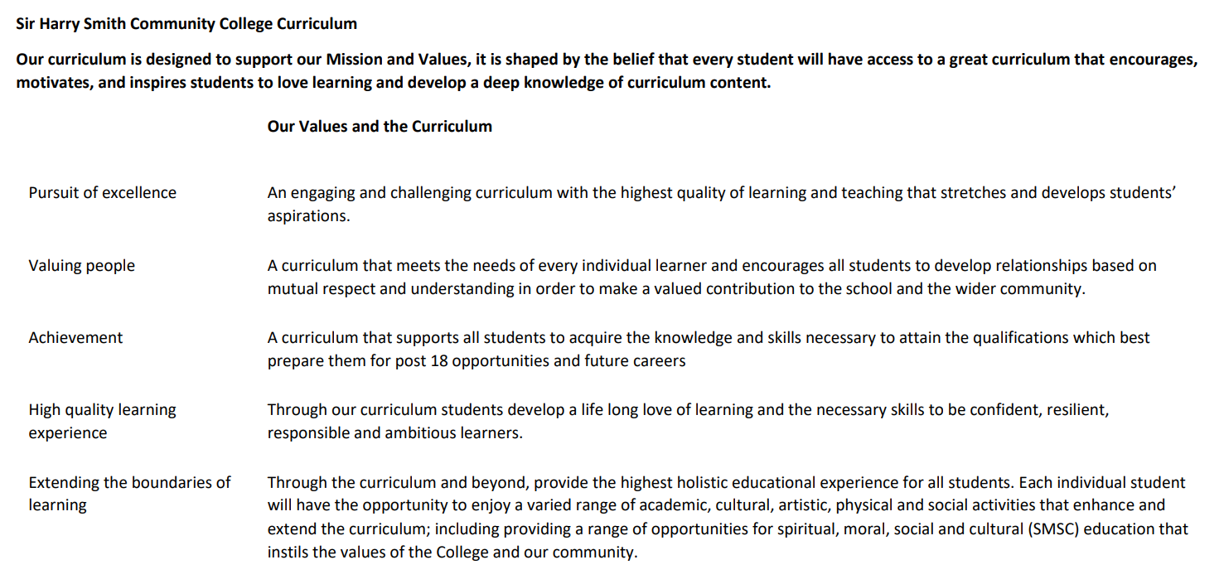

Sir Harry Smith Community College Curriculum Map SUBJECT: History YEAR 8 2022-23
Curriculum Intent: The Year 8 curriculum aims to build on the substantive knowledge gained in Year 7, while progressing students understanding of key moments in British History. Student knowledge of the medieval Church in Year 7 will be revisited by an investigation into the causes and consequences of the English Reformation, while the topic of power in the medieval state, first touched upon in Year 7, will be revisited and expanded through an indepth analysis of the causes, course and consequences of the British Civil Wars. The Plains Indians topic will give students an opportunity to look at a non-Western culture, while laying the foundation for later study of the American West at GCSE.
Lastly, the British Empire topic will enable students to understand the causes, course and consequence of the British Empire, arguably one of the most significant aspects in British history. The final investigation into the ‘Jack the Ripper’ murders enables students to sensitively look at this significant event through the lens of social history.
Throughout, students will be challenged to expand not just their substantive knowledge, but also their historical skills through frequently revisiting key second order concepts, both in lesson and through assessments.
School Values | Curriculum Focus | Term 1 – English Reformation and British Civil Wars | Term 2 – Interregnum and Plains Indians. Beginning of British Empire topic | Term 3 – British Empire, Slavery, and the ‘Jack the Ripper’ investigation
High Quality Learning Experience | Literacy Skills and Key Vocabulary | Catholic, Protestant, Reformation, Civil War, Puritan | Interregnum, Restoration, Plains Indians, Nomadic | Empire, Slavery, Middle passage, colony, evidence.
Pursuit of Excellence | Knowledge and Skills | Students will build upon what they learned in Year 7 about monarchy and the Catholic Church, by learning about the causes, course and consequence of both the English Reformation and the British Civil Wars. | Students will understand the events from 1649-1660 and the long term impact of the Interregnum, as well as the emergence of Parliament.  Students will conduct a non-Western world study on the Plains Indians, learning about their culture. Students will then begin learning about the British Empire. | Students will attempt to answer the overarching question of how the British Empire should be remembered. Linked to this, they will take an indepth look at Britain’s role in the Transatlantic slave trade, and the reasons for the end of the trade.  Lastly, students will take a (sensitive) look at the ‘Jack the Ripper’ investigation, where the focus will be on Victorian social history and the limitations of law enforcement at the time.
 | Subject specific pedagogy | Historical skills such as source work, interpretations, creating and evaluating arguments etc, as well as the substantive knowledge required, is embedded into every lesson. | Historical skills such as source work, interpretations, creating and evaluating arguments etc, as well as the substantive knowledge required, is embedded into every lesson. | Historical skills such as source work, interpretations, creating and evaluating arguments etc, as well as the substantive knowledge required, is embedded into every lesson.
Extending the boundaries of learning | Cultural Capital and beyond the curriculum | This term’s work will help students to understand how the local area and Britain in general changed during the Civil War, how a more secular society emerged, the reasons for the emergence of our constitutional monarch. There is much of local interest to highlight in the course. | This term’s work will help to broaden student’s understanding of the broad sweep of British History, encompassing Britain’s role in Empire and slavery and the legacy of our imperial past. In addition, learning about the Plains Indians will help students to gain an understanding of a very different society to our own, helping to promote diverse views. | Again, this term’s work will help students to understand our imperial past, and some of the debates/controversy over Empire and slavery more recently. In addition, students will tackle issues such as the representation of women in History through the Jack the Ripper case.
Achievement | Assessment | Students will receive formal assessments on both the Reformation and the causes of the English Civil War, evaluating both the substantive knowledge needed but also the second order concepts required, such as causation, source work, interpretation etc. | Students will receive a formal assessment on the Plains Indian topic, encompassing the knowledge gained and second order concepts such as sources/interpretations. | Students will receive a formal assessment on the legacy of the British Empire, covering the substantive knowledge required and the second order concepts such as interpretations and significance.
Valuing People | How our curriculum meets the needs of every individual | Differentiation is embedded into lessons, with different levels of challenge available for G &T students (e.g. more challenging articles/sources/questions) and SEND students (writing frames, pre-teaching of vocabulary). Individualised teacher feedback helps students to access the learning and improve. All students should be able to access and understand the learning, albeit at different levels. We also have a departmental TA who will be deployed to where he is most needed. Lastly, where appropriate, PP resources will be deployed to support students, e.g. through provision of extra revision resources.

