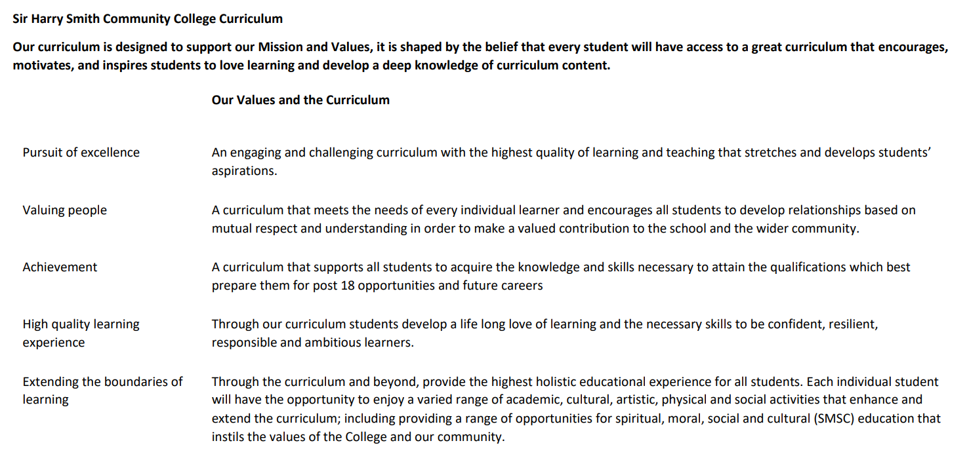

Sir Harry Smith Community College Curriculum Map SUBJECT: Maths YEAR 11 2022-23
Curriculum Intent: To ensure all pupils have the mathematical skills they need to move onto the next stage of their journey.
School Values | Curriculum Focus | Term 1 – Graphs and Algebra | Term 2 – Reasoning and Revision & Communication | Term 3 – Revision and Exams
High Quality Learning Experience | Literacy Skills and Key Vocabulary | Parallel, Horizontal, Vertical, Straight Line, Axis, Equation, Graph, Intercept, Linear, Table of Values, Gradient, Scale, Substitute, Coordinates, Point, Interception, Intersect, Reciprocal, Product, Quadratic, Parabola, Curve, Estimate, Cubic, Cube, Asymptote, Infinity, Tends Towards, Exponential, Growth, Decay, Rapid, Radius, Diameter, Pythagoras’ Theorem, Origin, Simplify, Tangent, Reflection, Mirror, Direct Proportion, Model, Distance, Speed, Time, Constant, Piece-wise, Pressure, Root, Trapezium, Area, Speed/Time Graph, Expand, Factorise, Identity, Multiply Out, Coefficient, Bracket, HCF, Binomial, Difference of Two Squares, Term, Trial and Improvement, Significant Figures, Solution Set, Greater/Less Than, Greater/Less Than or equal to, Form, Perimeter, Area, Volume, Opposite Angles, Check, Rearrange, Change, Square, Square Root, Converge, Input, Output, Variable, Function, Composite, Turning Point, Ratio, Sine, Cosine, Tangent, Opposite, Adjacent, Hypotenuse. | Enlargement, Multiplier, Scale Factor, Similar, Direct Proportion, Equation, Origin, Constant Ratio, Linear, Straight Line, Constant of Proportionality, Equation, Varies Directly, Density, Mass, Volume, Pressure, Force, Area, Inverse Proportion, Smooth Curve, Varies Inversely, Bar Model, Two-Way Table, LCM, Fraction, Percentage, Angle, Adjacent, Vertically Opposite, Point, Full Turn, Straight Line, Alternate, Corresponding, Co-interior, Bearing, Angle, Polygon, Regular, Interior, Exterior, Equilateral, Isosceles, Right Angle, Trapezium, Vector, Column, Horizontal, Vertical, Position, Circle, Segment, Circumference, Centre, Cyclic Quadrilateral, Bisect, Equal, Term, Expression Simplify, Power, Index, Coefficient, Difference, Second Difference, Non-Linear, Inequality, Fibonacci, Eliminate, Simultaneous, Proof, Demonstration, Counterexample, Justify, Even, Odd, Inequality, Region, Satisfy, Equation, Integer, Test. | All key language from years 7 to 11.
Pursuit of Excellence | Knowledge and Skills | Gradients and Lines – We build on earlier study of straight line graphs in years 9 and 10. We will plot straight lines from an equation, as well as find and interpret the equation of a straight line. We will explore parallel lines and, for higher tier students, perpendicular lines.  Non-Linear Graphs – We will expand and recap on our work on non-linear graphs including Quadratic, Cubic and Reciprocal. We will use graphs to find roots and turning points. Higher Tier Students will also look at exponential graphs, the equation of a circle and the equation of a tangent to a circle. They will also explore instantaneous rates of change using non-linear graphs.  Using Graphs – This block will revise conversion graphs and reflection in straight lines. We will also explore other graphs from real-life, including Distance/Time and Velocity/Time. Higher Tier Pupils will also cover the area under a curve in various contexts.  Expanding and Factorising – In this block if work, we will review all previous areas involving expanding and factorising into single brackets. All pupils will then move into factorising and expanding quadratics.  Changing the Subject – We will consolidate the work from year 9 on both equations and inequalities, before moving onto rearranging known and as yet un-met formulae. Higher Tier pupils will also cover more complex re-arrangement and solving equations by iteration.  Functions – We will introduce the formal function notation, and build on previous work using quadratics functions and graphs. Pupils will also have the opportunity to revisit trigonometric identities from the start of last year. | Multiplicative Reasoning – Students will develop multiplicative reasoning in a variety of contexts, from scale factors to complex algebra involving proportion. We will also review ratio problems.  Geometric Reasoning – We will revisit angle facts from previous years of study and develop increasingly complex chains of reasoning to solve problems in shapes. Higher Tier pupils will review the first four circle theorems, and cover the remaining theorems. Pupils will also revise vectors, Pythagoras’ theorem and Trigonometry.  Algebraic Reasoning – Students develop stronger algebraic reasoning skills by exploring more complex situations. They will review and extend their knowledge of sequences and other rules, using these to make and test conjectures. They will review equations, including simultaneous. Higher Tier Pupils will also look at formal proofs and solving inequalities in more than one variable.  Transforming and Constructing – Pupils will revise and extend their previous work on transformation and constructions and see how these relate to symmetry and properties of shape. We will look at the importance of description as well as correct mathematical language. We will consider invariance, as well as look at the Trigonometric graphs.  Listing and Describing – We look at ways to effectively and efficiently list information, which for higher tier students will include the product rule for counting. We will recap much of the work from data handling in previous years, and use diagrams to compare sets of data efficiently.  Show That – This block will vary by group, but is aimed around pupils developing clear and concise mathematical language to describe their reasoning ahead of their final examination. | The final term of work in year 11 will vary by class and pupil. Teachers will revisit any topics that they feel will benefit their pupils, as well as conducting formal exam practice.
 | Subject specific pedagogy | Mathematics at Sir Harry Smith is taught following a “Teaching for Mastery” curriculum. This curriculum approach focuses on exploring depth of concepts rather than breadth. The curriculum focuses on “five big ideas” which are explored in various ways throughout the course. The five big ideas are:  Variation – Questions are asked with minimal changes, to encourage pupils to identify patterns and connections between those changes in approaches.  Representation – Different problems are expressed using symbols, pictural representations or manipulative (physical) objects such as counters. This approach helps pupils understand that the same mathematical information can be expressed in multiple ways.  Mathematical Thinking – This idea explores the structure of a question and looks at not only how a question could be answered, but also what other questions may be asked. An example of this may be a graph or chart, with discussion about what could possibly be worked out from this information. This idea also looks at connections between other topics in maths.  Fluency – This idea is about learning key facts that can be applied in situations. This could include multiplication tables, angle facts or key definitions of numbers.  Coherence – The purpose of coherence is to draw the five ideas together. Giving pupils questions that allow them to explore the skills learnt in other contexts, or in draw skills from each of the other four areas to synergise an answer.
Extending the boundaries of learning | Cultural Capital and beyond the curriculum | Pupils in year 11 will be given the opportunity to compete in the UKMT intermediate maths challenge. This is a national competition that allows pupils to progress through more challenging topics and skills based on their current experience. We also compete in the UKMT team challenges, when possible, which are run at local level with the best performing teams going onto subsequent rounds nationally.  We seek to develop the pupils socially through by encouraging a growth mindset to build resilience, and metacognition to review the thought process made during lessons and questions. We encourage social working and discussion of problems to develop answers, in turn developing self-esteem and confidence. The curriculum features a range of physical “Skills of hand” to develop co-ordination. We encourage pupils to understand and challenge assumptions and question data they may be exposed to. Mathematics is a vibrant, international and multicultural language with symbols from ancient civilisations used today as well as adopting new discoveries all the time.
Achievement | Assessment | Small end of block assessment conducted every two to three weeks quickly identify areas of strength and opportunities to improve. Mock examinations are conducted in the second ½ term. | Small end of block assessment conducted every two to three weeks quickly identify areas of strength and opportunities to improve. A second mock examination is conducted towards the end of February. | GCSE Examinations
Valuing People | How our curriculum meets the needs of every individual | All pupils follow the same curriculum to ensure that all pupils have the same opportunities for success and development. Pupils’ needs are met on a pupil centred approach where teachers will carefully select strategies to help all pupils make progress. Rich problems throughout the scheme ensure that challenge is offered to all, while carefully selected supporting resources are used to support those children who need more help to access the curriculum fully. Timely intervention is offered to those pupils who need additional support through help from our team of specialist maths teaching assistants who support learners to close gaps and improve attainment.

