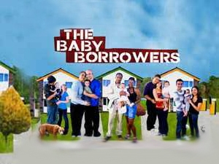
The ‘Baby Borrowers’ was a social experiment that was filmed for a BBC TV series in 2007.
The show features five couples aged between 16 and 19. They start off attempting to look after a baby for three days, before moving onto toddlers, pre-teens, teenagers and finally an elderly person. The TV show/experiment wanted to find out about what makes a successful relationship, what the demands are of becoming a parent for the first time and what makes a ‘good’ parent.
Your tasks:
- Watch the following clip: https://www.youtube.com/watch?v=uBFG-OeRwh4
- And then complete the table on the next page. You may want to watch the clip once and then re-watch it and pause it in order to make notes. Try to write detailed answers.
- After you have watched the clip and completed the table, have a go at completing the following questions as a summary of your findings:
What do you think is the ‘right’ age to start a family and why?

What makes a ‘good’ relationship?

What makes a ‘good’ parent?

Name | Age | Length of relationship | How effective is the relationship | How well do they cope as parents
Ava & Fisnik

Ryan & Lauren

Raiesa & Kallai

Alex & Sam

Carl & Kayleigh

On the welcome letter you received I also suggested watching the below series on the BBC iPlayer

If you would like to start looking at themes we will be studying, there are 2 series on BBC iPlayer which will aid in your understanding of the topics we will cover.

Life and Birth: https://www.bbc.co.uk/iplayer/episode/m000hk2g/life-and-birth-series-1-episode-1

The Baby Has Landed: https://www.bbc.co.uk/iplayer/episode/m000bpr3/the-baby-has-landed-series-1-1-brace-for-impact

