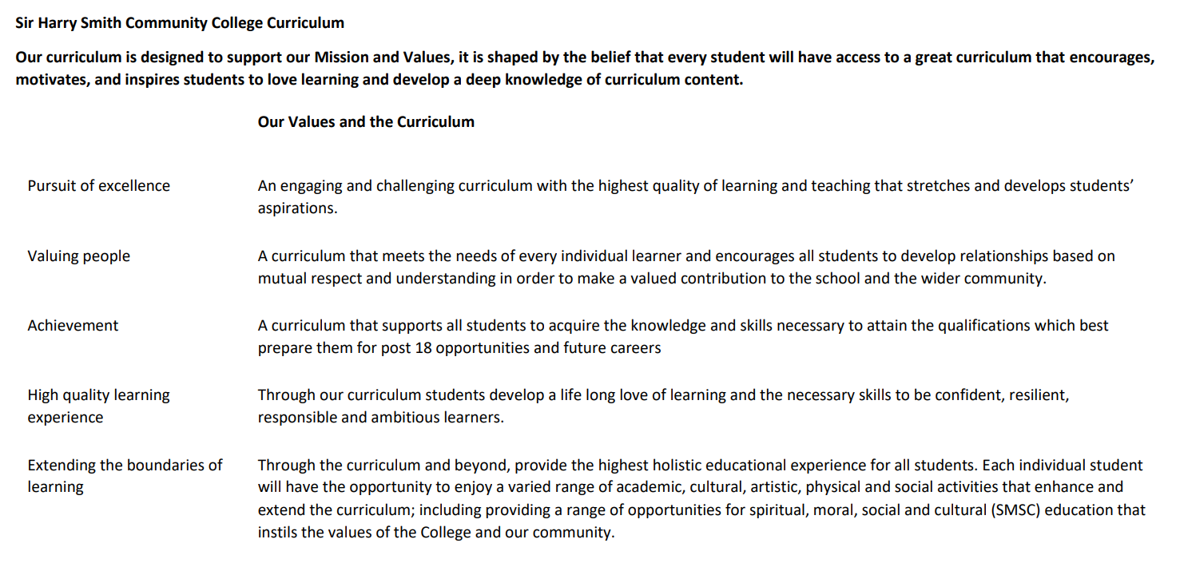

Sir Harry Smith Community College Curriculum Map SUBJECT: [Business Studies] YEAR 13 2022-23
Curriculum Intent:
The vision for A Level Business at Sir Harry Smith is to develop students into well-rounded individuals who have an understanding and an appreciation for the world around them. The course not only gives students a good basis for their future lives, by teaching them fundamental skills such as money management, organisation, resource management, jobs expectations and many other areas. However, further to this, throughout the different themes of the course there is a consistent link to ethical stances and what we should do to contribute towards society, whether this is as a business or as an individual.
With regard to these areas, the specification focuses on marketing, business activities, business decisions, and globalisation. These are key themes and areas that will benefit the students throughout their careers and help develop students into well-rounded individuals.
Throughout the course, there is a key focus on applying knowledge to practical business examples, this helps give students empathy for different situations and helps given them a real-life perspective of the impact of businesses. By giving students these skills, it will not only help student’s personal skills, but give them advantage in the competitive area of employment.

School Values | Curriculum Focus | Term 1  Topics 1.1 and 1.2  Topics 2.1 and 2.2 | Term 2  Topics 1.3 and 1.4  Topics 2.3 and 2.4 | Term 3  Topic 1.5 and mock exam prep  Topic 2.5 and mock exam prep
High Quality Learning Experience | Literacy Skills and Key Vocabulary | A Level Business is a wide-ranging course, that develops from a plethora of different skills and knowledge, clearly the knowledge and skills gained from GCSE Business will support students’ entry, however the skills listed below could be gained across the entire school curriculum:  - Analytical skills - these are imperative to be able to not only discuss business concepts within a class, but to break down theory within an exam answer.  - Application skills - which are a fundamental of business; being able to take the knowledge from learning and apply it within business context  - Literacy skills - which are used within exam answers, as most exam questions are essay-style questions  - Numeracy skills - which are important throughout the course; having the confidence to utilise business calculations and formulae.  - Debating skills - being able to argue what the correct course of action is, and to understand the different sides of a decision within a business scenario.
Pursuit of Excellence | Knowledge and Skills | By the end of this term students should be confident in the following areas:  - What are markets?  - The use and types of market research  - Understanding market positioning (the elements that make one product stand out from another)  - The factor that influence supply and demand  - How these factors interact on a supply & demand diagram  - How to calculate and interpret different types of elasticity  - The different sources a business can use to raise finance (internally & externally)  - The types and implications of liability  - The elements of business plans and the construction  of  - How businesses forecast  - Basics of business calculations; revenue, costs, profit, break even  - Creation of and purpose of budgeting | Further to revising and revisiting previous knowledge, this term, students will particularly focus on:  - Students should have a strong understanding of the elements of the marketing mix, including: o Product; the design mix  - Promotion; the promotional mix and branding  - Pricing; the different pricing strategies o Place; distribution  - The use of the marketing mix to help analyse a businesses  position, e.g. using the product life cycle and portfolio analysis  - Different approaches to staffing, whether staff are treated as an asset or a cost.  - An understanding of a flexible workforce  - Employer conflicts and relationship management  - Different methods of recruiting and training employees  - Understanding the construction of and impact of organisational design  - How businesses manage their finances, from types of profitability to understanding financial statements; income statements, balance sheet, and the analysis of these statements.  - The causes of business failure  - The different types of production and calculations involved with productivity  - Understanding the methods of and impacts of stock control  - Being able to explain the ways that quality is managed in a business | Further to revising and revisiting previous knowledge, this term, students will particularly focus on:  - The importance of entrepreneurs; understanding their role, their motives, their characteristics, and the difficulties they face becoming leaders  - Understanding the different objectives of a business  - Being able to explain the concepts of opportunity cost and trade-offs  - Understanding the different forms of business ownership and the limitations of each  - The economy, understanding the different elements that are influenced within the economy, including:  - Inflation o Exchange rates o Interest rates  - Taxation and government spending  - The business cycle  • The impact of different types of legislation on a business
 | Subject specific pedagogy | Topics 1.1 and 1.2  This introduces students to marketing, following through concepts such as what is marketing, how businesses conduct market research, and how they position themselves within a market. This is then developed with economic understanding, linking to elasticity of demand, income elasticity, and the impact of supply and demand.  Introducing with these topics help students understand the fundamentals of marketing which allow further understanding  Topics 2.1 and 2.2  Here, students learn the fundamentals of finance, from the different sources of finance within a business, to how businesses plan their finances; covering areas such as business plans, sales forecasting, cash flow forecasting and another essential knowledge such as break even  These are the fundamentals of business finance, and so introducing these topics helps students access the course | Topics 1.3 and 1.4  This continues marketing, focusing on how a business designs their products, and promote them. This follows into other areas of the marketing mix, such as pricing and distribution. Topic 1.4 focuses on how businesses themselves are organised, with regard to employees and organisational structures  The marketing mix follows naturally from the fundamentals of marketing, taught in term 1  Topics 2.3 and 2.4  Students develop this knowledge with understanding of how businesses manage their finances and resources, understanding core  elements such as  profitability, liquidity and productivity.  Once students understand the fundamentals of finance, knowing how they manage their resources is a natural progression | Topic 1.5  This looks at the different ways that businesses are structures and entrepreneurial motives. Focusing on entrepreneurs and forms of ownership. Further to this, students are given time to practise exam technique and develop this essential skill  This is a good way to round of learning for the year as once students understand businesses and marketing, they can apply their learning to different forms of business  Topics 2.5  Students focus their knowledge on the external environment, understanding how the external environment impacts businesses, from economic factors, to social influences, as well as other external impacts. We also use this time to help students apply their knowledge to exam technique.  By having prior knowledge of finance, and then learning external influences, it helps students analyse the impact of external influence on a business
Extending the boundaries of learning | Cultural Capital and beyond the curriculum | A large part of the course is devoted to linking business concepts to real-life examples. There created an enriched environment, as students’ learning is consistently being applied to real-life, world examples. This is supplemented with teachers leading their learning by reflecting on their own practice within industry and encouraging learners to do the same. There are of course some learners without any experience of the workplace, and therefore there is time in the scheme of work given to allow students to research their own career paths and potential career routes. For instance, in theme 1, when teaching marketing, there are a number of careers that lead from this (such as a marketing manager) and students are given time to reflect on this and research potential careers.  A Level Business is a course that relies upon a wide knowledge and skills-base, and therefore is naturally a cross-curricular subject; from literacy, to numeracy, to exploring theories and hypothesise, it uses a number of skills. Some of the main areas that business links with are English, Mathematics and Economics. Clear literacy and writing skills are fundamental to answering exam questions, Mathematics is used throughout the quantitative elements of the course, which are significant, whether this is simple calculations or interpreting and analysing data. Economics has clear links as there are cross-over topics, although they are taught to a higher level in economics, for instance learning about the external environment, elasticity, supply and demand, or other economic factors such as interest rates and exchange rates. Below are some examples where these links are within the course:  Term 1  Business builds on the skills used across a number of topics as it is a diverse course, however here are some examples. Clear links with economics - for instance through teaching of supply and demand. Furthermore, clear numeracy skills used, for instance with ratio analysis and calculations.  Term 2  Numeracy is important, for instance through topics taught in theme 2. Psychology is also linked well, an example being the motivations of employees.  Term 3  Again, psychology is used when linking entrepreneurial motivation. Furthermore, topics such as sociology are used in the impacts of external influences.
Achievement | Assessment | The curriculum is assessed throughout the course in a number of different ways. These range from informal assessment within the class, to more thorough, formal assessments. There is a large emphasis on understanding a quantity of different knowledge points and theories, and therefore key term tests make up a large part of informal assessment. Further to this, there is a large focus on quantitative skills within the course, as students are expected to be able to perform an array of calculations, therefore ongoing quantitative assessment also makes up a large part of informal testing.  Teachers are responsible for setting regular assessments. Within each theme there are a number of topics, at the end of each topic the students will have a topic assessment, which could take the form of exam-style questions or knowledge-based questions. Further to this, the class regularly use exam-style questions within the lesson to help develop their knowledge into the format of an exam answer.  All of these assessments lead towards formal assessment, in the form of mock examinations, which makes up the three formal exam weeks the students undertake each year.  There are various assessments throughout the course, from regular mini assessments within the class, to practise exam questions, to more formal assessments, such as:  - End of module tests  - In class mock exam questions  - End of year Mock examinations
Valuing People | How our curriculum meets the needs of every individual | Students Vision.  - To experience awe and wonder gaining an enthusiasm and appreciation for the importance of business in student’s lives  - To understand the perspectives of different groups when we apply our knowledge to real life  - To understand personal responsibilities for their own and businesses actions within society  - To gain lateral thinking skills, especially with regard to problem solving in different applied contexts.  - To practise essential business skills, which will be used throughout the student’s lives.  - To understand the importance of sustainability; understanding the importance they can make by being responsible.  The vision and aims of A Level Business at the Sir Harry Smith has been influenced by the Edexcel Specification that we follow, which highlight areas that we feel particularly important in the 21st Century.  - Awe and wonder - “develop an enthusiasm for studying business” (Edexcel 2014)  - Perspectives – “understand that business behaviour can be studied from a range of perspectives” (Edexcel 2014)  - Personal responsibilities - “develop a critical understanding of organisations and their ability to meet society’s needs and wants” (Edexcel 2014)  - Lateral thinking - “generate enterprising and creative approaches to business opportunities, problems and issues” (Edexcel 2014)  - Essential business skills - “acquire a range of relevant business and generic skills, including decision making, problem solving, the challenging of assumptions and critical analysis” (Edexcel 2014)  - Sustainability - “be aware of the ethical dilemmas and responsibilities faced by organisations and individuals” (Edexcel 2014)  The curriculum is divided into four separate themes. These themes are split evenly across Year 12 and Year 13, with students taking their knowledge of Theme 1 (marking and people) and Theme 2 (managing business activities) and develop their knowledge of these in Theme 3 and Theme 4 (Business decisions and strategy & global business). Each theme is normally the responsibility of one classroom teacher, so the students learn both the year's themes simultaneously with separate teachers.

